SEC Form 3
FORM 3 | UNITED STATES SECURITIES AND EXCHANGE COMMISSION  Washington, D.C. 20549  INITIAL STATEMENT OF BENEFICIAL OWNERSHIP OF SECURITIES  Filed pursuant to Section 16(a) of the Securities Exchange Act of 1934  or Section 30(h) of the Investment Company Act of 1940
  OMB APPROVAL
  OMB Number: | 3235-0104
  Estimated average burden
  hours per response: | 0.5
1. Name and Address of Reporting Person*  (Street) | 2. Date of Event Requiring Statement (Month/Day/Year)  09/23/2025 | 3. Issuer Name and Ticker or Trading Symbol  Sonder Holdings Inc. [ SOND ]
  Aronzon Paul
  (Last) | (First) | (Middle)
  C/O SONDER HOLDINGS INC.
  447 SUTTER ST. STE 405 #542
  SAN FRANCISCO | CA | 94108
  (City) | (State) | (Zip)
 |  | 4. Relationship of Reporting Person(s) to Issuer  (Check all applicable) | 5. If Amendment, Date of Original Filed (Month/Day/Year)
   | Director |  | 10% Owner
   | Officer (give title below) |  | Other (specify below)
6. Individual or Joint/Group Filing (Check Applicable Line)
Form filed by One Reporting Person
Form filed by More than One Reporting Person

Table I - Non-Derivative Securities Beneficially Owned
1. Title of Security (Instr. 4) | 2. Amount of Securities Beneficially Owned (Instr. 4) | 3. Ownership Form: Direct (D) or Indirect (I) (Instr. 5) | 4. Nature of Indirect Beneficial Ownership (Instr. 5)
Table II - Derivative Securities Beneficially Owned
(e.g., puts, calls, warrants, options, convertible securities)
1. Title of Derivative Security (Instr. 4) | 2. Date Exercisable and Expiration Date (Month/Day/Year) |  | 3. Title and Amount of Securities Underlying Derivative Security (Instr. 4) |  | 4. Conversion or Exercise Price of Derivative Security | 5. Ownership Form: Direct (D) or Indirect (I) (Instr. 5) | 6. Nature of Indirect Beneficial Ownership (Instr. 5)
1. Title of Derivative Security (Instr. 4) | Date Exercisable | Expiration Date | Title | Amount or Number of Shares | 4. Conversion or Exercise Price of Derivative Security | 5. Ownership Form: Direct (D) or Indirect (I) (Instr. 5) | 6. Nature of Indirect Beneficial Ownership (Instr. 5)
Explanation of Responses:
Remarks:
EX 24 - POA
No securities are beneficially owned.
 | /s/ Albert Watson Attorney-in Fact for Paul Aronzon | 09/30/2025
 | ** Signature of Reporting Person | Date
Reminder: Report on a separate line for each class of securities beneficially owned directly or indirectly.
* If the form is filed by more than one reporting person, see Instruction 5 (b)(v).
** Intentional misstatements or omissions of facts constitute Federal Criminal Violations See 18 U.S.C. 1001 and 15 U.S.C. 78ff(a).
Note: File three copies of this Form, one of which must be manually signed. If space is insufficient, see Instruction 6 for procedure.
Persons who respond to the collection of information contained in this form are not required to respond unless the form displays a currently valid OMB Number.
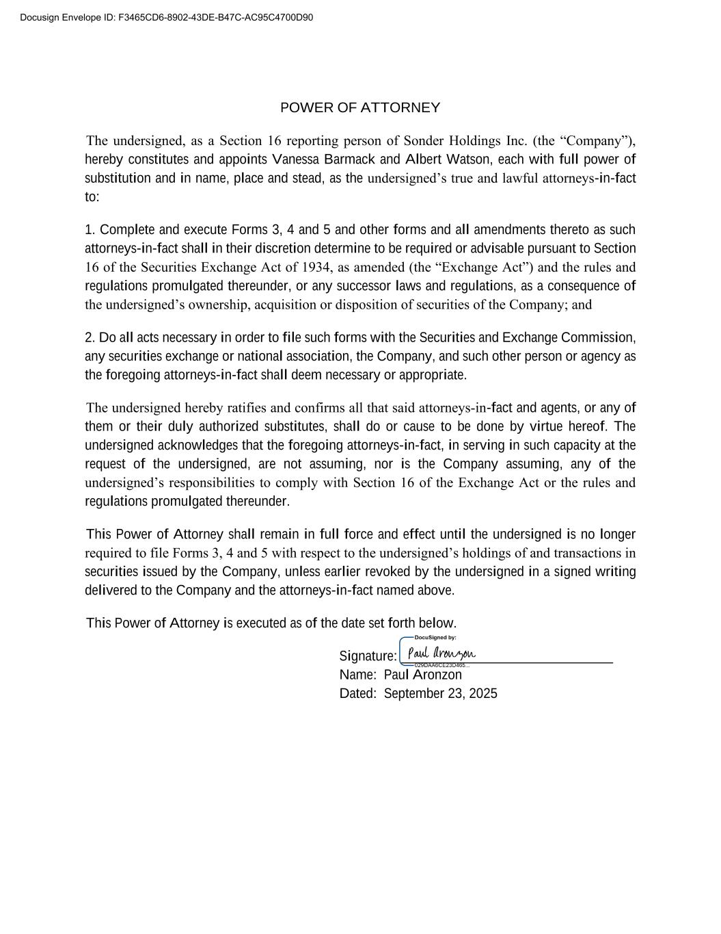
POWER OF ATTORNEY The undersigned, as a Section 16 reporting person of Sonder Holdings Inc. (the “Company”), hereby constitutes and appoints Vanessa Barmack and Albert Watson, each with full power of substitution and in name, place and stead, as the undersigned’s true and lawful attorneys-in-fact to: 1. Complete and execute Forms 3, 4 and 5 and other forms and all amendments thereto as such attorneys-in-fact shall in their discretion determine to be required or advisable pursuant to Section 16 of the Securities Exchange Act of 1934, as amended (the “Exchange Act”) and the rules and regulations promulgated thereunder, or any successor laws and regulations, as a consequence of the undersigned’s ownership, acquisition or disposition of securities of the Company; and 2. Do all acts necessary in order to file such forms with the Securities and Exchange Commission, any securities exchange or national association, the Company, and such other person or agency as the foregoing attorneys-in-fact shall deem necessary or appropriate. The undersigned hereby ratifies and confirms all that said attorneys-in-fact and agents, or any of them or their duly authorized substitutes, shall do or cause to be done by virtue hereof. The undersigned acknowledges that the foregoing attorneys-in-fact, in serving in such capacity at the request of the undersigned, are not assuming, nor is the Company assuming, any of the undersigned’s responsibilities to comply with Section 16 of the Exchange Act or the rules and regulations promulgated thereunder. This Power of Attorney shall remain in full force and effect until the undersigned is no longer required to file Forms 3, 4 and 5 with respect to the undersigned’s holdings of and transactions in securities issued by the Company, unless earlier revoked by the undersigned in a signed writing delivered to the Company and the attorneys-in-fact named above. This Power of Attorney is executed as of the date set forth below. Signature: ______________________________ Name: Paul Aronzon Dated: September 23, 2025 Docusign Envelope ID: F3465CD6-8902-43DE-B47C-AC95C4700D90

