Table of Contents

UNITED STATES

SECURITIES AND EXCHANGE COMMISSION

Washington, D.C. 20549

___________________________________

FORM 10-Q

___________________________________

(Mark One)

- QUARTERLY REPORT PURSUANT TO SECTION 13 OR 15(d) OF THE SECURITIES EXCHANGE ACT OF 1934

For the quarterly period ended June 30, 2025

OR

- TRANSITION REPORT PURSUANT TO SECTION 13 OR 15(d) OF THE SECURITIES EXCHANGE ACT OF 1934

For the transition period from ______ to ______

Commission file number 001-39907

___________________________________

SONDER HOLDINGS INC.

___________________________________

(Exact name of registrant as specified in its charter)

 | Delaware |  |  |  |  |  | 85-2097088
 | (State or other jurisdiction of incorporation or organization) |  |  |  |  |  | (I.R.S. Employer Identification No.)
 | 447 Sutter St. Suite 405, #542
 | San Francisco, California |  |  |  |  |  | 94108
 | (Address of principal executive offices) |  |  |  |  |  | (Zip Code)
 |  |  | (617) 300-0956
 |  | (Registrant’s telephone number, including area code)
 |  |  | ___________________________________
Securities registered pursuant to Section 12(b) of the Act:
 | Title of each class |  | Trading Symbol(s) |  |  |  | Name of each exchange on which registered
 | Common Stock, par value $0.0001 per share |  | SOND |  |  |  | The Nasdaq Stock Market LLC
 | Warrants, each 20 whole warrants exercisable for one share of Common |  | SONDW |  |  |  | The Nasdaq Stock Market LLC
 | Stock at an exercise price of $230.00 per share |  |  |  |  |  | The Nasdaq Stock Market LLC

Indicate by check mark whether the registrant: (1) has filed all reports required to be filed by Section 13 or 15(d) of the Securities Exchange Act of 1934 during the preceding 12 months (or for such shorter period that the registrant was required to file such reports), and (2) has been subject to such filing requirements for the past 90 days. Yes ☐ No ☒

Indicate by check mark whether the registrant has submitted electronically every Interactive Data File required to be submitted pursuant to Rule 405 of Regulation S-T (§232.405 of this chapter) during the preceding 12 months (or for such shorter period that the registrant was required to submit such files). Yes ☒ No ☐

Indicate by check mark whether the registrant is a large accelerated filer, an accelerated filer, a non-accelerated filer, a smaller reporting company, or an emerging growth company. See the definitions of “large accelerated filer,” “accelerated filer,” “smaller reporting company,” and “emerging growth company” in Rule 12b-2 of the Exchange Act.

Large accelerated filer | ☐ | Accelerated filer | ☐
Non-accelerated filer | ☒ | Smaller reporting company | ☒
 |  | Emerging growth company | ☒

If an emerging growth company, indicate by check mark if the registrant has elected not to use the extended transition period for complying with any new or revised financial accounting standards provided pursuant to Section 13(a) of the Exchange Act. ☐

Indicate by check mark whether the registrant is a shell company (as defined in Rule 12b-2 of the Exchange Act).

Yes ☐ No ☒

The registrant had 13,308,481 shares of common stock outstanding as of October 9, 2025.

Table of Contents
 |  |  |  |  |  |  |  |  |  |  |  |  |  |  |  |  |  |  | TABLE OF CONTENTS
 | PART I - FINANCIAL INFORMATION |  |  |  |  |  |  |  |  |  |  |  |  |  |  |  |  |  |  |  |  |  | Page
 |  | Item 1. Financial Statements |  |  |  |  |  |  |  |  |  |  |  |  |  |  |  |  |  |  |  |  | 5
 |  |  | Condensed Consolidated Balance Sheets (unaudited) |  |  |  |  |  |  |  |  |  |  |  |  |  |  |  |  |  |  |  | 5
 |  |  | Condensed Consolidated Statements of Operations and Comprehensive Income (Loss) (unaudited) |  |  |  |  |  |  |  |  |  |  |  |  |  |  |  |  |  |  |  | 6
 |  |  | Condensed Consolidated Statements of Cash Flows (unaudited) |  |  |  |  |  |  |  |  |  |  |  |  |  |  |  |  |  |  |  | 7
 |  |  | Condensed Consolidated Statements of Stockholders’ Deficit (unaudited) |  |  |  |  |  |  |  |  |  |  |  |  |  |  |  |  |  |  |  | 8
 |  |  | Notes to the Condensed Consolidated Financial Statements (unaudited) |  |  |  |  |  |  |  |  |  |  |  |  |  |  |  |  |  |  |  | 10
 |  | Item 2. Management's Discussion and Analysis of Financial Condition and Results of Operations |  |  |  |  |  |  |  |  |  |  |  |  |  |  |  |  |  |  |  |  | 38
 |  | Item 3. Quantitative and Qualitative Disclosures About Market Risk |  |  |  |  |  |  |  |  |  |  |  |  |  |  |  |  |  |  |  |  | 57
 |  | Item 4. Controls and Procedures |  |  |  |  |  |  |  |  |  |  |  |  |  |  |  |  |  |  |  |  | 57
 | PART II - OTHER INFORMATION
 |  | Item 1. Legal Proceedings |  |  |  |  |  |  |  |  |  |  |  |  |  |  |  |  |  |  |  |  | 60
 |  | Item 1A. Risk Factors |  |  |  |  |  |  |  |  |  |  |  |  |  |  |  |  |  |  |  |  | 60
 |  | Item 2. Unregistered Sales of Equity Securities, Use of Proceeds, and Issuer Purchases of Equity Securities |  |  |  |  |  |  |  |  |  |  |  |  |  |  |  |  |  |  |  |  | 60
 |  | Item 3. Defaults Upon Senior Securities |  |  |  |  |  |  |  |  |  |  |  |  |  |  |  |  |  |  |  |  | 60
 |  | Item 4. Mine Safety Disclosures |  |  |  |  |  |  |  |  |  |  |  |  |  |  |  |  |  |  |  |  | 60
 |  | Item 5. Other Information |  |  |  |  |  |  |  |  |  |  |  |  |  |  |  |  |  |  |  |  | 60
 |  | Item 6. Exhibits |  |  |  |  |  |  |  |  |  |  |  |  |  |  |  |  |  |  |  |  | 61
 | SIGNATURE |  |  |  |  |  |  |  |  |  |  |  |  |  |  |  |  |  |  |  |  |  | 63
 |  |  |  | 2

Table of Contents

SPECIAL NOTE REGARDING FORWARD-LOOKING STATEMENTS

This Quarterly Report on Form 10-Q contains forward-looking statements within the meaning of Section 27A of the Securities Act of 1933, as amended (the “Securities Act”), Section 21E of the Securities Exchange Act of 1934, as amended (the “Exchange Act”), and the Private Securities Litigation Reform Act of 1995. Forward-looking statements generally relate to future events or our expected future financial or operating performance. In some cases, you can identify forward-looking statements because they contain words such as “may,” “will,” “should,” “expects,” “plans,” “anticipates,” “could,” “intends,” “target,” “projects,” “contemplates,” “believes,” “estimates,” “predicts,” “potential,” or “continue,” or the negative of these words or other similar terms or expressions that concern our expectations, strategy, plans, or intentions. Forward-looking statements involve risks and uncertainties that could cause actual results to differ materially from historical experience or our present expectations.

Forward-looking statements contained in this Quarterly Report on Form 10-Q include, but are not limited to, statements about:

- our focus on achieving positive and sustainable adjusted free cash flow (“Adjusted FCF”);

- our forecasts and projections, including our cost-saving initiatives, restructuring initiatives, portfolio optimization program, and Cash Flow Positive Plan;

- expectations for our business, revenue, expenses, results of operations, financial condition, and cash flows;

- our license agreement with Marriott International, Inc. and Global Hospitality Licensing S.À R.L (together, “Marriott”) (the “Marriott Agreement”), the anticipated benefits of the Marriott Agreement, and other plans and expectations related to the Marriott relationship;
- our expectations concerning future transaction structures and the anticipated rent, rent abatement, capital expenditure provisions, and other terms of our future leases;

- the expected adequacy of our capital resources, the availability of future financing or other capital resources, and the anticipated use of proceeds from any financings;

- management’s conclusion regarding its substantial doubt about the Company’s ability to continue as a going concern, and the related mitigation plans, including any impact on our key stakeholder relationships;
- our ability to enter into satisfactory leases or renew existing properties on satisfactory terms;

- trends in the hospitality, real estate, and travel industries;

- our ability to achieve our financial, operating, and growth forecasts, and to predict and plan for risks and challenges;

- our ability to achieve or maintain profitability in the future;

- our relationships with landlords;

- our portfolio optimization program, including lease renegotiation efforts, potential lease amendments and terminations, and the scope and timing of property exits, and their potential effects on our portfolio, results of operations, and cash flow, including any anticipated cost savings;
- our pricing and revenue management strategies, pricing and occupancy forecasts and anticipated trends, and expectations about demand elasticity;

- our efforts to expand globally and in jurisdictions where we do not currently operate;

- our competitive advantage and anticipated differentiation in cost structure and guest experience compared to other accommodation providers;

- expectations about our distinctive type of hospitality service;

- our ability to anticipate and satisfy guest demands, including through the introduction of new features, amenities or services;

- expectations about our relationships with third-party distribution channels and indirect channels, and the percentage of future revenue attributable to bookings through indirect channels;

- our revenue, expenses, operating results, and cash flows, as well as our key operating metrics;

- our reputation and the strength of our brand;

- our assessments and beliefs regarding the timing and outcome of pending legal proceedings and any liability that we may incur as a result of those proceedings;

- changes in our executive management and expectations about employee relations and our ability to attract, retain, motivate, or integrate qualified personnel;

- our efforts to remediate material weaknesses in our internal controls over financial reporting;

- our ability to produce timely and accurate financial statements or comply with applicable regulations;

- our ability to meet and continue meeting the listing standards of The Nasdaq Stock Market LLC (“Nasdaq”);

- our relationships with third-party services and technologies;

3

Table of Contents

- expectations about our geographic market mix and product mix between hotels and apartments, and their impact on our financial results;

- our plans to roll out additional features, amenities and technologies, and our beliefs about the positive impact of our technology investments on our brand and financial results;

- our assessments and estimates that determine our effective tax rate and regarding any tax-related audits or other tax proceedings;

- the anticipated ratio of Occupied Nights to Bookable Nights (“Occupancy Rate”) and expectations about guests’ average length of stay;

- the anticipated growth in our portfolio of units that are available for guests to book (“Live Units”) and units for which we have signed real estate contracts but which are not yet available for guests to book (“Contracted Units”), including the anticipated scope and timing of any removals of units from our portfolio;
- anticipated seasonality and other variations in our results of operations from period-to-period, including statements about anticipated Revenue per Available Room (“RevPAR”) in specified periods; and
- other expectations, beliefs, plans, strategies, anticipated developments, and other matters that are not historical facts.

We caution you that the foregoing list may not contain all of the forward-looking statements made in this Quarterly Report on Form 10-Q.

You should not place undue reliance on our forward-looking statements because the matters they describe are subject to known and unknown risks, uncertainties, and other factors, many of which are beyond our control. Neither we nor any other person assumes responsibility for the accuracy and completeness of any of these forward-looking statements. Moreover, the forward-looking statements made in this Quarterly Report on Form 10-Q relate only to events as of the date on which the statements are made. We undertake no obligation to update any forward-looking statements made in this Quarterly Report on Form 10-Q to reflect events or circumstances after the date of this Quarterly Report on Form 10-Q or to reflect new information or the occurrence of unanticipated events, except as required by law.

You should note that we may announce material information to our investors using our investor relations website (https://investors.sonder.com/), filings with the Securities and Exchange Commission (the “SEC”), press releases, public conference calls and webcasts. We use these channels, as well as social media, to communicate with our investors. It is possible that the information that we post on these channels could be deemed to be material information. We therefore encourage investors to visit these websites from time to time. The information contained on such websites and social media posts is not incorporated by reference into this filing. Further, our references to website URLs in this filing are intended to be inactive textual references only.

For a discussion of our risk factors, see the section entitled “Risk Factors” in our Annual Report on Form 10-K for the fiscal year ended December 31, 2024 (the “Annual Report”), which is incorporated by reference into this Quarterly Report on Form 10-Q, and our subsequent filings with the SEC. Additional factors that could cause results or performance to differ materially from those expressed in our forward-looking statements are detailed in other filings we may make with the SEC, copies of which are available from us at no charge. Please consider our forward-looking statements in light of those risks as you read this report. New risks and uncertainties emerge from time to time, and it is not possible for us to predict all risks and uncertainties that could have an impact on the forward-looking statements contained in this Quarterly Report on Form 10-Q. We cannot assure you that the results, events and circumstances reflected in the forward-looking statements will be achieved or occur, and actual results, events or circumstances could differ materially from those described in the forward-looking statements.

4

Table of Contents

PART I - FINANCIAL INFORMATION

Item 1. Financial Statements

SONDER HOLDINGS INC. AND SUBSIDIARIES

CONDENSED CONSOLIDATED BALANCE SHEETS (Unaudited)

(in thousands)

 |  | June 30, 2025 |  |  | December 31, 2024
Assets
Current assets:
Cash and cash equivalents | $ | 27,130 |  | $ | 20,786
Restricted cash |  | 43,828 |  |  | 51,268
Accounts receivable, net of allowance of $15,953 and $14,587 at June 30, 2025 and December 31, 2024, respectively |  | 12,003 |  |  | 13,918
Prepaid expenses |  | 2,597 |  |  | 4,141
Other current assets |  | 11,605 |  |  | 9,733
Total current assets |  | 97,163 |  |  | 99,846
Property and equipment, net |  | 4,387 |  |  | 5,933
Operating lease right-of-use (“ROU”) assets |  | 882,139 |  |  | 1,013,854
Other non-current assets |  | 21,118 |  |  | 17,544
Total assets | $ | 1,004,807 |  | $ | 1,137,177
Liabilities, mezzanine equity and stockholders’ deficit
Current liabilities:
Accounts payable | $ | 49,193 |  | $ | 33,724
Accrued liabilities |  | 36,167 |  |  | 32,621
Taxes payable |  | 23,471 |  |  | 22,224
Deferred revenue |  | 96,150 |  |  | 71,729
Other current liabilities |  | 19,822 |  |  | 5,513
Current portion of long-term debt |  | 1,000 |  |  | 1,000
Current operating lease liabilities |  | 162,349 |  |  | 171,736
Total current liabilities |  | 388,152 |  |  | 338,547
Non-current operating lease liabilities |  | 867,816 |  |  | 1,009,169
Long-term debt, net |  | 217,922 |  |  | 217,236
Other non-current liabilities |  | 16,142 |  |  | 8,113
Total liabilities |  | 1,490,032 |  |  | 1,573,065
Commitments and contingencies (Note 12)
Mezzanine equity:
Series A redeemable convertible preferred stock: $0.0001 par value; 250,000,000 shares authorized at June 30, 2025 and
December 31, 2024, 59,690,000 and 43,300,000 shares issued and outstanding at June 30, 2025 and December 31, 2024,
respectively |  | 230,212 |  |  | 162,907
Stockholders’ deficit:
Common stock |  | 1 |  |  | 1
Additional paid-in capital |  | 971,552 |  |  | 977,112
Cumulative translation adjustment |  | (2,704) |  |  | 7,360
Accumulated deficit |  | (1,684,286) |  |  | (1,583,268)
Total stockholders’ deficit |  | (715,437) |  |  | (598,795)
Total liabilities and stockholders’ deficit | $ | 1,004,807 |  | $ | 1,137,177

See accompanying notes to unaudited condensed consolidated financial statements.

5

Table of Contents
 |  | SONDER HOLDINGS INC. AND SUBSIDIARIES
 |  | CONDENSED CONSOLIDATED STATEMENTS OF OPERATIONS
 |  | AND COMPREHENSIVE INCOME (LOSS)
 |  |  |  | (Unaudited)
 |  | (in thousands, except share data)
 |  |  |  | Three months ended June 30, |  |  |  |  |  | Six months ended June 30,
 |  |  |  | 2025 |  |  | 2024 |  |  | 2025 |  |  | 2024
Revenue |  |  | $ | 147,085 |  | $ | 164,601 |  | $ | 265,941 |  | $ | 298,080
Costs and operating expenses:
Cost of revenue (excluding depreciation and amortization) |  |  |  | 80,975 |  |  | 94,652 |  |  | 177,824 |  |  | 195,015
Operations and support |  |  |  | 37,996 |  |  | 46,411 |  |  | 76,028 |  |  | 96,391
General and administrative |  |  |  | 6,740 |  |  | 29,272 |  |  | 33,557 |  |  | 53,557
Research and development |  |  |  | 3,863 |  |  | 4,393 |  |  | 7,801 |  |  | 9,064
Sales and marketing |  |  |  | 17,707 |  |  | 21,572 |  |  | 33,029 |  |  | 40,821
Integration costs |  |  |  | 2,143 |  |  | — |  |  | 3,682 |  |  | —
Restructuring and other charges |  |  |  | 4,541 |  |  | — |  |  | 4,541 |  |  | 2,592
Total costs and operating expenses |  |  |  | 153,965 |  |  | 196,300 |  |  | 336,462 |  |  | 397,440
Loss from operations |  |  |  | (6,880) |  |  | (31,699) |  |  | (70,521) |  |  | (99,360)
Interest expense, net |  |  |  | 1,648 |  |  | 8,016 |  |  | 11,097 |  |  | 15,339
Lease adjustment gains, net |  |  |  | (5,325) |  |  | (71,123) |  |  | (16,463) |  |  | (95,024)
Loss on preferred stock issuance |  |  |  | 43,842 |  |  | — |  |  | 43,842 |  |  | —
Other income, net |  |  |  | (2,342) |  |  | (1,576) |  |  | (8,516) |  |  | (2,359)
Total non-operating expense (income), net |  |  |  | 37,823 |  |  | (64,683) |  |  | 29,960 |  |  | (82,044)
Income (loss) before income taxes |  |  |  | (44,703) |  |  | 32,984 |  |  | (100,481) |  |  | (17,316)
Provision (benefit) for income taxes |  |  |  | (180) |  |  | 237 |  |  | 537 |  |  | 424
Net income (loss) |  |  | $ | (44,523) |  | $ | 32,747 |  | $ | (101,018) |  | $ | (17,740)
Basic and diluted net income (loss) per common share |  | $ |  | (3.96) |  | $ | 2.94 |  | $ | (8.44) |  | $ | (1.59)
Other comprehensive income (loss):
Net income (loss) |  | $ |  | (44,523) |  | $ | 32,747 |  | $ | (101,018) |  | $ | (17,740)
Change in foreign currency translation adjustment |  |  |  | (6,865) |  |  | 1,395 |  |  | (10,064) |  |  | 806
Comprehensive income (loss) |  |  | $ | (51,388) |  | $ | 34,142 |  | $ | (111,082) |  | $ | (16,934)

See accompanying notes to unaudited condensed consolidated financial statements.

6

Table of Contents
 | SONDER HOLDINGS INC. AND SUBSIDIARIES
 | CONDENSED CONSOLIDATED STATEMENTS OF CASH FLOWS (Unaudited)
 | (in thousands)
 |  | Six months ended June 30,
 |  | 2025 |  |  | 2024
Cash flows from operating activities:
Net loss |  | $ | (101,018) |  | $ | (17,740)
Adjustments to reconcile net loss to net cash used in operating activities:
Depreciation and amortization |  |  | 4,586 |  |  | 9,965
Stock-based compensation |  |  | 803 |  |  | 4,788
Amortization of operating lease ROU assets |  |  | 64,845 |  |  | 89,252
Lease adjustment gains, net |  |  | (16,463) |  |  | (95,024)
Gain on foreign exchange |  |  | (7,181) |  |  | (1,058)
Capitalization of paid-in-kind interest on long-term debt |  |  | 11,555 |  |  | 13,385
Credit loss expense |  |  | 1,366 |  |  | 483
Amortization of debt discounts/premium and issuance costs |  |  | 506 |  |  | 1,625
Loss on preferred stock issuance |  |  | 43,842 |  |  | —
Other non-cash activities |  |  | (811) |  |  | 1,341
Changes in:
Accounts receivable |  |  | 1,190 |  |  | (3,003)
Prepaid expenses |  |  | 1,577 |  |  | (203)
Other current and non-current assets |  |  | (3,303) |  |  | (224)
Accounts payable |  |  | 13,959 |  |  | 9,283
Accrued liabilities |  |  | 2,978 |  |  | 929
Taxes payable |  |  | 21 |  |  | 1,639
Deferred revenue |  |  | 24,106 |  |  | 14,843
Operating lease ROU assets and operating lease liabilities, net |  |  | (69,831) |  |  | (103,560)
Other current and non-current liabilities |  |  | 3,302 |  |  | 192
Net cash used in operating activities |  |  | (23,971) |  |  | (73,087)
Cash flows from investing activities:
Purchase of property and equipment |  |  | (2,653) |  |  | (2,092)
Proceeds on the disposition of property and equipment |  |  | 450 |  |  | —
Proceeds of key money investment |  |  | 7,500 |  |  | —
Capitalization of internal-use software |  |  | — |  |  | (117)
Net cash provided by (used in) investing activities |  |  | 5,297 |  |  | (2,209)
Cash flows from financing activities:
Repayment of debt |  |  | (500) |  |  | (505)
Proceeds from debt financing |  |  | — |  |  | 10,000
Payment of debt issuance costs |  |  | — |  |  | (578)
Proceeds from preferred stock issuance |  |  | 17,980 |  |  | —
Net cash provided by financing activities |  |  | 17,480 |  |  | 8,917
Effects of foreign exchange on cash |  |  | 98 |  |  | (995)
Net change in cash, cash equivalents, and restricted cash |  |  | (1,096) |  |  | (67,374)
Cash, cash equivalents, and restricted cash at beginning of period |  |  | 72,054 |  |  | 136,497
Cash, cash equivalents, and restricted cash at end of period |  | $ | 70,958 |  | $ | 69,123

See accompanying notes to unaudited condensed consolidated financial statements.

7

Table of Contents
 |  |  | SONDER HOLDINGS INC. AND SUBSIDIARIES
 |  | CONDENSED CONSOLIDATED STATEMENTS OF STOCKHOLDERS’ DEFICIT (Unaudited)
 |  |  |  | Three and six months ended June 30, 2025
 |  |  |  | (in thousands, except share data)
 |  |  |  |  |  |  |  |  | Post-Combination
 |  |  |  |  |  |  |  |  | Exchangeable Common |  |  |  |  | Additional |  |  | Accumulated |  |  |  |  |  | Total
 |  |  |  | Common Stock |  |  |  |  | Stock |  |  |  |  |  |  |  |  |  |  |  |  |  | Total
 |  |  |  |  |  |  |  |  |  |  |  |  |  |  | Paid-in |  | Translation |  |  | Accumulated |  | Stockholders’
 |  |  |  | Shares |  |  | Amount |  | Shares |  |  | Amount |  |  | Capital |  |  | Adjustment |  | Deficit |  |  | Deficit
 | Balance at December 31, 2024 |  |  | 11,041,999 |  | $ | 1 |  | 551,072 |  | $ | — |  | $ | 977,112 |  | $ | 7,360 |  | $ (1,583,268) |  | $ | (598,795)
 | Conversion of exchangeable stock |  | 113 |  |  |  | — |  | (113) |  |  | — |  |  | — |  |  | — |  | — |  |  | —
 | Vesting of restricted stock units, net of shares withheld for taxes |  | 132,856 |  |  |  | — |  | — |  |  | — |  |  | — |  |  | — |  | — |  |  | —
 | Preferred stock accretion to redemption value |  |  | — |  |  | — |  | — |  |  | — |  |  | 3,239 |  |  | — |  | — |  |  | 3,239
 | Paid-in-kind dividend on preferred stock |  |  | — |  |  | — |  | — |  |  | — |  |  | (5,885) |  |  | — |  | — |  |  | (5,885)
 | Conversion of preferred stock |  | 667,000 |  |  |  | — |  | — |  |  | — |  |  | 2,120 |  |  | — |  | — |  |  | 2,120
 | Stock-based compensation |  |  | — |  |  | — |  | — |  |  | — |  |  | 2,269 |  |  | — |  | — |  |  | 2,269
 | Components of comprehensive loss:
 | Net loss |  |  | — |  |  | — |  | — |  |  | — |  |  | — |  |  | — |  | (56,495) |  |  | (56,495)
 | Change in cumulative translation adjustment |  |  | — |  |  | — |  | — |  |  | — |  |  | — |  |  | (3,199) |  | — |  |  | (3,199)
 | Balance at March 31, 2025 |  |  | 11,841,968 |  | $ | 1 |  | 550,959 |  | $ | — |  | $ | 978,855 |  | $ | 4,161 |  | $ (1,639,763) |  | $ | (656,746)
 | Preferred stock accretion to redemption value |  |  | — |  |  | — |  | — |  |  | — |  |  | (881) |  |  | — |  | — |  |  | (881)
 | Paid-in-kind dividend on preferred stock |  |  | — |  |  | — |  | — |  |  | — |  |  | (8,078) |  |  | — |  | — |  |  | (8,078)
 | Conversion of preferred stock |  | 923,000 |  |  |  | — |  | — |  |  | — |  |  | 3,122 |  |  | — |  | — |  |  | 3,122
 | Stock-based compensation |  |  | — |  |  | — |  | — |  |  | — |  |  | (1,466) |  |  | — |  | — |  |  | (1,466)
 | Components of comprehensive loss:
 | Net loss |  |  | — |  |  | — |  | — |  |  | — |  |  | — |  |  | — |  | (44,523) |  |  | (44,523)
 | Change in cumulative translation adjustment |  |  | — |  |  | — |  | — |  |  | — |  |  | — |  |  | (6,865) |  | — |  |  | (6,865)
 | Balance at June 30, 2025 |  |  | 12,764,968 |  | $ | 1 |  | 550,959 |  | $ | — |  | $ | 971,552 |  | $ | (2,704) |  | $ (1,684,286) |  | $ | (715,437)

See accompanying notes to unaudited condensed consolidated financial statements.

8

Table of Contents
 |  |  | SONDER HOLDINGS INC. AND SUBSIDIARIES
 |  | CONDENSED CONSOLIDATED STATEMENTS OF STOCKHOLDERS’ DEFICIT (continued) (Unaudited)
 |  |  | Three and six months ended June 30, 2024
 |  |  |  | (in thousands, except share data)
 |  |  |  |  |  |  |  |  | Post-Combination |  |  |  |  |  | Additional |  | Accumulated |  |  |  |  |  |  | Total
 |  |  | Common Stock |  |  |  |  |  | Exchangeable Common Stock |  |  |  |  |  |  |  |  |  |  |  |  |  |  | Total
 |  |  |  |  |  |  |  |  |  |  |  |  |  |  | Paid-in |  |  | Translation |  | Accumulated |  |  | Stockholders’
 |  |  | Shares |  |  | Amount |  |  | Shares |  |  | Amount |  |  | Capital |  |  | Adjustment |  |  | Deficit |  |  | Deficit
 | Balance at December 31, 2023 |  | 10,380,725 |  |  | $ | 1 |  | 712,982 |  | $ | — |  | $ | 977,503 |  | $ | 4,976 |  | $ | (1,359,181) |  | $ | (376,701)
 | Vesting of restricted stock units |  | 28,422 |  |  |  | — |  | — |  |  | — |  |  | — |  |  | — |  |  | — |  |  | —
 | Stock-based compensation |  | — |  |  |  | — |  | — |  |  | — |  |  | 3,009 |  |  | — |  |  | — |  |  | 3,009
 | Components of comprehensive loss:
 | Net loss |  | — |  |  |  | — |  | — |  |  | — |  |  | — |  |  | — |  |  | (50,487) |  |  | (50,487)
 | Change in cumulative translation adjustment |  | — |  |  |  | — |  | — |  |  | — |  |  | — |  |  | (589) |  |  | — |  |  | (589)
 | Balance at March 31, 2024 |  | 10,409,147 |  |  | $ | 1 |  | 712,982 |  | $ | — |  | $ | 980,512 |  | $ | 4,387 |  | $ | (1,409,668) |  | $ | (424,768)
 | Conversion of exchangeable stock |  | 161,910 |  |  |  | — |  | (161,910) |  |  | — |  |  | — |  |  | — |  |  | — |  |  | —
 | Issuance of delayed draw warrants |  | — |  |  |  | — |  | — |  |  | — |  |  | 1,488 |  |  | — |  |  | — |  |  | 1,488
 | Stock-based compensation |  | — |  |  |  | — |  | — |  |  | — |  |  | 1,779 |  |  | — |  |  | — |  |  | 1,779
 | Components of comprehensive income:
 | Net income |  | — |  |  |  | — |  | — |  |  | — |  |  | — |  |  | — |  |  | 32,747 |  |  | 32,747
 | Change in cumulative translation adjustment |  | — |  |  |  | — |  | — |  |  | — |  |  | — |  |  | 1,395 |  |  | — |  |  | 1,395
 | Balance at June 30, 2024 |  | 10,571,057 |  |  | $ | 1 |  | 551,072 |  | $ | — |  | $ | 983,779 |  | $ | 5,782 |  | $ | (1,376,921) |  | $ | (387,359)

See accompanying notes to unaudited condensed consolidated financial statements.

9

Table of Contents

SONDER HOLDINGS INC. AND SUBSIDIARIES

NOTES TO CONDENSED CONSOLIDATED FINANCIAL STATEMENTS (Unaudited)

Note 1. Basis of Presentation

Nature of Operations

Sonder Holdings Inc., together with its wholly owned subsidiaries (collectively, the “Company,” “we,” “us,” or “our”), provides short and long-term accommodations to travelers in various cities across North America, Europe, and the Middle East. We are a leading global brand of premium, design-forward apartments and intimate boutique hotels serving the modern traveler. Launched in 2014, Sonder offers inspiring, thoughtfully designed accommodations and innovative, tech-enabled service combined into one seamless experience.

Basis of Financial Statement Presentation and Principles of Consolidation

The accompanying condensed consolidated financial statements have been prepared in conformity with accounting principles generally accepted in the United States of America (“GAAP”, or “generally accepted accounting principles”). The condensed consolidated financial statements present the results of operations, financial position, and cash flows of the Company in accordance with consolidation accounting guidance. All intercompany balances and transactions have been eliminated in consolidation. The unaudited condensed consolidated balance sheet as of December 31, 2024 included herein was derived from the audited consolidated financial statements as of that date, but does not include all disclosures, including certain notes required by GAAP on an annual reporting basis. In management’s opinion, the unaudited condensed consolidated financial statements reflect all normal recurring adjustments necessary to present fairly the balance sheets and statements of operations and comprehensive loss, stockholders’ deficit, and cash flows for the interim periods, but are not necessarily indicative of the results of operations to be anticipated for the full fiscal year or any future period.

These unaudited condensed consolidated financial statements should be read in conjunction with the Company’s audited consolidated financial statements and notes included in the Annual Report, which was initially filed with the SEC on July 23, 2025.

The Company qualifies as an emerging growth company as defined in the Jumpstart Our Business Startups Act of 2012, and as a “smaller reporting company” as defined in Rule 12b-2 under the Exchange Act, and, as such, may take advantage of specified reduced reporting requirements and deferred accounting standards adoption dates, and is relieved of other significant requirements that are otherwise generally applicable to other public companies.

Notice of Delisting

On August 20, 2025, the Company received a notice (the “Q2 10-Q Notice”) from Nasdaq notifying the Company that, because the Company was delinquent in filing the Quarterly Report on Form 10-Q for the quarterly period ended June 30, 2025, the Company continues to not comply with Nasdaq Listing Rule 5250(c)(1) (the “Listing Rule”), which requires companies with securities listed on Nasdaq to timely file all required periodic reports with the SEC. The Q2 10-Q Notice had no immediate effect on the listing or trading of the Company’s common stock or Public Warrants on the Nasdaq Global Select Market.

In accordance with Nasdaq’s listing rules, the Company was required to submit a plan of compliance (the “Plan”) to Nasdaq demonstrating the Company’s ability to regain compliance with the Listing Rule and Nasdaq has the discretion to grant the Company up to 180 calendar days from the due date of the Annual Report, or October 13, 2025, to regain compliance. The Q2 10-Q Notice required the Company to submit an update to the Plan no later than September 4, 2025. The Company submitted an update to the Plan on September 4, 2025 and the filing of this Quarterly Report on Form 10-Q cures the filing deficiency described in the Q2 10-Q Notice.

Going Concern

The accompanying condensed consolidated financial statements are prepared in accordance with general accepted accounting principles applicable to a going concern, which contemplates the realization of assets and the satisfaction of liabilities in the normal course of business. The Company has a history of net losses and negative operating cash flows and expects to continue to incur additional losses in the future. Although the Company continues to pursue a strategy to realize

10

Table of Contents

improved operations, including anticipated improvements from integration through the Marriott Agreement (as defined below), the timing of realization cannot be guaranteed to ensure liquidity is available when needed to meet the Company’s obligations. The Company’s liquidity may be insufficient to meet its obligations for at least one year from the date of issuance of these financial statements, which raises substantial doubt about the Company’s ability to continue as a going concern.

Management’s plans to address the substantial doubt about the Company’s ability to continue as a going concern, as described above, include the following actions:

- engaging a financial advisor to assist in identifying and securing strategic alternatives and financing arrangements;

- continuing to focus on identifying and executing cost optimization initiatives,

- continuing to review the Company’s lease portfolio to mitigate losses related to certain underperforming properties and to assess the Company’s portfolio of rents relative to current operations and existing market rents; and
- improving the Company’s financial performance through the potential to increase revenue by integrating with Marriott’s commercial engine and deliver costs savings.

There can be no assurances of the Company’s ability to realize these plans. As a result, these conditions raise substantial doubt about the Company’s ability to continue as a going concern for at least one year from the date of issuance of these financial statements.

Marriott Agreement

Under the Marriott Agreement, Marriott agreed to provide the Company with $15.0 million of Key Money (as defined in the Marriott Agreement) in two tranches by March 31, 2025. The Company received $7.5 million of Key Money on November 21, 2024. On April 11, 2025, the Company received the remaining $7.5 million of Key Money, completing the $15.0 million investment.

On August 5, 2025, the Company amended the Marriott Agreement to, among other things, defer certain fees and other amounts owed to Marriott by the Company under the Marriott Agreement for a period of up to 12 months.

Credit Risk

Financial instruments that potentially subject the Company to concentrations of credit risk consist primarily of cash and cash equivalents. The Company manages the credit risk associated with cash and cash equivalents by investing in lower risk money market funds and by maintaining operating accounts that are diversified among various institutions with good credit quality. The Company maintains cash accounts that, at times, exceed federally insured limits. The Company has not experienced any losses from maintaining cash accounts in excess of such limits. Management believes that the Company is not exposed to any significant risks on its cash and cash equivalent accounts.

Use of Estimates

The preparation of consolidated financial statements in accordance with GAAP requires management to make estimates and assumptions that affect the reported amounts of assets and liabilities and disclosure of contingent assets and liabilities at the date of the condensed consolidated financial statements, and the reported amounts of revenue and expense during the reporting periods. Examples of management’s estimates and assumptions include, but are not limited to, the fair value of share-based awards, estimated useful life of long-lived assets, allowance for credit losses, valuation of intellectual property and intangible assets, contingent liabilities, valuation allowance for deferred tax assets, ROU asset impairment, valuation of the preferred stock issuance and valuation of non-routine complex transactions, such as recognition of the NPA Warrants, NPA Waiver Warrants, Preferred Stock Participation Right, Earn Out Liability, SPAC Warrants (each as defined below) and forward contracts, among others. These estimates are based on information available as of the date of the condensed consolidated financial statements; therefore, actual results could differ from those estimates.

Integration Costs

The Company defines integration costs as costs incurred to integrate under the Marriott Agreement. These include costs incurred to integrate the Company’s portfolio of properties under the Marriott system, costs incurred to comply with certain Marriott standards, technology and systems costs related to the integration.

11

Table of Contents
Supplemental Cash Flow Information
The following table shows supplemental cash flow information (in thousands):
 |  | Six months ended June 30,
 |  | 2025 |  |  | 2024
Supplemental disclosures of cash flow information:
Cash paid for income taxes |  | $ | 250 |  | $ | 544
Cash paid for interest |  | $ | 430 |  | $ | 772
Supplemental disclosures of non-cash investing and financing activities
Accrued purchases of property and equipment |  | $ | 844 |  | $ | 40
Operating ROU assets obtained in exchange for operating lease liabilities, net of adjustments(1) |  | $ | (81,915) |  | $ | (137,811)
Reconciliation of cash, cash equivalents, and restricted cash:
Cash and cash equivalents |  | $ | 27,130 |  | $ | 17,542
Restricted cash |  |  | 43,828 |  |  | 51,581
Cash, cash equivalents, and restricted cash at end of period |  | $ | 70,958 |  | $ | 69,123

- Operating ROU assets declines and early lease termination gains are primarily related to the impact of lease terminations.

Reclassifications

Certain prior period amounts have been reclassified on our unaudited condensed consolidated statements of operations and comprehensive income and statements of cash flows to conform with our current period presentation.

Note 2. Recently Issued Accounting Standards

Recently Adopted Accounting Standards

The Company has not adopted any recent accounting pronouncements that are expected to have a material impact on its results of operations, financial position, or cash flows.

Recently Issued Accounting Standards Not Yet Adopted

In December 2023, the FASB issued ASU No. 2023-09 Income Taxes (Topic 740): Improvements to Income Tax Disclosures (“ASU 2023-09”), which requires companies to disclose, on an annual basis, specific categories in the effective tax rate reconciliation and provide additional information for reconciling items that meet a quantitative threshold. In addition, ASU 2023-09 requires companies to disclose additional information about income taxes paid. ASU 2023-09 will be effective for annual periods beginning January 1, 2025 and will be applied on a prospective basis with the option to apply the standard retrospectively. We are evaluating the disclosure impact of ASU 2023-09 and its impact on the Company’s consolidated financial statements.

In November 2024, the FASB issued ASU 2024-03, Income Statement - Reporting Comprehensive Income - Expense Disaggregation Disclosures (Subtopic 220-40) (“ASU 2024-03”), which requires companies to disclose additional information about specific expense categories in the notes to the financial statements. ASU 2024-03 will be effective for annual periods beginning January 1, 2026 and will be applied either prospectively to financial statements issued for reporting periods after the effective date of this update or retrospectively to any or all prior periods presented in the financial statements. Early adoption is permitted. We are evaluating the disclosure impact of ASU 2024-03 and its impact on the Company’s consolidated financial statements.

12

Table of Contents

Note 3. Revenue

The Company generates revenues primarily by providing accommodations to its guests. Direct revenue was historically generated from stays booked through Sonder.com, the Sonder app, or directly through the Company’s sales personnel. Beginning in April 2025, direct revenue is generated from stays booked through Marriott.com and the Marriott Bonvoy® app, as part of the Company’s phased integration under the Marriott Agreement, or directly through the Company’s sales personnel. As of July 2025, Marriott.com and the Marriott Bonvoy® app fully replaced the booking functionality of Sonder.com and the Sonder app. Indirect revenue is generated from stays booked through third party online travel agencies (“OTAs”).

The following table sets forth the Company’s total revenues disaggregated between direct and indirect (in thousands):

 | Three months ended June 30, |  |  |  |  |  | Six months ended June 30,
 | 2025 |  |  | 2024 |  |  | 2025 |  |  | 2024
Direct revenue | $ | 57,352 |  | $ | 77,893 |  | $ | 98,859 |  | $ | 136,148
Indirect revenue |  | 89,733 |  |  | 86,708 |  |  | 167,082 |  |  | 161,932
Total revenue | $ | 147,085 |  | $ | 164,601 |  | $ | 265,941 |  | $ | 298,080

No individual guest represented over 10% of revenues for the three and six months ended June 30, 2025 and 2024.

Three OTAs represented approximately 28%, 18%, and 11% of revenues for the three months ended June 30, 2025. Two OTAs represented approximately 22% and 18% of revenues for the three months ended June 30, 2024. Three OTAs represented approximately 28%, 18%, and 13% of revenues for the six months ended June 30, 2025. Three OTAs represented approximately 23%, 18%, and 10% of revenues for the six months ended June 30, 2024.

No OTAs represented over 10% of the gross accounts receivable balance at June 30, 2025 and December 31, 2024.
Note 4. Balance Sheet Details
Other current assets
Other current assets consists of the following (in thousands):
 | June 30, 2025 |  |  |  | December 31, 2024
Non-income tax assets |  | 10,254 |  |  | 8,150
Deposits due from landlords |  | 299 |  |  | 539
Other current assets |  | 1,052 |  |  | 1,044
Total other current assets | $ | 11,605 |  | $ | 9,733

Other non-current assets

Other non-current assets consists of the following (in thousands):

Long-term deposits due from landlords

Deferred tax assets

Debt issuance costs on undrawn credit facilities

Other non-current assets

Total other non-current assets

 | June 30, 2025 |  |  | December 31, 2024
$ | 16,207 |  | $ | 12,813
 | 4,471 |  |  | 4,171
 | 130 |  |  | 259
 | 310 |  |  | 301
$ | 21,118 |  | $ | 17,544

13

Table of Contents
Accrued liabilities
Accrued liabilities consists of the following (in thousands):
 |  | June 30, 2025 |  |  |  | December 31, 2024
Accrued legal expenses |  | $ | 20,284 |  | $ | 18,540
Accrued compensation |  |  | 6,253 |  |  | 1,703
Accrued direct costs⁽¹⁾ |  |  | 3,198 |  |  | 3,454
Accrued other liabilities |  |  | 6,432 |  |  | 8,924
Total accrued liabilities |  | $ | 36,167 |  | $ | 32,621

- Direct costs include utilities, maintenance, insurance, cleaning, and other expenses related to the Company’s properties.

Other current liabilities
Other current liabilities consists of the following (in thousands):
 | June 30, 2025 |  |  |  | December 31, 2024
NPA Warrants⁽²⁾ liability | $ | 12,615 |  | $ | —
NPA Waiver Warrants⁽²⁾ liability |  | 1,345 |  |  | 1,585
Preferred Stock Participation Right |  | 2,590 |  |  | 1,284
Other |  | 3,272 |  |  | 2,644
Total other current liabilities | $ | 19,822 |  | $ | 5,513

- As defined in Note 5, Fair Value Measurement and Financial Instruments.

Other non-current liabilities
Other non-current liabilities consists of the following (in thousands):
 | June 30, 2025 |  |  |  | December 31, 2024
Marriott key money liability | $ | 14,559 |  | $ | 7,344
Other |  | 1,583 |  |  | 769
Total other non-current liabilities | $ | 16,142 |  | $ | 8,113

Note 5. Fair Value Measurement and Financial Instruments

Fair Value Hierarchy

Accounting standards require the Company to maximize the use of observable inputs and minimize the use of unobservable inputs when measuring fair value. The standard describes three levels of inputs that may be used to measure fair value:

Level 1: Quoted prices in active markets. These are typically obtained from real-time quotes for transactions in active exchange markets involving identical assets and liabilities.

Level 2: Quoted prices for similar assets and liabilities in active markets. These are typically quoted prices for identical or similar instruments in markets that are not active, and model-derived valuations in which all significant inputs are observable in active markets.

Level 3: Unobservable inputs in which there is little or no market data that are significant to the fair value of the assets or liabilities.

A financial instrument’s classification within the fair value hierarchy is based on the lowest level of any input that is significant to the fair value measurement.

Preferred Stock Participation Right

14

Table of Contents

As part of the August 2024 Securities Purchase Agreements (as defined in Note 7, Redeemable Preferred Stock), the Company recognized a liability for the Preferred Stock Participation Right (as defined in Note 7, Redeemable Preferred Stock) of $1.3 million within other current liabilities in the condensed consolidated balance sheets as of December 31, 2024. The change in fair value of the participation right recognized from inception on August 13, 2024 through the year ended December 31, 2024 was not significant. The change in fair value of the participation right recognized for both the three and six months ended on June 30, 2025 was $1.3 million.

SPAC Warrants

As part of Gores Metropoulos II, Inc.’s (“GMII”) initial public offering, GMII issued 9,000,000 public warrants (the “Public Warrants”) and 5,500,000 private placement warrants (the “Private Placement Warrants”), of which, every 20 warrants are exercisable for one share of common stock at a price of $230.00 per share (collectively, the “SPAC Warrants”).

Management has determined that the SPAC Warrants issued in GMII’s initial public offering, which remained outstanding at the consummation of the business combination of GMII with Sonder Operating Inc. f/k/a Sonder Holdings Inc. (the “Business Combination”) and became exercisable for shares of the Company’s common stock, are subject to accounting treatment as a liability. At the consummation of the Business Combination and at June 30, 2025, the Company used the Public Warrants stock price to value the Public Warrants.

At June 30, 2025, the SPAC Warrants were valued at $0.01 per warrant.

Refer to Note 9, Warrants and Stockholders’ Deficit, for additional information about the SPAC Warrants.

Earn Out Liability

In addition to the consideration paid at the consummation of the Business Combination, certain investors may receive their pro rata share of up to an aggregate of 725,000 additional shares of the Company’s common stock as consideration upon the common stock achieving certain benchmark share prices (the “Earn Out”), as set forth in the merger agreement (the “Merger Agreement”). Management has determined that the Earn Out is subject to accounting treatment as a liability (the “Earn Out Liability”).

At June 30, 2025 and December 31, 2024, the Earn Out Liability was not significant.

Delayed Draw Warrants

The fair value of the Delayed Draw Warrants (as defined in Note 6, Debt) was estimated by separating the Delayed Draw Notes (as defined in Note 6, Debt) into the debt and warrants components and assigning a fair value to each component. The value assigned to the debt component was the estimated fair value as of the issuance date of similar debt without the warrants. The value assigned to the Delayed Draw Warrants component was estimated using the Black-Scholes option-pricing model using Level 3 inputs and was considered to be non-recurring in nature, in accordance with ASC 820, Fair Value Measurement. The warrants component was recorded as a debt discount, which is amortized using the effective interest method over the period from the date of issuance through the maturity date. Upon consummation of the Business Combination, the fair value of the Delayed Draw Warrants was $5.6 million and was included in additional paid-in capital in the condensed consolidated balance sheets. As described in Note 6, Debt, in connection with the Third Notes Amendment to that certain Note and Warrant Purchase Agreement, dated as of December 10, 2021 (the “2021 Purchase Agreement”), the purchasers to the 2021 Note Purchase Agreement (the “2021 NPA Purchasers”) received New Delayed Draw Warrants (as defined in Note 6, Debt) and the previously issued Delayed Draw Warrants to the 2021 NPA Purchasers were canceled. In August 2024, all New Delayed Draw Warrants were exercised for cash.

NPA Waiver Obligation and NPA Waiver Warrants

In connection with the NPA Waiver (as defined in Note 6, Debt), the Company promised to issue shares or to deliver cash to the 2021 NPA Purchasers (the “NPA Waiver Obligation”). The Company accounted for the NPA Waiver Obligation as a liability classified instrument. Upon issuing the NPA Waiver Obligation, the fair value was $1.3 million.

Following approval of the Share Increase Proposal (as defined in the NPA Waiver) at the Company’s annual meeting of stockholders held on December 23, 2024 (the “2024 Annual Meeting”), on December 30, 2024, the Company issued warrants to the 2021 NPA Purchasers to purchase an aggregate of 500,000 shares of the Company’s common stock, each

15

Table of Contents

with an exercise of $0.01 (the “NPA Waiver Warrants”). The NPA Waiver Obligation was marked to fair value of $1.6 million immediately prior to the settlement of the obligation. Upon settlement of the obligation, the NPA Waiver Obligation was recharacterized as NPA Waiver Warrants, which are accounted for as liabilities. As of the effective date of December 30, 2024, the NPA Waiver Warrants can be exercised with no restrictions. As such, at June 30, 2025 and December 31, 2024, the Company’s stock price was used to value all NPA Waiver Warrants. The change in the fair value of the NPA Waiver Warrants for both the three and six months ended on June 30, 2025 was $0.2 million. The change in fair value of the NPA Waiver Warrants as of the effective date of December 30, 2024 through the quarter ended on December 31, 2024 was not significant.

NPA Warrants

In connection with the Company’s entrance into the Sixth NPA Amendment (as defined in Note 6, Debt), the Company issued warrants to the Investors to purchase an aggregate of up to 5 million shares of the Common Stock at $1.00 per share (collectively, the “NPA Warrants”). Each NPA Warrant became exercisable after the Company obtained the 2025 Stockholder Approval (as defined in Note 7, Redeemable Preferred Stock) and will be exercisable until April 11, 2030. The Company accounted for the NPA Warrants as a liability classified instrument. Upon issuing the NPA Warrants on April 11, 2025, the fair value was $10.5 million. The change in the fair value of the NPA Warrants as of the effective date of April 11, 2025 through the quarter ended June 30, 2025 was an increase of $2.1 million.

The Company used a Black-Scholes Merton (“BSM Model”) model to estimate the fair value of the NPA Warrants using Level 3 inputs. The key inputs and assumptions used in the BSM Model are as follows:

 | April 11, 2025 |  |  | June 30, 2025
Risk-free interest rate |  | 4.11 % |  | 3.74 %
Expected volatility |  | 142.7 % |  | 140.8 %
Expected dividend yield |  | — % |  | — %
Contractual expiration |  | 5.00 years |  | 4.78 years
Strike price |  | $1.00 |  | $1.00
Stock price |  | $2.25 |  | $2.70
16

Table of Contents

Recurring Fair Value Measurements

At June 30, 2025, the Preferred Stock Participation Right, NPA Warrants and NPA Waiver Warrants were included in other current liabilities in the condensed consolidated balance sheets. At June 30, 2025, the Earn Out Liability and Public Warrants liability were included in other non-current liabilities in the consolidated balance sheets. The following table presents fair value information for liabilities measured at fair value on a recurring basis as of June 30, 2025 (in thousands):

 | Level 1 |  |  | Level 3 |  |  |  | Total
Preferred Stock Participation Right | $ | — |  | $ | 2,590 |  | $ | 2,590
NPA Warrants⁽¹⁾ |  | — |  |  | 12,615 |  |  | 12,615
NPA Waiver Warrants |  | 1,345 |  |  | — |  |  | 1,345
Earn Out Liability |  | — |  |  | 15 |  |  | 15
Public Warrants |  | 246 |  |  | — |  |  | 246
Total liabilities measured at fair value | $ | 1,591 |  | $ | 15,220 |  | $ | 16,811

- At inception, on April 11, 2025, the fair value of the NPA Warrants was $10.5 million.

At December 31, 2024, the Preferred Stock Participation Right and NPA Waiver Warrants were included in other current liabilities in the condensed consolidated balance sheets. At December 31, 2024, the Earn Out Liability and Public Warrants liability were included in other non-current liabilities in the condensed consolidated balance sheets. The following table presents fair value information for liabilities measured at fair value on a recurring basis as of December 31, 2024 (in thousands):

 | Level 1 |  |  | Level 3 |  |  |  | Total
Preferred Stock Participation Right⁽¹⁾ | $ | — |  | $ | 1,284 |  | $ | 1,284
NPA Waiver Warrants⁽²⁾ |  | 1,585 |  |  | — |  |  | 1,585
Earn Out Liability |  | — |  |  | 15 |  |  | 15
Public Warrants |  | 203 |  |  | — |  |  | 203
Total liabilities measured at fair value | $ | 1,788 |  | $ | 1,299 |  | $ | 3,087

- At inception, on August 13, 2024, the fair value of the Preferred Stock Participation Right was $1.3 million.
- At inception, on December 30, 2024 when the NPA Waiver Obligation was recharacterized as NPA Waiver Warrants, the fair value of the NPA Waiver Warrants were $1.6 million.

The following table represents changes in Level 3 liabilities measured at fair value on a recurring basis for the six months ended June 30, 2025 (in thousands):
 |  | Level 3
Beginning balance, at January 1, 2025 | $ | 1,299
Issuance of NPA Warrants |  | 10,527
Change in fair value of NPA Warrants |  | 2,088
Change in fair value of Preferred Stock Participation Right |  | 1,306
Ending balance, at June 30, 2025 | $ | 15,220

17

Table of Contents

The following table presents changes in Level 3 liabilities measured at fair value on a recurring basis for the year ended December 31, 2024 (in thousands):

Beginning balance, at January 1, 2024

Issuance of Forward Contract Liability⁽¹⁾
Issuance of Preferred Stock Participation Right

Issuance of NPA Waiver Obligation

Change in fair value of Forward Contract Liability⁽¹⁾

Change in fair value of Earn Out Liability

Change in fair value of Preferred Stock Participation Right

Change in fair value of NPA Waiver Obligation

Settlement of Forward Contract Liability⁽¹⁾

Settlement of NPA Waiver Obligation

Ending balance, at December 31, 2024

Level 3

$ 45

53,690

1,291

1,343

28,652

(30)

(7)

237

(82,342)

(1,580)

- 1,299

- As part of the August 2024 Securities Purchase Agreements, as described further in Note 7, Redeemable Preferred Stock, the transaction included a Liability-classified forward contract for commitments of investors to purchase, and commitments of the Company to sell, additional shares of Series A Preferred Stock. This commitment ended upon the issuance of the second tranche of Series A Preferred Stock in November 2024.

There were no transfers of financial instruments between valuation levels during the six months ended June 30, 2025 and the year ended December 31, 2024.

Management estimates that the fair values of its cash equivalents, restricted cash, accounts receivable, prepaid expenses, other current assets, accounts payable, accrued liabilities, sales tax payable, deferred revenue and other current liabilities, approximates their carrying values due to the relatively short maturity of the instruments. The carrying value of the Company’s long-term debt approximates its fair value because it bears interest at a market rate and all other terms are also reflective of current market terms.

These assumptions are inherently subjective and involve significant management judgment. Any change in fair value is recognized as a component of other income, net, on the condensed consolidated statements of operations and comprehensive loss.

Note 6. Debt

Note Purchase Agreements

On December 10, 2021, the Company entered into the 2021 Purchase Agreement with the 2021 NPA Purchasers for the sale of delayed draw notes in an aggregate of $165.0 million (the “Delayed Draw Notes”) to be available to the Company following the consummation of the Business Combination. The 2021 Purchase Agreement also provided for the issuance of warrants to purchase an aggregate of 123,750 shares of the Company’s common stock, with an exercise price of $250 per share (the “Delayed Draw Warrants”).

On June 10, 2024, the Company entered into a waiver and amendment to the 2021 Purchase Agreement (the “Third Notes Amendment”) to provide for (i) a permanent waiver of certain non-compliance relating to financial reporting, (ii) the limited forbearance of certain rights and remedies available under the transaction documents, (iii) the amendment of certain financial covenants, and
- additional commitments with an aggregate principal amount of $10.0 million. In addition, the 2021 NPA Purchasers also received detachable warrants (the “New Delayed Draw Warrants”) to purchase an aggregate of 475,264 shares of the Company’s common stock, each with an exercise price of $0.01 per share and an expiration date five years after the issuance date, and the previously issued Delayed Draw Warrants to the 2021 NPA Purchasers were canceled. The 2021 NPA Purchasers were also provided with customary registration rights for shares issuable upon exercise of the New Delayed Draw Warrants. Subsequently on June 10, 2024, the Company issued the $10.0 million of Delayed Draw Notes, together with the New Delayed Draw Warrants. In August 2024, all New Delayed Draw Warrants were exercised for cash. The Company used the proceeds from this issuance of Delayed Draw Notes and the exercise of the New Delayed Draw Warrants for general corporate purposes.

On July 12, 2024, the Company entered into an amendment to the 2021 Purchase Agreement to provide for additional commitments with an aggregate principal amount of up to $6.0 million issuable at the Company’s election. Subsequently

18

Table of Contents

on July 12, 2024, the Company issued the $6.0 million of Delayed Draw Notes. The Company used the proceeds from this issuance for general corporate purposes.

On August 13, 2024, the Company entered into an amendment to the 2021 Purchase Agreement to, among other things, (i) extend the maturity date of all outstanding Delayed Draw Notes to December 10, 2027, (ii) extend the Payment-in-Kind (“PIK”) interest payments through March 31, 2025, and at the option of the Delayed Draw Notes obligors further extend the PIK interest payments through December 31, 2026, and (iii) provide for additional commitments with an aggregate principal amount of up to $4.0 million. Subsequently on August 13, 2024, the Company issued the $4.0 million of Delayed Draw Notes. The Company used the proceeds from this issuance for general corporate purposes.

On October 28, 2024, the Company entered into a limited waiver and consent agreement (the “NPA Waiver”) to the 2021 Purchase Agreement to, among other things, provide for the Company’s commitment to, on the date that the Company files its Current Report on Form 8-K disclosing the voting results of the Company’s 2024 Annual Meeting, (1) if the Share Increase Proposal (as defined in the NPA Waiver) is approved at the 2024 Annual Meeting, issue warrants to the 2021 NPA Purchasers to purchase an aggregate of (A) 500,000 shares of the Company’s common stock, if the Company elects to issue warrants with an exercise price of $0.01 or (B) 625,000 shares of the Company’s common stock, if the Company elects to issue warrants with an exercise price of $1.00, or

- if the Share Increase Proposal is not approved at the 2024 Annual Meeting, make a payment to the 2021 NPA Purchasers in the aggregate amount of $3.0 million. As a result of the NPA Waiver, the debt balances associated with the Delayed Draw Notes have been reclassified from current portion of long-term debt to long-term debt, net as of June 30, 2025 and December 31, 2024. Following approval of the Share Increase Proposal at the 2024 Annual Meeting, the Company issued warrants to the 2021 NPA Purchasers.

On April 11, 2025, the Company entered into an amendment to the 2021 Purchase Agreement (the “Sixth NPA Amendment”), which modifies the 2021 Purchase Agreement and the subordinated secured notes issued pursuant to the 2021 Purchase Agreement (the “2021 Notes”).

Among other things, the Sixth NPA Amendment provides for (i) certain waivers in connection with the consummation of the transactions contemplated by the April 2025 Securities Purchase Agreements (as defined in Note 7, Redeemable Preferred Stock), (ii) the cancellation of an amount equal to 15% of the sum of the aggregate principal amount of the 2021 Notes and accrued but unpaid interest on the 2021 Notes as of the amendment date, (iii) a reduction in the interest rate applicable to the 2021 Notes, (iv) an extension of the option to pay interest in kind, and (v) amendments to certain covenants under the 2021 Purchase Agreement.

In connection with the Company’s entrance into the Sixth NPA Amendment, the Company issued warrants to the Investors (as defined in the Sixth NPA Amendment) to purchase an aggregate of up to 5 million shares of the Company’s common stock at $1.00 per share (collectively, the “NPA Warrants”). Each NPA Warrant became exercisable after the Company obtained the 2025 Stockholder Approval and will be exercisable until April 11, 2030. The exercise price of the NPA Warrants is subject to adjustment in the event of stock dividends, stock splits, stock combinations, reorganizations or similar events affecting the Common Stock. Subject to limited exceptions, a holder of the NPA Warrants will not have the right to exercise any portion of its NPA Warrant if the holder (together with such holder’s affiliates, and any persons acting as a group together with such holder or any of such holder’s affiliates) would beneficially own a number of shares of Common Stock in excess of 4.99% of the shares of Common Stock then outstanding. At the holder’s option, upon notice to the Company, the holder may increase or decrease this beneficial ownership limitation not to exceed 9.99% of the shares of Common Stock then outstanding, with any such increase becoming effective upon 61 days’ prior notice to the Company.

The Sixth NPA Amendment was evaluated and constitutes a single transaction that is accounted for as a troubled debt restructuring. The Sixth NPA Amendment is considered a troubled debt restructuring because the Company was experiencing financial difficulty at the time of the transaction and the 2021 NPA Purchasers granted a concession to the Company. A concession was determined to be granted to the Company, as the effective interest rate of the restructured debt was lower than the effective interest rate of the debt preceding the Third Notes Amendment.

In accordance with ASC 470-60, Troubled Debt Restructurings by Debtors, the Company first reduced the carrying amount of the Delayed Draw Notes by the fair value of the NPA Warrants, as this represented value provided to the 2021 NPA Purchasers in connection with the debt cancellation. Since the total undiscounted future cash payments exceed the carrying value of the Delayed Draw Notes, there is no gain recognized on the troubled debt restructuring. Instead, the Company calculated a new effective interest rate in the amount that equates (i) the present value of future cash payments of the modified terms to (ii) the carrying value. Other direct costs incurred by the Company in connection with the troubled debt restructuring are expensed in the period incurred.

19

Table of Contents

At June 30, 2025 and December 31, 2024, the effective interest rate of the Delayed Draw Notes was 4.7% and 16.7%, respectively.

As discussed in Note 15, Subsequent Events, on August 5, 2025, the Company entered into a Note and Warrant Purchase Agreement (the “2025 Purchase Agreement”), with certain qualified institutional buyers or accredited investors (each a “2025 NPA Purchaser” and, collectively, the “2025 NPA Purchasers”), certain of whom are holders of shares of the Company’s Series A Preferred Stock, whereby the Company issued and sold $24.54 million of units (the “Units”), each comprised of (i) a senior secured promissory note (the “2025 Notes”) and (ii) a warrant to purchase shares of the Company’s common stock, par value $0.0001 per share at an exercise price of $1.50 per share (the “2025 Warrants,” the shares underlying the Warrants, the “2025 Warrant Shares”, and the offering of the Units, the “August 2025 Financing”).

The 2025 Notes mature on July 4, 2026 and accrue interest on the unpaid principal amount at a rate of 15.0% per annum, payable in kind quarterly in arrears. The 2025 Notes are subject to mandatory redemption upon the occurrence of change of control events, certain asset sales and excess cash flow amounts, subject to certain exceptions. The Company may use the proceeds of the 2025 Notes for working capital and general corporate purposes.

Loan Agreement

As discussed in Note 15, Subsequent Events, on August 5, 2025, the Company entered into a Loan Agreement (the “Loan Agreement”) with Marriott International, Inc. (“MI”), as administrative and collateral agent for the lenders, providing for senior secured notes (the “Lender Notes”) to evidence the replacement, on a cashless basis and for a period of up to 12 months, of certain fees and other amounts (the “Roll-Up Payments”) owed to MI by the Company pursuant to the Third Amendment (as defined in Note 15, Subsequent Events).

The Lender Notes mature on July 4, 2026 and accrue interest on the unpaid principal amount at a per annum rate equal to the prime rate, plus 3.00%, payable in kind monthly in arrears. The Lender Notes are subject to mandatory prepayment upon the occurrence of change of control events, certain asset sales and excess cash flow amounts, subject to certain exceptions. The Lender Notes are guaranteed by the Company’s domestic subsidiaries and are secured by substantially all of the assets of the Company and its domestic subsidiaries on a pari passu basis and rank pari passu in right of payment to the 2025 Notes. The Lender Notes and related liens will rank senior in right of payment and lien priority to the 2021 Notes. The Company may use the proceeds of the Lender Notes for paying the Roll-Up Payments and general corporate purposes.

The Loan Agreement includes customary events of default, including, among others, payment defaults, material breach of representations and warranties, breach of covenants, cross-default to other indebtedness, judgment defaults and bankruptcy and insolvency defaults, as well as an event of default if the Company fails to raise gross proceeds of at least $32.5 million from capital sources by November 15, 2025. The occurrence of an event of default could result in the acceleration of the Company’s obligations under the Lender Notes, an increase in the rate of interest and the lenders’ exercise of certain other rights and remedies provided for under the Loan Agreement, the other transaction documents and applicable law.

On April 11, 2025, the Company received the remaining $7.5 million of Key Money under the Marriott Agreement, completing the $15.0 million investment.

Equipment Financing Agreement

On July 25, 2023, the Company entered into a master equipment financing agreement (the “EFA”), which is accounted for as debt under ASC 470. In accordance with the EFA, the Company received approximately $3.0 million in exchange for conveying an interest in certain furniture, fixtures, and equipment (the “FF&E”). The EFA contains customary terms and events of default and provides for 12 quarterly payments with an effective interest rate of approximately 12.8% at both June 30, 2025 and December 31, 2024, which includes a balloon payment at the end of the term. The EFA terminates in July 2026. Upon maturity, all interest in the FF&E will revert back to the Company.

20

Table of Contents
Long term debt, net consisted of the following (in thousands):
 |  | June 30, 2025 |  |  |  | December 31, 2024
Delayed Draw Notes, including capitalized PIK interest |  | $ | 205,631 |  | $ | 229,996
EFA |  |  | 1,250 |  |  | 1,500
Add (Less): unamortized debt premium (discount) |  |  | 12,041 |  |  | (13,260)
Total debt, net |  | $ | 218,922 |  | $ | 218,236
Less: current portion of long-term debt |  |  | (1,000) |  |  | (1,000)
Total long-term debt, net |  | $ | 217,922 |  | $ | 217,236

At both June 30, 2025 and December 31, 2024, the current portion of long-term debt consisted of $1.0 million in principal on the EFA.

2022 Loan and Security Agreement

On December 10, 2022, the Company entered into a loan and security agreement with Silicon Valley Bank (“SVB”) (now, a division of First Citizens Bank & Trust Company) (the “2022 Loan and Security Agreement”) for a revolving line of credit in an aggregate principal balance of $60.0 million with a maturity date of December 21, 2025. The facility may be utilized for revolving loans or letter of credit issuances subject to the terms of the 2022 Loan and Security Agreement. As of June 30, 2025, all letters of credit under this facility are fully cash collateralized, and as a result, the Company may not draw against the facility pursuant to the terms of the agreement. The 2022 Loan and Security Agreement includes: (i)(x) a letter of credit fee for each letter of credit equal to 1.5% per annum of the dollar equivalent of the face amount of each letter of credit issued and (y) a letter of credit fronting fee equal to 0.25% per annum of the dollar equivalent of the face amount of each letter of credit issued, and (ii) an unused revolving line fee equal to 0.25% per annum of the average unused portion of the revolving line of credit.

On April 28, 2023, the Company amended the 2022 Loan and Security Agreement to, among other things, (i) reduce the required cash holdings account balances in the Company’s operating accounts, securities accounts, and depository accounts at or through SVB or its affiliates, (ii) amend the minimum consolidated adjusted EBITDA financial covenant, and (iii) provide additional flexibility to the Company under certain of the negative covenants in the agreement.

On November 6, 2023, the Company amended the 2022 Loan and Security Agreement to (i) remove the adjusted quick ratio financial covenant to which the Company was previously subject, (ii) update certain financial reporting requirements, (iii) reduce the letter of credit sublimit from $60.0 million to $45.0 million, and (iv) permit a prepayment of the Delayed Draw Notes.

On July 12, 2024, the Company amended the 2022 Loan and Security Agreement to obtain (i) consent by SVB to enter into the Fourth Notes Amendment and (ii) consent to the incurrence by the Company of up to $6.0 million of additional Delayed Draw Notes.

On August 13, 2024, the Company amended the 2022 Loan and Security Agreement to obtain consent by SVB to allow the Company to incur up to $4.0 million of additional Delayed Draw Notes and to enter into the August 2024 Securities Purchase Agreements.

On April 11, 2025, the Company entered into the SVB Amendment, by and among the Company, certain of its domestic subsidiaries party thereto, as co-borrowers (together with the Company, the “Borrowers”), and SVB, as lender, which amends the 2022 Loan and Security Agreement. Among other things, the SVB Amendment provides for (i) certain waivers in connection with the consummation of the transactions contemplated by the April 2025 Securities Purchase Agreements, (ii) the reduction of the revolving line of credit from $60.0 million to $35.0 million and the reduction of the letter of credit sublimit from $45.0 million to $35.0 million, and (iii) amendments to certain of the covenants under the 2022 Loan and Security Agreement.

At June 30, 2025, the Company was in compliance with all financial covenants related to the 2022 Loan and Security Agreement, as amended. Additionally, at June 30, 2025, there were no revolving borrowings outstanding under the 2022

21

Table of Contents

Loan and Security Agreement. Outstanding letters of credit at June 30, 2025 and December 31, 2024 were permitted under the 2022 Loan and Security Agreement and totaled $40.9 million and $48.3 million, respectively.

As discussed in Note 15, Subsequent Events, the Company terminated the 2022 Loan and Security Agreement on August 5, 2025.

2020 Québec Credit Facility

In December 2020, a Canadian subsidiary of the Company entered into an agreement with Investissement Québec, a Quebecois public investment entity, that provides a loan facility of CAD $25.0 million and an additional loan, referred to as a conditional-refund financial contribution (“CRFC”), of CAD $5.0 million (the “2020 Québec Credit Facility”). The loan and the CRFC bear interest at a fixed rate of 6.0% per annum for a period of 10 years starting from the first date of the loan disbursement. At December 31, 2024, the Company was in compliance with all financial covenants related to the 2020 Québec Credit Facility, but had not yet met the drawdown requirements, and as such, there have been no borrowings against the 2020 Québec Credit Facility. On July 29, 2024, the Company received formal notification from Investissement Québec that, at the Company’s request, the 2020 Québec Credit Facility had been terminated. The Company was in compliance with all financial covenants related to the 2020 Québec Credit Facility during fiscal year 2024 until its termination on July 29, 2024.

Restricted Cash

During the six months ended June 30, 2025 and 2024, the Company entered into multiple cash collateral agreements in connection with the issuance of letters of credit and corporate credit card programs. At June 30, 2025 and December 31, 2024, the Company had $43.8 million and $51.3 million, respectively, of cash collateral which is reported as restricted cash on the condensed consolidated balance sheets.

Note 7. Redeemable Preferred Stock

On August 13, 2024, the Company entered into securities purchase agreements (the “August 2024 Securities Purchase Agreements”) with certain qualified institutional buyers or accredited investors (each a “August 2024 Purchaser” and collectively, the “August 2024 Purchasers”) of an aggregate of 43.3 million newly issued shares of Series A Preferred Stock, in exchange for cash consideration in an aggregate amount of approximately $43.3 million (the “August 2024 Preferred Financing”). The sale of the Series A Preferred Stock pursuant to the August 2024 Preferred Financing took place in two tranches. The first tranche, comprised of approximately 14.7 million shares of Series A Preferred Stock for an aggregate purchase price of approximately $14.7 million, closed on August 13, 2024. The second tranche, comprised of approximately 28.6 million shares of Series A Preferred Stock for an aggregate purchase price of approximately $28.6 million, closed on November 6, 2024, following the satisfaction of certain closing conditions set forth in the August 2024 Securities Purchase Agreements, including the filing of the Annual Report and the Company’s Quarterly Reports on Form 10-Q for the fiscal quarters ended March 31, 2024 and June 30, 2024 (collectively, the “SEC Documents”). The August 2024 Securities Purchase Agreements required the Company to hold a special meeting of stockholders within 30 calendar days of the filing of the SEC Documents for the purpose of obtaining stockholder approval of proposals to issue shares of common stock to the August 2024 Purchasers in connection with the conversion of the Series A Preferred Stock into common stock that would, absent such approval, violate Nasdaq Rules 5635(b), (c) and (d) (the “2024 Stockholder Approval”). The August 2024 Securities Purchase Agreements also require the Company to file a registration statement under the Securities Act within 30 calendar days of the filing of the SEC Documents with respect to the resale of shares of common stock receivable upon conversion of the Series A Preferred Stock. Following receipt of the 2024 Stockholder Approval, all 43.3 million shares of the Series A Preferred Stock are convertible into shares of common stock. At the Special Meeting of Stockholders held on September 30, 2024, the Company obtained the 2024 Stockholder Approval.

22

Table of Contents

The Company recognized a loss on preferred stock issuance of $83.8 million and was recorded for the year ended December 31, 2024, attributable to the August 2024 Securities Purchase Agreements. The Company identified the following two freestanding financial instruments issued in connection with the transaction, (a) Mezzanine equity-classified Series A Preferred Stock and (b) Liability-classified forward contract for commitments of investors to purchase, and commitments of the Company to sell, additional Series A Preferred Stock. As of the transaction inception, these instruments had an aggregate fair value of $98.5 million and the Company received $14.7 million from the first tranche closing, resulting in the $83.8 million loss on preferred stock issuance. The loss on preferred stock issuance for the year ended December 31, 2024 consisted of $82.5 million related to the two freestanding financial instruments discussed above, as well as $1.3 million associated with the recognition of the Preferred Stock Participation Right, as discussed below.

As part of the August 2024 Securities Purchase Agreements, the transaction included a Liability-classified forward contract for commitments of investors to purchase, and commitments of the Company to sell, additional Series A Preferred Stock. This commitment ended upon the issuance of the second tranche of Series A Preferred Stock in November 2024. The Company recognized a change in fair value of the forward contract of $28.7 million as the remeasurement reflecting fluctuations in the underlying variables and assumptions from inception on August 13, 2024 through the final closing of the second tranche on November 6, 2024.

Francis Davidson, the Company’s former Chief Executive Officer and a former member of the Company’s Board of Directors (the “Board”), and Sanjay Banker, a member of the Board, are parties to the August 2024 Securities Purchase Agreements, with commitments of approximately $1.5 million, and $0.1 million, respectively, in the August 2024 Preferred Financing.

The August 2024 Securities Purchase Agreements grant the August 2024 Purchasers the right to purchase up to 25% of any equity offering within the next five years (a “Subsequent Financing”). The August 2024 Purchasers are entitled to participate on a pro-rata basis (determined by their proportionate participation in the August 2024 Preferred Financing) at a purchase price equal to 75% of the purchase price of any other investor in such Subsequent Financing. The Company recognized a liability for this Preferred Stock Participation Right of $2.6 million within other current liabilities in the condensed consolidated balance sheets as of June 30, 2025. The change in fair value of the participation right recognized from inception on August 13, 2024 through December 31, 2024 was not significant. The change in change in fair value of the participation right recognized for both the three and six months ended on June 30, 2025 was $1.3 million.

The August 2024 Securities Purchase Agreements contain other representations, warranties and covenants of the Company and the August 2024 Purchasers.

April 2025 Security Purchase Agreements

On April 11, 2025, the Company entered into the April 2025 Securities Purchase Agreements, with certain qualified institutional buyers or accredited investors (each a “April 2025 Purchaser” and collectively, the “April 2025 Purchasers”) whereby the Company issued and sold an aggregate of 17.98 million shares (the “Preferred Shares”) of Series A Preferred Stock, at a purchase price of $1.00 per share, resulting in aggregate gross proceeds to the Company of $17.98 million (such offering, the “April 2025 Preferred Financing”). The terms of the Preferred Shares are identical to the outstanding shares of Series A Preferred Stock.

Under the April 2025 Securities Purchase Agreements, the April 2025 Purchasers each agreed that the Preferred Shares collectively will be immediately convertible into up to 19.99% of the outstanding shares of the Company’s common stock, par value $0.0001 per share, on April 11, 2025. The April 2025 Securities Purchase Agreements require the Company to hold a special meeting of stockholders within 30 calendar days after the Company has filed the Annual Report for the purpose of obtaining stockholder approval of a proposal to approve the issuance of the shares of common stock issuable upon conversion of the Preferred Shares in accordance with Rule 5635 of Nasdaq and, such proposal, the (“First Nasdaq Proposal”) and a proposal to increase the number of authorized shares of common stock to 210,921,255 shares (the “First Authorized Share Proposal” and, such approvals for the First Nasdaq Proposal and the First Authorized Share Proposal collectively, the “2025 Stockholder Approval”). Following receipt of 2025 Stockholder Approval, the Preferred Shares are fully convertible into shares of Common Stock and will vote on all applicable matters in accordance with the Certificate of Designation. The Company obtained the 2025 Stockholder Approval at the Special Meeting of Stockholders held on June 6, 2025 (the “2025 Special Meeting”).

23

Table of Contents

The April 2025 Securities Purchase Agreements also require the Company to file a registration statement under the Securities Act, within 30 calendar days of the filing the Annual Report with respect to the resale of shares of common stock receivable upon conversion of the Preferred Shares.

Francis Davidson, the Company’s former CEO and a former member on the Board, entered into an April 2025 Securities Purchase Agreement with the Company as part of the April 2025 Preferred Financing, pursuant to which Mr. Davidson purchased $595,000 in the April 2025 Preferred Financing.

To the extent the April 2025 Purchasers do not already have such right, the April 2025 Securities Purchase Agreements grant the April 2025 Purchasers the Preferred Stock Participation Right to purchase up to 25% of any Subsequent Financing until August 13, 2029. The April 2025 Purchasers are entitled to participate on a pro-rata basis (determined by their proportionate ownership of the common stock assuming conversion of their shares of Series A Preferred Stock) at a purchase price equal to 75% of the purchase price of any other investor in such Subsequent Financing.

Certificate of Designation; Other Terms of Preferred Stock

In connection with the August 2024 Preferred Financing, the Company filed the Certificate of Designation (the “Certificate of Designation”) creating the Series A Preferred Stock and establishing the rights, preferences and other terms of the Series A Preferred Stock. The Series A Preferred Stock ranks senior to the common stock with respect to the payment of dividends and distribution of assets upon liquidation, dissolution and winding up, and has a liquidation preference equal to the original issue price of $1.00 per share of Series A Preferred Stock, as adjusted for any stock dividends, splits, combinations and similar events on the Series A Preferred Stock.

Holders of the Series A Preferred Stock are entitled to receive, when, as and if declared by the Board, cumulative dividends in cash (subject to conditions that a cash payment (i) may not violate the Company’s debt agreements and (ii) may not be made without the prior written consent of holders of at least 70% of the outstanding Series A Preferred Stock) or, if not declared and paid in cash, receive an accrual of cumulative dividends as PIK on the liquidation preference, or at a rate of (a) fifteen percent (15.00%) from August 13, 2024 through August 13, 2025, (b) ten percent (10.00%) from August 14, 2025 through August 13, 2027, and (c) five percent (5.00%) from August 14, 2027 through August 13, 2028 on the sum of (i) the liquidation preference per share of Series A Preferred Stock and (ii) all accumulated and unpaid dividends (if any), payable quarterly, in arrears. Dividends accumulate on a daily basis from the most recent date as to which dividends have been paid, or, if no dividends have been paid, from the date of issuance of such shares of Series A Preferred Stock (whether or not (i) any of the Company’s agreements prohibit the current payment of dividends, (ii) there shall be earnings or funds of the Company legally available for the payment of such dividends, or (iii) the Company declares the payment of dividends), until the earlier of: (x) the date that the Company publicly reports that it has realized at least $87.0 million of free cash flow (representing cash used in operating activities plus cash used in investing activities) over a twelve month period; or (y) August 13, 2028.

The Series A Preferred Stock has no stated maturity and will remain outstanding indefinitely unless converted into common stock. The Series A Preferred Stock will be convertible at the holders’ option into common stock at an initial conversion price of the lower of (i) $1.00 and (ii) a ten percent (10%) discount to the lowest daily VWAP of the common stock on the principal trading market therefor in the seven (7) trading days prior to the date of delivery of an Optional Conversion Notice (as defined in the Certificate of Designation); provided that the conversion price will not be less than $0.50, as adjusted for any stock dividends, splits, combinations or other similar events on the common stock or Series A Preferred Stock.

In the event of a Fundamental Change (as defined in the Certificate of Designation), any holder of Series A Preferred Stock may require the Company to redeem all or any portion of its Series A Preferred Stock at a price per share equal to the greater of (i) the liquidation preference, plus an amount equal to all accumulated and unpaid dividends on such shares (including dividends accrued and unpaid on previously unpaid dividends), or (ii) the amount that such holder would have received in the Fundamental Change on an as-converted basis.

Following the Company obtaining the 2024 Stockholder Approval, holders of the Series A Preferred Stock are entitled to vote on an as-converted-to-common-stock basis as provided in the Certificate of Designation, are entitled to a 0.7 vote for each share of Series A Preferred Stock they hold, and powers of the holders of the common stock, and are entitled to vote together with the common stock with respect to any question upon which holders of common stock have the right to vote. In addition, approval of holders of 70% of the shares of Series A Preferred Stock is required to among other things (i) alter or change the terms of the Series A Preferred Stock or of any other capital stock of the Company so as to affect adversely

24

Table of Contents

the Series A Preferred Stock, (ii) create, authorize the creation of, or issue any Senior Securities or Parity Securities (as such terms are defined in the Certificate of Designation) to the Series A Preferred Stock as to dividend, redemption or distribution of assets upon a Fundamental Change, (iii) increase or decrease the authorized number of shares of Series A Preferred Stock, (iv) issue more than a number of shares of common stock set forth in the Certificate of Designation prior to July 1, 2025, or (v) issue any Series A Preferred Stock except pursuant to the terms of the August 2024 Securities Purchase Agreements.

Prior to the consummation of the April 2025 Preferred Financing, on April 11, 2025, the holders of 70% of the shares of Series A Preferred Stock approved an amendment to the Certificate of Designation to increase the number of authorized shares of Series A Preferred Stock from 43.30 million to 61.28 million, consented to the transactions contemplated by the April 2025 Securities Purchase Agreements and approved matters related to the April 2025 Preferred Financing and the issuance of the New Delayed Draw Warrants that were subject to certain provisions in the Certificate of Designation. After obtaining such approval, the Company filed a Certificate of Amendment to the Certificate of Designation to increase the number of authorized shares of Series A Preferred Stock from 43.3 million to 61.28 million.

The Company recognized a loss on preferred stock issuance of $43.8 million, which was recorded for the three and six months ended June 30, 2025, attributable to the April 2025 Securities Purchase Agreements. The transaction provided for 17.98 million Preferred Shares of Preferred Stock, a purchase price of $1.00 per share, resulting in aggregate gross proceeds to the Company of $17.98 million. The terms of the Preferred Shares are identical to the outstanding shares of Series A Preferred Stock. As of the transaction inception, the newly issued mezzanine equity-classified Series A Preferred Stock had an aggregate fair value of $61.8 million and the Company received $17.98 million from the transaction closing, resulting in the $43.8 million loss on preferred stock issuance. No similar loss was recognized during the three and six months ended June 30, 2024, as no issuance of this nature occurred.

The Company paid-in-kind its dividend on the Series A Preferred Stock of $8.1 million and $14.0 million for the three and six months ended June 30, 2025, respectively. PIK dividends are recognized using the fair value of the Series A Preferred Stock at the commitment date, which is the issuance date of each tranche for non-discretionary PIK dividends.

During the six months ended June 30, 2025, holders of a portion of the Series A Preferred Stock elected to convert their Series A Preferred Stock into common stock. The following table summarizes the activity of the outstanding Series A Preferred Stock as follows:

Balance, December 31, 2024

Issuance of preferred stock

Shares converted to common stock

Balance, June 30, 2025

Note 8. Leases

Series A Preferred Stock

43,300,000

17,980,000

(1,590,000)

59,690,000

The Company leases buildings or portions of buildings for guest usage and warehouses to store furniture under noncancellable operating lease agreements, which expire through 2045. The Company is required to pay property taxes, insurance, and maintenance costs for certain of these facilities.

The Company has lease agreements with lease and non-lease components and has elected to utilize the practical expedient to account for lease and non-lease components together in the condensed consolidated statements of operations and comprehensive loss for all classes of underlying assets.

Operating lease ROU assets are included within operating lease right-of-use assets in the condensed consolidated balance sheets. The corresponding operating lease liabilities are included within current operating lease liabilities and non-current operating lease liabilities in the condensed consolidated balance sheets. ROU assets represent the Company’s right to use an underlying asset for the lease term and lease liabilities represent the Company’s obligation to make lease payments arising from the lease.

25

Table of Contents

Lease expense for fixed operating lease payments is recognized on a straight-line basis over the lease term. The Company’s lease terms may include options to extend or terminate the lease when it is reasonably certain that it will exercise that option.

Components of lease expense are as follows (in thousands):
 |  | Three months ended June 30, |  |  |  |  |  |  |  |  |  |  | Six months ended June 30,
 | 2025 |  |  |  |  | 2024 |  |  |  |  |  |  | 2025 |  |  |  | 2024
Operating lease cost | $ |  | 57,581 |  |  | $ |  | 72,266 |  |  | $ |  | 132,747 |  |  | $ | 154,380
Short-term lease cost |  |  | 1,109 |  |  |  |  | 3 |  |  |  |  | 1,651 |  |  |  | 38
Variable lease cost |  |  | 2,151 |  |  |  |  | 2,176 |  |  |  |  | 3,663 |  |  |  | 2,441
Total operating lease cost | $ |  | 60,841 |  |  | $ |  | 74,445 |  |  | $ |  | 138,061 |  |  | $ | 156,859
Supplemental information related to operating leases is as follows (in thousands):
 |  | Three months ended June 30, |  |  |  |  |  |  |  |  |  |  | Six months ended June 30,
 |  | 2025 |  |  |  | 2024 |  |  |  |  |  |  | 2025 |  |  |  | 2024
Cash payments for operating leases |  | $ | 65,683 |  |  |  | $ | 77,474 |  |  |  | $ | 138,190 |  |  | $ | 158,980
Operating ROU assets obtained in exchange for operating lease liabilities, net of
adjustments⁽¹⁾ | $ |  | (21,852) |  |  | $ |  | (55,925) |  |  | $ |  | (81,915) |  |  | $ | (137,811)
Early lease terminations gains⁽¹⁾ | $ |  | 5,325 |  |  | $ |  | 71,123 |  |  | $ |  | 16,463 |  |  | $ | 95,024

- Operating ROU assets declines and early lease termination gains are primarily related to the impact of lease terminations.

At June 30, 2025 and December 31, 2024, the weighted-average remaining lease term was 6.7 years and 6.8 years, respectively, and the weighted-average discount rate used to determine the net present value of the lease liabilities was 9.5% and 9.4%, respectively.

At June 30, 2025, remaining maturities for operating lease liabilities are as follows (in thousands):
 |  | June 30, 2025
Remaining 2025 | $ | 124,272
2026 |  | 246,834
2027 |  | 219,042
2028 |  | 198,102
2029 |  | 156,310
Thereafter |  | 450,704
Gross lease payments | $ | 1,395,264
Less: imputed interest |  | (365,099)
Total operating lease liabilities, net | $ | 1,030,165

Operating lease obligations primarily represent the initial contracted term for leases that have commenced as of June 30, 2025. In addition, as of June 30, 2025, we have entered into leases that have not yet commenced with future lease payments totaling $630.0 million, excluding purchase options, that are not yet recorded on the condensed consolidated balance sheets and are not reflected in the figure above. These leases will commence between 2025 and 2026 with non-cancelable lease terms of five to 20 years. Certain leases do not have a scheduled commencement date, as they are currently subject to renegotiation.

As of June 30, 2025, we determined that four properties were no longer being used for any business purposes and applied abandonment accounting pursuant to ASC 360, Property, Plant, and Equipment. The properties were returned to the landlords, and we fully amortized the respective ROU assets of $10.4 million. The respective remaining lease liabilities, consist of $4.8 million in current operating lease liabilities and $11.9 million in non-current operating lease liabilities, remained in the condensed consolidated balance sheets. No termination agreements have been executed, as we are currently involved in litigation with the landlords.

26

Table of Contents

Note 9. Warrants and Stockholders’ Deficit

Preferred Stock Warrants

Upon consummation of the Business Combination, (i) the Company’s then existing Series A and Series B preferred stock warrants were converted into 7,761 post-combination shares of the Company’s common stock for a value of $1.2 million, and (ii) the Company’s then existing Series C and Series D preferred stock warrants automatically converted into warrants to purchase shares of the Company’s common stock.

The Series C and Series D preferred stock warrants are accounted for as equity in accordance with ASC 815-40, Derivatives and Hedging – Contracts on an Entity’s Own Equity (“ASC 815-40”).

Common Stock Warrants

Former Series C and D Preferred Stock Warrants: In connection with the Business Combination, the Company had outstanding warrants to purchase 21,281 shares of common stock as of June 30, 2025 and December 31, 2024.

Delayed Draw Warrants: The Delayed Draw Warrants which were outstanding as of December 31, 2023 were issued to the NPA Purchasers and were accounted for as equity-classified warrants in accordance with ASC 815-40. Upon consummation of the Business Combination, the value of the Delayed Draw Warrants was $5.6 million and was recorded within additional paid-in capital in the consolidated balance sheets. The 2021 NPA Purchasers were also provided with customary registration rights for the shares issuable upon exercise of the Delayed Draw Warrants. In connection with the Third Notes Amendment to the 2021 Purchase Agreement, the 2021 NPA Purchasers received New Delayed Draw Warrants to purchase an aggregate of 475,264 shares of the Company’s common stock, each with an exercise price of $0.01 per share and an expiration date five years after the issuance date, and the previously issued Delayed Draw Warrants to the 2021 NPA Purchasers were canceled. In August 2024, all New Delayed Draw Warrants were exercised for cash.

SPAC Warrants: The Public Warrants remained outstanding upon consummation of the Business Combination and became exercisable for whole shares of common stock. The Public Warrants will expire on January 18, 2027, or earlier upon redemption or liquidation. The Private Placement Warrants had terms and provisions that were identical to those of the Public Warrants, except that the Private Placement Warrants could be physical (cash) or net share (cashless) settled and were not redeemable, so long as they were held by Gores Metropoulos Sponsor II, LLC or its permitted transferees, and are entitled to certain registration rights. As discussed in Note 5, Fair Value Measurement and Financial Instruments, during the three months ended March 31, 2022, the Private Placement Warrants were transferred by the warrant holders in accordance with the terms of the Private Placement Warrant agreement and became Public Warrants.

The SPAC Warrants are accounted for as liabilities, as there are certain terms and features of the warrants that do not qualify for equity classification in accordance with ASC 815-40. The fair value of the SPAC Warrants at both June 30, 2025 and December 31, 2024 was a liability of $0.2 million, which was recorded in the other non-current liabilities in the condensed consolidated balance sheets. The change in fair value for the six months ended June 30, 2025 was $43 thousand.

Exchangeable Stock

Upon consummation of the Business Combination on January 18, 2022, each share of Sonder Canada Inc. (“Legacy Sonder Canada”) exchangeable common stock (“Legacy Sonder Canada Exchangeable Stock” and collectively, “Legacy Sonder Canada Exchangeable Shares”) was exchanged into a new series of the same class of virtually identical Legacy Sonder Canada Exchangeable Common Stock (“Post-Combination Exchangeable Common Stock” and collectively, “Post-Combination Exchangeable Shares”) exchangeable for the Company’s common stock. On that date, all the Legacy Sonder Canada Exchangeable Shares were automatically converted into 1,616,767 Post-Combination Exchangeable Shares for a value of $49.7 million.

27

Table of Contents

The Company had the following authorized and outstanding Post-Combination Exchangeable Common Stock (in thousands, except per share amounts):

 | June 30, 2025 |  |  |  | December 31, 2024
Shares authorized |  | 2,000,000 |  |  | 2,000,000
Shares issued and outstanding |  | 550,959 |  |  | 551,072
Issuance price per share | $ | 30.80 |  | $ | 30.80
Net carrying value | $ | 16,970 |  | $ | 16,973
Aggregate liquidation preference | $ | 16,970 |  | $ | 16,973

The net carrying value of the Post-Combination Exchangeable Shares is included in additional paid-in capital in the condensed consolidated balance sheets.

Common and Preferred Stock

The Company’s certificate of amendment of amended and restated certificate of incorporation authorized shares of all classes of capital stock were increased to 462,921,255 shares, consisting of: (a)

212,921,255 shares of general common stock, including: (i) 210,921,255 shares of common stock, and (ii) 2,000,000 shares of special voting common stock, par value $0.001 per share, and (b)

250,000,000 shares of Preferred Stock, par value $0.0001 per share.

The Company had reserved the following shares of common stock for future issuance:
 |  |  |  |  |  | June 30, 2025 |  |  |  |  | December 31, 2024
Post-Combination Exchangeable Common Shares |  |  |  |  |  |  |  | 550,959 |  |  |  |  |  | 551,072
Outstanding stock options |  |  |  |  |  |  |  | 1,812,654 |  |  |  |  |  | 2,129,040
Outstanding restricted stock units (“RSUs”) |  |  |  |  |  |  |  | 1,605,782 |  |  |  |  |  | 236,985
Outstanding performance stock units (“PSUs”) |  |  |  |  |  |  |  | 1,774,525 |  |  |  |  |  | —
Outstanding market stock units (“MSUs”) |  |  |  |  |  |  |  | 58,498 |  |  |  |  |  | 531,996
Outstanding Public Warrants liability |  |  |  |  |  |  |  | 724,997 |  |  |  |  |  | 724,997
Shares issuable pursuant to Earn Out Liability |  |  |  |  |  |  |  | 725,000 |  |  |  |  |  | 725,000
Outstanding former Series C and D preferred stock warrants liability |  |  |  |  |  |  |  | 21,281 |  |  |  |  |  | 21,281
Shares available for grant under the Employee Stock Purchase Plan |  |  |  |  |  |  |  | 463,930 |  |  |  |  |  | 463,930
Shares available for grant under the 2021 Equity Incentive Plan |  |  |  |  |  |  |  | 5,780,494 |  |  |  |  |  | 8,092,529
Shares available for grant under the 2023 Inducement Equity Incentive Plan |  |  |  |  |  |  |  | 258,201 |  |  |  |  |  | 326,677
Total common stock reserved for future issuance |  |  |  |  |  |  |  | 13,776,321 |  |  |  |  |  | 13,803,507
Note 10. Equity Incentive Plans and Stock-Based Compensation
Stock-based Compensation Expense
Total stock-based compensation expense is as follows (in thousands):
 | Three months ended June 30, |  |  |  |  |  |  | Six months ended June 30,
 | 2025 |  |  | 2024 |  |  |  | 2025 |  |  |  |  |  | 2024
Operations and support | $ | 576 |  | $ |  | 771 |  | $ |  | 1,330 |  |  | $ | 1,629
General and administrative |  | (2,346) |  |  |  | 705 |  |  |  | (1,101) |  |  |  | 2,550
Research and development |  | 275 |  |  |  | 264 |  |  |  | 508 |  |  |  | 527
Sales and marketing |  | 29 |  |  |  | 39 |  |  |  | 66 |  |  |  | 82
Total stock-based compensation expense | $ | (1,466) |  | $ |  | 1,779 |  | $ |  | 803 |  |  | $ | 4,788
 | 28

Table of Contents

Stock Options: The Company measures stock-based compensation expense for stock options at the grant date fair value of the award and recognizes the expense on a straight-line basis over the requisite service period, which is generally the vesting period. The fair value of stock options is estimated using the Black-Scholes option-pricing model. During the three and six months ended June 30, 2025, the Company recorded stock-based compensation expense from stock options of approximately $0.2 million and $0.8 million, respectively. During the three and six months ended June 30, 2024, the Company recorded stock-based compensation expense from stock options of approximately $0.4 million and $1.5 million, respectively.

The Company recognizes only the portion of the option award granted that is ultimately expected to vest as compensation expense and elects to recognize gross share-based compensation expense with actual forfeitures as they occur.

Fair Value of Stock Options: The fair value of each stock option award is estimated using the Black-Scholes option-pricing model, which uses the fair value of the Company’s common stock and requires the input of the following subjective assumptions:

Expected term. The expected term for options granted to employees, officers, and directors is based on the historical pattern of option exercise behavior and the period of time they are expected to be outstanding.

Expected volatility. The expected volatility assumption is based on the historical volatility of the Company’s common stock over the period for which data was available.

Expected Dividends. The dividend assumption is based on the Company’s historical experience. To date, Company has not paid any dividends on its common stock.

Risk-Free Interest Rate. The risk-free interest rate used in the valuation is the implied yield currently available on the United States Treasury zero-coupon issues, with a remaining term equal to the expected life term of the Company’s options.

The following table summarizes the key assumptions used to determine the fair value of the Company’s stock options granted to employees, non-employees, officers, and directors:

 | Three months ended June 30, |  |  |  | Six months ended June 30,
 | 2025 |  | 2024 |  | 2025 |  | 2024
Expected term (in years) | n/a |  | 6.09 - 6.22 |  | 5.04 - 8.44 |  | 6.09 | - 6.22
Expected volatility | n/a |  | 50.4% - 51.2% |  | 51.5% |  | 50.4% | - 51.2%
Dividend yield | n/a |  | —% |  | —% |  | —%
Risk-free interest rate | n/a |  | 3.50% - 4.40% |  | 3.96% - 4.21% |  | 3.50% | - 4.40%
Weighted-average grant-date fair value per share | n/a |  | $1.35 - $13.69 |  | $1.29 |  | $1.35 - $13.69

Performance and Market-Based Equity Awards

The Company maintains certain performance and market-based equity awards. Refer to Note 11, Equity Incentive Plans and Stock-Based Compensation, of the Annual Report for details of the awards. From the awards, the Company recognized $(2.2) million and $(2.1) million for the three and six months ended June 30, 2025, respectively, and $0.2 million and $0.6 million for the three and six months ended June 30, 2024, respectively.

PSUs

The PSUs are subject to pre-determined performance metrics consisting of strategic and financial goals and related vesting criteria, as well as certain market conditions. The number of PSUs that will be eligible to vest is determined upon the Compensation Committee’s certification of achievement of the applicable metrics and criteria. For the three and six months ended June 30, 2025, the Company recorded stock-based compensation expense from PSUs of approximately $1.3 million and $1.7 million, respectively. For both the three and six months ended June 30, 2024, the Company did not grant any PSUs.

29

Table of Contents

RSUs

The fair value of the Company’s RSUs is expensed ratably over the vesting period. The Company’s RSUs generally vest over four years, with a cliff equal to one-fourth of the award after the first year, and then quarterly thereafter over the remaining service period. For the three and six months ended June 30, 2025, the Company recorded stock-based compensation expense from RSUs of approximately $1.1 million and $2.1 million, respectively. For the three and six months ended June 30, 2024, the Company recorded stock-based compensation expense from RSUs of approximately $1.0 million and $2.3 million, respectively.

MSUs

In May 2022, the Company issued MSUs to certain key executives in accordance with the Company’s 2021 Management Equity Incentive Plan. One-sixth of the MSUs vest upon (including prior to but contingent on) the occurrence of each of six distinct triggering events, including if certain share price targets are met, within the five-year period ending July 17, 2027.

The Company determined the grant-date fair value of the MSUs using a Monte Carlo simulation. The Company recognizes stock-based compensation for the MSUs over the requisite service period, which is approximately four years, using the accelerated attribution method. During the three and six months ended June 30, 2025, the Company did not grant any MSUs. For the three and six months ended June 30, 2025, the Company recognized approximately $(1.9) million and $(1.7) million, respectively, in stock-based compensation expense from MSUs. For the three and six months ended June 30, 2024, the Company recognized approximately $0.2 million and $0.4 million, respectively, in stock-based compensation expense from MSUs.

Note 11. Net Loss per Common Share

Basic net loss per share is computed by dividing the net loss by the weighted-average number of shares of common stock outstanding during the period, less weighted-average shares subject to repurchase. The diluted net income (loss) per share is computed by giving effect to all potentially dilutive securities outstanding for the period. For periods in which the Company reports net losses, diluted net loss per share attributable to common stockholders is the same as basic net loss per share attributable to common stockholders, because potentially dilutive common shares are anti-dilutive.

The following tables set forth the computation of basic and diluted net loss per share (in thousands, except number of shares and per share information):

 |  | Three months ended June 30, |  |  |  |  |  | Six months ended June 30,
 |  | 2025 |  |  | 2024 |  |  | 2025 |  |  | 2024
Numerator:
Net income (loss) | $ | (44,523) |  | $ | 32,747 |  | $ | (101,018) |  | $ | (17,740)
Add: Accretion to redeemable value of preferred stock |  | (881) |  |  | — |  |  | 2,358 |  |  | —
Add: Paid-in-kind dividend on preferred stock |  | (8,078) |  |  | — |  |  | (13,963) |  |  | —
Net income (loss) attributable to common stockholders | $ | (53,482) |  | $ | 32,747 |  | $ | (112,623) |  | $ | (17,740)
Denominator:
Weighted average basic and diluted common shares outstanding |  | 13,506,695 |  |  | 11,150,682 |  |  | 13,339,076 |  |  | 11,167,172
Net income (loss) per common share:
Basic and diluted | $ | (3.96) |  | $ | 2.94 |  | $ | (8.44) |  | $ | (1.59)
 |  | 30

Table of Contents

The following potential common shares outstanding were excluded from the computation of diluted net loss per share because including them would have been anti-dilutive:

 | Three months ended June 30, |  |  |  | Six months ended June 30,
 | 2025 |  | 2024 |  | 2025 |  | 2024
Convertible preferred stock | 59,690,000 |  | — |  | 59,690,000 |  | —
Options to purchase common stock | 1,812,654 |  | 2,463,538 |  | 1,812,654 |  | 2,463,538
Common stock subject to repurchase or forfeiture | — |  | 75,390 |  | — |  | 75,390
Outstanding RSUs | 1,605,782 |  | 554,001 |  | 1,605,782 |  | 554,001
Outstanding PSUs | 1,774,525 |  | — |  | 1,774,525 |  | —
Outstanding MSUs | 58,498 |  | 271,450 |  | 58,498 |  | 271,450
Exchangeable shares | 550,959 |  | 551,072 |  | 550,959 |  | 551,072
Total common stock equivalents | 65,492,418 |  | 3,915,451 |  | 65,492,418 |  | 3,915,451

Note 12. Commitments and Contingencies

Operating leases

See Note 8, Leases, for commitments related to our operating leases.

Surety Bonds

A portion of the Company’s leases are supported by surety bonds provided by affiliates of certain insurance companies. At June 30, 2025, the Company had commitments from six surety providers in the amount of $38.3 million, of which $14.6 million was outstanding. The availability, terms and conditions, and pricing of bonding capacity are dependent on, among other things, continued financial strength and stability of the insurance company affiliates providing the bonding capacity, general availability of such capacity, and the Company’s corporate credit rating.

Legal and Regulatory Matters

The Company has been and expects to continue to become involved in litigation or other legal proceedings from time to time, including the matters described below. Except as described below, the Company is not currently a party to any litigation or legal proceedings that, in the opinion of management, is likely to have a material adverse effect on the Company’s business. Regardless of outcome, litigation and other legal proceedings can have an adverse impact on the Company because of defense and settlement costs, diversion of management resources, possible restrictions on the business as a result of settlement or adverse outcomes, and other factors.

The Company establishes an accrued liability for loss contingencies related to legal matters when a loss is both probable and reasonably estimable. These accruals represent management’s best estimate of probable losses. The Company recorded an estimated accrual of $23.2 million and $23.5 million in the condensed consolidated balance sheets as of June 30, 2025 and December 31, 2024, respectively. Management’s views and estimates related to these matters may change in the future, as new events and circumstances arise and the matters continue to develop. Until the final resolution of legal matters, there may be an exposure to losses in excess of the amounts accrued. With respect to outstanding legal matters and based on management’s current knowledge, we do not believe that the amount or range of reasonably possible losses will, either individually or in the aggregate, have a material adverse effect on the Company’s business, results of operations, financial condition, and cash flows.

New York City Litigation

In February 2020, the Company was informed about an investigation underway by the New York City Department of Health and Mental Hygiene relating to possible Legionella bacteria contamination in the water supply at the Company’s property located at 20 Broad Street, New York, NY (the “Broad Street Property”). Due to the failure of the owner of the Broad Street Property (the “Broad Street Landlord”) to address the Legionella bacteria contamination and the associated health risks posed to guests, the Company withheld payment of rent to the Broad Street Landlord on grounds of, among other reasons, constructive eviction. On July 30, 2020, the Broad Street Landlord sued Sonder USA Inc., Sonder Canada

31

Table of Contents

Inc., and Sonder Holdings Inc. (the “Sonder Parties”) for breach of the lease, seeking no less than $3.9 million in damages. The Sonder Parties filed counterclaims against the Broad Street Landlord and the property management company for breach of contract, seeking significant damages. The Broad Street Landlord filed a motion for summary judgment. The hearing and oral argument for the summary judgment motion occurred on December 21, 2021. On October 13, 2023, the court issued an order granting the summary judgment motion with respect to liability for the claim for breach of guaranty against Sonder Canada Inc., the claim for breach of contract against Sonder USA Inc., and reasonable attorney’s fees; dismissing the Sonder Parties’ counterclaims; and ordering a trial for the amount of damages. On November 13, 2023, the Sonder Parties filed a notice of appeal of the October 13, 2023 court order on liability. On May 9, 2024, the appellate court affirmed the trial court’s order as to liability, but directed the trial court to allow the Sonder Parties the right to conduct discovery concerning the amount of the Broad Street Landlord’s alleged damages. Discovery has commenced in the trial court regarding the Broad Street Landlord’s alleged damages. A trial date to determine damages has not yet been set. On June 12, 2024, the Sonder Parties filed a motion in the appellate court seeking leave to reargue aspects of the appellate court’s order, or alternatively, for leave to appeal the order. On September 26, 2024, the appellate court granted the Sonder Parties’ motion to reargue and issued an order reversing the portion of the trial court’s decision dismissing the Sonder Parties’ breach of contract claim related to the Broad Street Landlord’s failure to maintain the plumbing systems in good repair for the period prior to when the Sonder Parties began withholding payment of rent. On October 21, 2024, the Broad Street Landlord filed a motion seeking leave to amend its complaint in order to assert $37.0 million in damages. Oral argument on that motion occurred in the trial court on March 5, 2025, and discovery was stayed pending the court’s determination of the motion. On October 9, 2025, the court granted the motion.

Sonder Stockholder Litigation

On April 11, 2024, a putative securities class action lawsuit titled Duffaydar v. Sonder Holdings Inc., et al., Case No. 24-cv-02952-SB (JCx) was filed in the U.S. District Court for the Central District of California (the “Central District Court”) naming the Company and certain of its current and former officers and directors as defendants. A lead plaintiff and lead counsel were appointed, and an amended complaint was filed on December 23, 2024. The amended complaint purported to bring suit on behalf of stockholders who purchased or otherwise acquired the Company’s securities between March 16, 2023 and March 15, 2024, and alleged that the defendants made false and misleading statements about the Company’s financial results and condition, including the Company’s valuation of operating lease right of use assets, in violation of Sections 10(b) and 20(a) of the Exchange Act. The amended complaint sought unspecified compensatory damages, fees and costs. The defendants filed a motion to dismiss on February 21, 2025. Following briefing, the Central District Court granted the motion to dismiss on August 27, 2025, dismissed all claims against all defendants with leave to amend by September 8, 2025, and stated that if no amended complaint was filed by that date, the plaintiff’s claims would be dismissed with prejudice. On September 8, 2025, the parties filed a stipulation confirming that the plaintiff would not file an amended complaint, that the action would accordingly be dismissed with prejudice, that no appeal would be filed, and that the parties would bear their own fees and costs in the action.

On January 28, 2025, a putative stockholder derivative lawsuit titled Versen v. Davidson, et al., Case No. 25-cv-00761-SB (JCx) (the “Versen action”), was filed in the Central District Court naming certain of the Company’s current and former officers and directors as defendants and naming the Company as a nominal defendant. The derivative complaint was based on allegations similar to those in the Duffaydar class action and purported to assert claims against the individual defendants for making false and misleading statements about the Company’s financial results and condition in violation of Section 14(a) of the Exchange Act and for breach of their fiduciary duties, unjust enrichment, abuse of control, gross mismanagement, waste of corporate assets and contribution under Sections 10(b) and 21D of the Exchange Act. The plaintiff sought corporate reforms, unspecified damages and restitution, and fees and costs. On May 1, 2025, the Central District Court stayed this matter.

On March 7, 2025, a putative stockholder derivative lawsuit titled Akcayli v. Davidson, et al., Case No. 25-cv-02060-SB (JCx) (the “Akcayli action”), was filed in the Central District Court naming certain of the Company’s current and former officers and directors as defendants and naming the Company as a nominal defendant. The derivative complaint was based on allegations similar to those described in the Duffaydar class action and purported to assert similar claims against the same individual defendants as those in the Versen derivative action. The plaintiff sought corporate reforms, unspecified damages and restitution, and fees and costs. On May 27, 2025, the Central District Court stayed this matter.

On March 17, 2025, a putative stockholder derivative lawsuit titled Hunter v. Aggarwal, et al., Case No. 25-cv-02352-SB (JCx) (the “Hunter action”), was filed in the Central District Court naming certain of the Company’s current and former officers and directors as defendants and naming the Company as a nominal defendant. The derivative complaint was based on allegations similar to those described in the Duffaydar class action and purported to assert similar claims against the

32

Table of Contents

same individual defendants as the Versen derivative action. The plaintiff sought corporate reforms, unspecified damages and restitution, and fees and costs. On June 27, 2025, the Central District Court entered an order continuing the defendants’ deadline to respond to the derivative complaint until after the Central District Court issued an order regarding the motion to dismiss in the Duffaydar class action.

The parties to the Versen, Akcayli and Hunter actions each stipulated to the dismissal of those actions without prejudice, with no payment or other consideration of any kind being made to the plaintiffs or their counsel, with all parties agreeing not to file appeals, with agreement that the parties complied with the requirements of Federal Rule of Civil Procedure 11, and with all parties bearing their own fees and costs in the actions. Pursuant to those stipulations, the Central District Court entered orders on September 17, 2025 dismissing each of those actions in their entirety without prejudice and directing the Company to provide notice of those voluntary dismissals in its next periodic filing with the SEC, which is the Quarterly Report on Form 10-Q.

GMII Litigation

On December 23, 2024, a putative stockholder of GMII filed a purported class action lawsuit titled Porter v. Metropoulos, et al., Case No. 2024-1336 in the Court of Chancery of the State of Delaware against Gores Metropoulos Sponsor II, LLC, the directors and officers of GMII, and two of the Company’s officers. The complaint purports to assert claims for breach of fiduciary duty, aiding and abetting breach of fiduciary duty and unjust enrichment in connection with the merger between GMII and Legacy Sonder and seeks unspecified damages and disgorgement. An amended complaint was filed on May 9, 2025, which dismissed one of the Company’s officers. The defendants filed a motion to dismiss on May 23, 2025. The plaintiff filed an opposition to the motion to dismiss on August 8, 2025, and the defendants filed a reply brief in support of the motion on September 5, 2025. The Company cannot reasonably estimate the amount of any possible financial loss that could result from this matter.

Tax Contingencies

The Company is subject to audit or examination by various domestic and foreign tax authorities with regards to tax matters. Income tax examinations may lead to ordinary course adjustments or proposed adjustments to the Company’s taxes or net operating losses with respect to years under examination as well as subsequent periods. Indirect tax examinations may lead to ordinary course adjustments or proposed adjustments to transaction taxes which may increase operating expenses. The Company establishes an accrued liability for loss contingencies related to tax matters when a loss is both probable and reasonably estimable. These accruals represent management’s best estimate of probable losses.

In June 2019, His Majesty’s Revenue and Customs (“HMRC”) issued notices of determination and decisions that stated that, for the period October 2017 to April 2018, Sonder Europe Limited (“Sonder Europe”) incorrectly accounted for value added taxes (“VAT”) under the Tour Operators’ Margin Scheme (“TOMS”) for Sonder Europe’s leasing of residential apartments in the United Kingdom on long-term contracts and the subsequent short-term rental to travelers. In January 2023, Sonder Europe appealed to the First-Tier Tribunal Tax Chamber (the “FTT”) against HMRC’s notices. On July 5, 2023, the FTT delivered a ruling holding that supplies of accommodation made by Sonder Europe fell within the scope of the TOMS under the relevant VAT regulations. HMRC appealed the FTT’s ruling and on December 3, 2024, the appeal was heard in the Upper Tribunal. On January 14, 2025, the Upper Tribunal ruled that the FTT’s decision was wrong, and Sonder Europe was required to account for VAT on the full value of its supplies to travelers, rather than on the margin between the cost to Sonder Europe and the amount paid by travelers. The Company filed an appeal in March 2025.

The Company recorded estimated accruals of $14.8 million and $15.3 million, respectively, in the taxes payable line item of the condensed consolidated balance sheets as of June 30, 2025 and December 31, 2024, respectively, for such matters.

Changes in tax laws, regulations, administrative practices, principles, and interpretations may impact the Company’s tax contingencies. Due to various factors, including the inherent complexities and uncertainties of the judicial, administrative, and regulatory processes in certain jurisdictions, the timing of the resolution of income tax controversies is highly uncertain, and the amounts ultimately paid, if any, upon resolution of the issues raised by the taxing authorities may differ from the amounts accrued. It is reasonably possible that within the next twelve months the Company will receive additional assessments by various tax authorities or possibly reach resolution of tax controversies in one or more jurisdictions. These assessments or settlements could result in changes to the Company’s contingencies related to positions on prior years’ tax filings. The actual amount of any change could vary significantly depending on the ultimate timing and nature of any settlements, and the range of possible outcomes is not currently estimable.

33

Table of Contents

Indemnifications

The Company has entered into indemnification agreements with all of its directors and executive officers. The indemnification agreements and the Company’s Amended and Restated Bylaws (the “Bylaws”) require the Company to indemnify these individuals to the fullest extent not prohibited by Delaware law. Subject to certain limitations, the indemnification agreements and Bylaws also require the Company to advance expenses incurred. In addition, the Company entered into indemnification agreements with directors and officers of GMII in connection with the consummation of the Business Combination. These indemnification agreements provide these directors and officers with contractual rights to indemnification and advancement of certain expenses arising out of their service as directors and officers of GMII. The Company may be required to provide indemnification under the indemnification agreements or the Bylaws in relation to the legal proceedings described above in Note 12, Commitments and Contingencies. There are no claims that management is aware of that could have a material adverse effect on the Company’s business, results of operations, financial condition and cash flows.

In the ordinary course of business, the Company has included limited indemnification provisions under certain agreements with parties with whom it has commercial relations of varying scope and terms with respect to certain matters, including losses arising out of its breach of such agreements or out of intellectual property infringement claims made by third parties. It is not possible to determine the maximum potential loss under these indemnification provisions due to the limited history of prior indemnification claims and the unique facts and circumstances involved in each particular provision. To date, no material costs have been incurred, either individually or collectively, in connection with the Company’s indemnification provisions.

Note 13. Income Taxes

The provision (benefit) for income taxes for the three months ended June 30, 2025 and June 30, 2024 was $(0.2) million and $0.2 million, respectively. The provision for income taxes for the six months ended June 30, 2025 and June 30, 2024 was $0.5 million and $0.4 million, respectively. The difference between the Company’s effective tax rate and the U.S. statutory rate of 21.0% for both periods was primarily due to a full valuation allowance related to the Company’s net deferred tax assets.

On July 4, 2025, the One Big Beautiful Bill Act (“OBBBA”) was enacted in the U.S. The OBBBA includes significant provisions, such as the permanent extension of certain expiring provisions of the Tax Cuts and Jobs Act, modifications to the international tax framework and the restoration of favorable tax treatment for certain business provisions. The legislation has multiple effective dates, with certain provisions effective in 2025 and others implemented through 2027. We are currently assessing its impact on our consolidated financial statements.

Note 14. Restructuring Activities

On February 20, 2024, the Company announced a reduction in force plan affecting 17% of the corporate workforce. The Company substantially completed these efforts during the first quarter of 2024. Total costs and cash expenditures were approximately $3.0 million in restructuring costs, primarily related to employee severance and benefits costs, and were recognized and substantially paid in the first quarter of 2024.

In April 2025, the Company completed a reduction in force with approximately $4.5 million in associated restructuring costs, all of which are expected to be paid out in the year ended December 31, 2025.

These restructuring costs are included in restructuring and other charges in the condensed consolidated statements of operations and comprehensive loss.

34

Table of Contents

Note 15. Subsequent Events

August 2025 Transactions

August 2025 Note and Warrant Purchase Agreement

On August 5, 2025, the Company entered into a Note and Warrant Purchase Agreement (the “2025 Purchase Agreement”), with certain qualified institutional buyers or accredited investors (each a “2025 Purchaser” and, collectively, the “2025 Purchasers”), certain of whom are holders of shares of the Company’s Series A Preferred Stock, whereby the Company issued and sold $24.54 million of Units, each comprised of (i) a senior secured promissory note (the “2025 Notes”) and (ii) warrant to purchase shares of the Company’s common stock, par value $0.0001 per share, at an exercise price of $1.50 per share the (“2025 NPA Warrants”).

The 2025 Notes mature on July 4, 2026 and accrue interest on the unpaid principal amount at a rate of 15.0% per annum, payable in kind quarterly in arrears. The 2025 Notes are subject to mandatory redemption upon the occurrence of change of control events, certain asset sales and excess cash flow amounts, subject to certain exceptions. The 2025 Notes are guaranteed by the Company’s domestic subsidiaries and are secured by substantially all of the assets of the Company and its domestic subsidiaries on a pari passu basis and rank pari passu in right of payment with the Lender Notes (defined below). The 2025 Notes and related liens will rank senior in right of payment and lien priority to the 2021 Notes. The Company may use the proceeds of the 2025 Notes for working capital and general corporate purposes.

The 2025 Purchase Agreement contains customary representations, warranties and affirmative and negative covenants of the Company and certain of its subsidiaries, including, among other restrictions and subject to certain exceptions, limitations on the ability of the Company and its subsidiaries to incur additional indebtedness, grant liens, dispose of assets, make certain restricted payments, enter into affiliate transactions, make capital expenditures, and make investments.

The 2025 Notes also include customary events of default, including, among others, payment defaults, material breach of representations and warranties, breach of covenants, cross-default to other indebtedness, judgment defaults and bankruptcy and insolvency defaults, as well as an event of default if the Company fails to raise gross proceeds of at least $32.5 million from capital sources by November 15, 2025. The occurrence of an event of default could result in the acceleration of the Company’s obligations under the 2025 Notes, an increase in the rate of interest and the 2025 Purchasers’ exercise of certain other rights and remedies provided for under the 2025 Notes, the other transaction documents and applicable law.

The 2025 Purchase Agreement requires the Company to include proposals in a preliminary proxy statement on Schedule 14A filed no later than December 15, 2025, with a definitive proxy statement including such proposal distributed as soon as practicable, for the purpose of obtaining stockholder approval of (i) the issuance of the shares of common stock issuable upon exercise of the 2025 Warrants as required by Rule 5635 of Nasdaq (the “Second Nasdaq Proposal”) and (ii) an amendment to the Company’s certificate of incorporation to increase the number of authorized shares of Common Stock to allow for the issuance of the 2025 Warrant Shares (the “Second Authorized Share Proposal” and such approvals for the Second Nasdaq Proposal and the Second Authorized Share Proposal collectively, the “New Stockholder Approval”).

If the Company obtains the New Stockholder Approval, the 2025 Warrants will be exercisable for shares of common stock until August 5, 2029. Subject to certain exceptions, the exercise price of the 2025 Warrants is subject to adjustment in the event of stock dividends, stock splits, stock combinations, reorganizations or similar events affecting the common stock, or in the event the Company is deemed to have sold any common stock or securities of the Company that would entitle the holder thereof to acquire common stock for a consideration per share less than a price equal to the exercise price of the 2025 Warrants in effect immediately prior to such issuance. Subject to limited exceptions, a holder of the 2025 Warrants will not have the right to exercise any portion of its 2025 Warrant if the holder (together with such holder’s affiliates, and any persons acting as a group together with such holder or any of such holder’s affiliates) would beneficially own a number of shares of common stock in excess of 4.99% of the shares of common stock then outstanding. At the holder’s option, upon notice to the Company, the holder may increase or decrease this beneficial ownership limitation not to exceed 19.99% of the shares of common stock then outstanding, with any such increase becoming effective upon 61 days’ prior notice to the Company. Under the 2025 Warrants, the Company is obligated to file a registration statement under the Securities Act, by no later than December 15, 2025 with respect to the resale of the 2025 Warrant Shares.

The 2025 Warrants, which are collectively exercisable for an aggregate of 21,196,402 shares of common stock, provide that, in the case of certain fundamental transactions (including reclassification or reorganization of common stock, merger or consolidation of the Company or sale of all or substantially all assets in connection with which the Company is

35

Table of Contents

dissolved), the holder of the 2025 Warrant receives, subject to specified exceptions, the right to purchase and receive the securities or other property (including cash) receivable upon such event as if the holder of the 2025 Warrant had exercised such Warrant immediately prior to such event.

The 2025 Purchase Agreement also grants a certain Covered Investor (as defined in the 2025 Purchase Agreement), which is a 2025 Purchaser and a holder of the Company’s Series A Preferred Stock, the right to purchase up to 100% of any equity offering or certain debt financings until July 4, 2026.

Second Voting Support Agreement

In connection with the August 2025 Financing, on August 5, 2025, the Company entered into an agreement with stockholders representing a majority of the Company’s outstanding voting power, pursuant to which the stockholder parties thereto agreed to, among other things, vote in favor of the Second Nasdaq Proposal and the Second Authorized Share Proposal (the “Second Voting Support Agreement”). Certain of the stockholders entering into the Second Voting Support Agreement also participated in the Financing.

Loan Agreement

On August 5, 2025, the Company entered into a Loan Agreement (the “Loan Agreement”) with Marriott International, Inc. (“MI”), as administrative and collateral agent for the lenders, providing for senior secured notes (the “Lender Notes”) to evidence the replacement, on a cashless basis and for a period of up to 12 months, of certain fees and other amounts (the “Roll-Up Payments”) owed to MI by the Company pursuant to the Third Amendment described further below.

The Lender Notes mature on July 4, 2026 and accrue interest on the unpaid principal amount at a per annum rate equal to the prime rate, plus 3.00%, payable in kind monthly in arrears. The Lender Notes are subject to mandatory prepayment upon the occurrence of change of control events, certain asset sales and excess cash flow amounts, subject to certain exceptions. The Lender Notes are guaranteed by the Company’s domestic subsidiaries and are secured by substantially all of the assets of the Company and its domestic subsidiaries on a pari passu basis and rank pari passu in right of payment to the 2025 Notes. The Lender Notes and related liens will rank senior in right of payment and lien priority to the 2021 Notes. The Company may use the proceeds of the Lender Notes for paying the Roll-Up Payments and general corporate purposes.

The Loan Agreement contains customary representations, warranties and affirmative and negative covenants of the Company and certain of its subsidiaries, including, among other restrictions and subject to certain exceptions, limitations on the ability of the Company and its subsidiaries to incur additional indebtedness, grant liens, dispose of assets, make certain restricted payments, enter into affiliate transactions, make capital expenditures, and make investments.

The Loan Agreement also includes customary events of default, including, among others, payment defaults, material breach of representations and warranties, breach of covenants, cross-default to other indebtedness, judgment defaults and bankruptcy and insolvency defaults, as well as an event of default if the Company fails to raise gross proceeds of at least $32.5 million from capital sources by November 15, 2025. The occurrence of an event of default could result in the acceleration of the Company’s obligations under the Lender Notes, an increase in the rate of interest and the lenders’ exercise of certain other rights and remedies provided for under the Loan Agreement, the other transaction documents and applicable law.

Third Amendment to Marriott Agreement

On August 5, 2025, the Company entered into the Third Amendment to the Marriott Agreement, pursuant to which, among other things, the Roll-Up Payments owed to MI by the Company under the Marriott Agreement shall be replaced, on a cashless basis for a period of up to 12 months, in an amount evidenced under the Lender Notes.

Consent and Seventh Amendment to Note and Warrant Purchase Agreement

On August 5, 2025, the Company entered into the Seventh Amendment to the 2021 Purchase Agreement (the “Seventh NPA Amendment”).

Among other things, the Seventh NPA Amendment provides for certain waivers in connection with the consummation of the transactions contemplated by the 2025 Purchase Agreement and the Loan Agreement and amendments to certain covenants under the 2021 Purchase Agreement.

36

Table of Contents

2022 Loan and Security Agreement

On August 5, 2025, in connection with the August 2025 Financing, the Company terminated the 2022 Loan and Security Agreement.

37

Table of Contents

Item 2. Management’s Discussion and Analysis of Financial Condition and Results of Operations

The following discussion and analysis of the financial condition and results of operations of Sonder Holdings Inc. (“Sonder,” “Company,” “we,” “us” or “our”) should be read together with Sonder’s condensed consolidated financial statements and related notes included elsewhere in this Quarterly Report on Form 10-Q and the audited consolidated financial statements and related notes thereto included in the Annual Report. This discussion contains forward-looking statements based upon current expectations that involve risks and uncertainties. Sonder’s actual results may differ materially from those anticipated in these forward-looking statements as a result of various factors, including those set forth under the section entitled “Risk Factors” herein or in the Annual Report and our subsequent SEC filings. Sonder’s historical results are not necessarily indicative of the results that may be expected for any period in the future. Except as otherwise noted, all references to 2024 refer to the year ended December 31, 2024.

Overview

We are a leading global brand of premium, design-forward apartments and intimate boutique hotels serving the modern traveler. Launched in 2014, Sonder offers inspiring, thoughtfully designed accommodations and innovative, tech-enabled service combined into one seamless experience. Sonder properties are found in prime locations in 37 cities, spanning nine countries and three continents. The Sonder app gives guests control over their stay. Complete with self-service features, simple check-in and 24/7 on-the-ground support, Sonder’s amenities and services are just a tap away, making a world of better stays open to all. In August 2024, we announced a strategic licensing agreement with Marriott and completed the full integration with Marriott’s digital channels and platform in the second quarter of 2025. As of June 30, 2025, we had approximately 8,300 units available for guests to book at 152 properties. As of July 2025, Marriott.com and the Marriott Bonvoy® app fully replaced the booking functionality of Sonder.com and the Sonder app and direct bookings are now processed exclusively through Marriott.com and the Marriott Bonvoy® app, or handled by the Company’s sales personnel.

Sonder’s Business Model

We work directly with real estate owners to lease properties that meet our standards and furnish and decorate the properties to provide a design-led, technology-enabled experience, and then make them available for guests to book through direct channels (i.e., Marriott.com, the Marriott Bonvoy® app, or our sales personnel as of July 2025 or through indirect channels, such as through Airbnb, Inc. (“Airbnb”), Expedia Group, Inc. (“Expedia”), Booking Holdings Inc. (“Booking.com”), and other OTAs).

Our design-focused accommodations come in a variety of shapes and sizes to accommodate our guests – from a multiple-bedroom apartment with a fully-equipped kitchen and private laundry facilities, to a hotel room or suite. Our diverse product portfolio serves various traveler types, including leisure travelers, families, digital nomads, and business travelers. We manage our properties using proprietary and third-party technologies and deliver services to guests via the Sonder app and 24/7 on-the-ground support.

We currently lease all of our properties. In many of our leases, we have negotiated an upfront allowance paid by the real estate owner to help offset the capital invested to prepare and furnish a building and the individual units.

In August 2024, we entered into the Marriott Agreement and integrated our properties with Marriott in the second quarter of 2025. As of June 2025, all Sonder properties are available for booking on Marriott’s digital channels, including Marriott.com and the Marriott Bonvoy® mobile app under the new “Sonder by Marriott Bonvoy” collection, and are expected to benefit from access to Marriott’s global sales organization and third-party agreements. Our properties also participate in the Marriott Bonvoy® travel platform, which began in October 2024 after the first phase of integration was complete.

38

Table of Contents

Recent Developments

The following summary of certain events and developments subsequent to June 30, 2025 should be read in conjunction with the additional information contained elsewhere in this report, including the information in Note 15, Subsequent Events to the condensed consolidated financial statements included in this report.

Marriott License Agreement

On August 5, 2025, the Company amended the Marriott Agreement to, among other things, defer certain fees and other amounts owed to Marriott by the Company under the Marriott Agreement, for a period of up to 12 months.

April 2025 Transactions

Securities Purchase Agreements

As previously disclosed, on April 11, 2025, the Company entered into Securities Purchase Agreements (the “April 2025 Securities Purchase Agreements”) whereby the Company issued and sold an aggregate of 17.98 million shares (the “Preferred Shares”) of Preferred Stock, at a purchase price of $1.00 per share, resulting in aggregate gross proceeds to the Company of $17.98 million (the “April 2025 Preferred Financing”). The terms of the Preferred Shares are identical to the outstanding shares of Series A Preferred Stock.

Consent, Waiver and Sixth Amendment to Note and Warrant Purchase Agreement

As previously disclosed, on April 11, 2025, the Company entered into the Waiver, Consent and Sixth Amendment (the “Sixth NPA Amendment”), which modifies the 2021 Purchase Agreement. Among other things, the Sixth NPA Amendment provides for (a) certain waivers in connection with the consummation of the transactions contemplated by the April 2025 Securities Purchase Agreements, (b) the cancellation of an amount equal to 15% of the sum of the aggregate principal amount of the 2021 Notes (as defined in the 2021 Purchase Agreement) and accrued but unpaid interest on the Notes as of the amendment date, (c) a reduction in the interest rate applicable to the Notes, (d) an extension of the option to pay interest in kind and (e) amendments to certain covenants under the 2021 Purchase Agreement.

In connection with the Company’s entrance into the Sixth NPA Amendment, the Company issued warrants to the investors to purchase an aggregate of up to 5 million shares of common Stock at $1.00 per share (collectively, the “NPA Warrants”).

Consent, Waiver and Sixth Amendment to 2022 Loan and Security Agreement

As previously disclosed, on April 11, 2025, the Company entered into the Consent, Waiver and Sixth Amendment (the “SVB Amendment”), which modifies that certain Loan and Security Agreement, dated as of December 21, 2022 (the “2022 Loan and Security Agreement”). Among other things, the SVB Amendment provides for (a) certain waivers in connection with the consummation of the transactions contemplated by the April 2025 Securities Purchase Agreements, (b) the reduction of the revolving line of credit from $60.0 million to $35.0 million and the reduction of the letter of credit sublimit from $45.0 million to $35.0 million, and (c) amendments to certain of the covenants under the 2022 Loan and Security Agreement.

Waiver to 2022 Loan and Security Agreement

On June 27, 2025, the Company obtained a waiver to the 2022 Loan and Security Agreement from SVB that waived our noncompliance with certain financial reporting covenants.

Termination of the 2022 Loan and Security Agreement

On August 5, 2025, the Company terminated the 2022 Loan and Security Agreement.

August 2025 Transactions

Note and Warrant Purchase Agreement

As previously disclosed, on August 5, 2025, the Company entered into a Note and Warrant Purchase Agreement (the “2025 Purchase Agreement”), with certain qualified institutional buyers or accredited investors (each a “2025 Purchaser” and,

39

Table of Contents

collectively, the “2025 Purchasers”), certain of whom are holders of shares of the Company’s Series A Preferred Stock, whereby the Company issued and sold $24.54 million of units, each comprised of (i) a senior secured promissory note (the “2025 Notes”) and (ii) warrant to purchase shares of the Company’s common stock, par value $0.0001 per share, at an exercise price of $1.50 per share (the “2025 Warrants).

Loan Agreement

As previously disclosed, on August 5, 2025, the Company entered into a Loan Agreement (the “Loan Agreement”) with Marriott International, Inc. (“MI”), as administrative and collateral agent for the lenders, providing for senior secured notes (the “Lender Notes”) to evidence the replacement, on a cashless basis and for a period of up to 12 months, of certain fees and other amounts (the “Roll-Up Payments”) owed to MI by the Company pursuant to the Third Amendment described further below.

The Lender Notes mature on July 4, 2026 and accrue interest on the unpaid principal amount at a per annum rate equal to the prime rate, plus 3.00%, payable in kind monthly in arrears. The Lender Notes are subject to mandatory prepayment upon the occurrence of change of control events, certain asset sales and excess cash flow amounts, subject to certain exceptions. The Lender Notes are guaranteed by the Company’s domestic subsidiaries and are secured by substantially all of the assets of the Company and its domestic subsidiaries on a pari passu basis and rank pari passu in right of payment to the 2025 Notes. The Lender Notes and related liens will rank senior in right of payment and lien priority to the 2021 Notes (defined below). The Company may use the proceeds of the Lender Notes for paying the Roll-Up Payments and general corporate purposes.

The Loan Agreement includes customary events of default, including, among others, payment defaults, material breach of representations and warranties, breach of covenants, cross-default to other indebtedness, judgment defaults and bankruptcy and insolvency defaults, as well as an event of default if the Company fails to raise gross proceeds of at least $32.5 million from capital sources by November 15, 2025. The occurrence of an event of default could result in the acceleration of the Company’s obligations under the Lender Notes, an increase in the rate of interest and the lenders’ exercise of certain other rights and remedies provided for under the Loan Agreement, the other transaction documents and applicable law.

Consent and Seventh Amendment to Note and Warrant Purchase Agreement

As previously disclosed, on August 5, 2025, the Company entered into the and Seventh Amendment (the “NPA Amendment”), by and among the Company, the subsidiary note obligors party thereto (together with the Company, the “Note Obligors”), the subsidiary guarantors party thereto, the investors party thereto and Alter Domus (US) LLC, as collateral agent, which modifies that certain Note and Warrant Purchase Agreement, dated as of December 10, 2021 by and among the Note Obligors, the guarantors party thereto from time to time, and the investors party thereto from time (as amended, amended and restated, supplemented, or otherwise modified from time to time, the “2021 Purchase Agreement”), and the subordinated secured notes issued pursuant to the 2021 Purchase Agreement (the “2021 Notes”).

Among other things, the NPA Amendment provides for certain waivers in connection with the consummation of the transactions contemplated by the Purchase Agreement and the Loan Agreement and amendments to certain covenants under the 2021 Purchase Agreement.

40

Table of Contents

Management Discussion Regarding Opportunities, Challenges and Risks

Cash Flow Positive Plan

A primary focus is to put the business on a solid path to achieving sustainable positive Adjusted FCF as soon as possible (the “Cash Flow Positive Plan”). Adjusted FCF is a non-GAAP measure, and the most directly comparable GAAP measure is cash used in operating activities, which was $(24.0) million for the six months ended June 30, 2025 compared to $(73.1) million for the six months ended June 30, 2024. We have continued to make progress toward this goal as our Adjusted FCF of $(24.4) million for the six months ended June 30, 2025 was a $28.9 million improvement compared to the six months ended June 30, 2024.

As part of our efforts to reach positive Adjusted FCF, we implemented a portfolio optimization program in November 2023 to mitigate losses related to certain underperforming properties and to assess our portfolio of rents relative to current operations and existing market rents. As of December 31, 2024, we had signed agreements to exit or reduce rent at approximately 110 buildings, or 4,500 units, as part of our portfolio optimization program. As of June 30, 2025, all 85 buildings, or 3,300 units within the original scope of this program with finalized exit agreements were exited.

While the original phase of this initiative has been completed, we continue to evaluate additional properties that may no longer meet our financial or strategic objectives and may pursue further optimization actions as appropriate.

Additionally, we anticipate that the Marriott Agreement will deliver significant revenue opportunities and operating efficiencies for Sonder. Following full integration with Marriott’s extensive global sales and marketing capabilities, as well as with Marriott’s loyalty platform and distribution and booking channels, we expect these sources of new and improved demand to drive substantial uplift in RevPAR over time. We also expect to realize substantial customer acquisition cost savings through improved distribution channel mix and preferred distribution channel rates. In April 2025, we announced that we are implementing cost reduction initiatives which, when complete, are expected to deliver approximately $50 million of annualized cost savings compared to the third quarter of 2024. The savings are anticipated to come from a combination of headcount reductions, software savings, and other efficiencies in conjunction with the Marriott integration.

Our ability to reach our Adjusted FCF goal is subject to certain risks, including potential changes in travel demand due to macroeconomic factors or other developments affecting our industry, uncertainties associated with the timing and scope of new property openings, uncertainties associated with the portfolio optimization program described above, our ability to achieve other intended cost reductions and efficiencies, our strategic licensing agreement with Marriott, and the other risks and uncertainties described in the Annual Report, under Part I, Item 1A, “Risk Factors”.

Supply Growth

A key driver of our revenue growth is our ability to convert Contracted Units into Live Units and, to a lesser extent, to continue signing properties with favorable terms. Certain signed leases have contingencies or conditions that we or the landlord must satisfy before we lease the units, and from time to time, we exclude some of these leases from our Contracted Units total based on our judgment about the likelihood that the contingencies or conditions will be satisfied.

As part of our Cash Flow Positive Plan, we slowed our planned pace of new unit signings to focus on growth primarily through the conversion of our Contracted Units into Live Units. We have also defaulted or expect to default on certain lease agreements due to the non-payment of rent. While we intend to cure any current or future defaults to avoid the loss of profitable properties, liquidity constraints may prevent us from doing so and we may incur material monetary damages and future litigation. We have also deferred rents and expect to continue deferring rent on certain lease agreements due to our current cash constraints and may encounter additional litigation. During the three months ended June 30, 2025, Live Units decreased 19.4% from June 30, 2024 to approximately 8,300 units, due to the portfolio optimization program. During the six months ended June 30, 2025, Live Units decreased 19.4% from June 30, 2024 to approximately 8,300 units, due to the portfolio optimization program and the termination of certain lease agreements.

We are also focused on targeting 100% capital light deals for incremental unit signings. While we continue to sign capital light properties, development cost uncertainty and augmented risk around financing and landlord sentiment surrounding our stock price performance began to slow the pace of signings starting in the second half of 2022. These factors have been more acute since 2023, resulting in fewer units signed in these periods than in prior years.

41

Table of Contents

Ability to Attract and Retain Guests

Another key driver of our revenue growth is our ability to bring back repeat guests and to attract new guests through various channels. We source demand from a variety of channels, including directly, through Marriott.com and the Marriott Bonvoy® app (which, as of July 2025, replaced the booking functionality of Sonder.com and the Sonder app), or our sales personnel, and indirectly, through OTAs, such as Airbnb, Expedia, and Booking.com. While bookings made through OTAs incur channel transaction fees, they allow us to attract new guests who may not be familiar with the Sonder brand. In general, direct bookings are more advantageous to us as they do not incur channel transaction fees and also allow us to have a more direct relationship with our guests. Direct revenue as a percentage of total revenue was 39% and 47% for the three months ended June 30, 2025 and June 30, 2024, respectively. Additionally, we continue to focus on expanding our corporate sales business.

To a lesser extent, we also sourced demand from the Marriott Bonvoy® travel platform. During the period from October 2024 through the completion of the full Marriott integration, Marriott Bonvoy members have early access to earn and redeem Marriott Bonvoy points when booking directly on Sonder.com, and Sonder properties are featured on Marriott.com with links to Sonder.com for booking. Revenue earned through this method is captured in the direct total revenue reported above.

We completed the full Marriott integration in the second quarter of 2025. As of June 2025, all Sonder properties are available for booking on Marriott’s digital channels, including Marriott.com and the Marriott Bonvoy® mobile app under the new “Sonder by Marriott Bonvoy” collection. The Marriott Agreement provides us with access to Marriott’s global sales organization and third-party agreements. Our properties will also continue participating in the Marriott Bonvoy® travel platform.

Technology

Technology is essential to our guest experience, as it leads guests through their entire Sonder stay, from booking through check-out. Technology also underpins our hospitality operations, including demand generation, revenue management, day-to-day operations, and more. By leveraging technology, our goal is to reduce operating costs and provide a better guest experience at a compelling value.

The full Marriott integration, which was completed in the second quarter of 2025, is expected to complement Sonder’s existing technology. We have invested, and will continue to invest, in our technology infrastructure and in integrating our properties and systems into Marriott's platform and systems.

Restructuring

In April 2025, we completed a reduction in force with approximately $2.8 million in associated restructuring costs, all of which are expected to be paid out in the year ended December 31, 2025.

Key Business Metrics

We track the following key business metrics to evaluate our performance, identify trends, formulate financial projections, and make strategic decisions. Accordingly, we believe these key business metrics provide useful information to investors and others in understanding and evaluating our results of operations in the same manner as our management team. These key business metrics may be different from similarly titled metrics presented by other companies.

42

Table of Contents

The following table provides the key metrics (rounded):

 |  | Three months ended June 30, |  |  |  |  |  | Change |  |  |  |  |  | Six months ended June 30, |  |  |  |  |  | Change
 |  | 2025 |  |  | 2024 |  |  | No. |  |  | % |  |  | 2025 |  |  | 2024 |  |  | No. |  |  | %
Live Units (end of period) |  | 8,300 |  |  | 10,300 |  |  | (2,000) |  |  | (19.4)% |  |  | 8,300 |  |  | 10,300 |  |  | (2,000) |  |  | (19.4)%
Bookable Nights |  | 798,000 |  |  | 1,011,000 |  |  | (213,000) |  |  | (21.1)% |  |  | 1,656,000 |  |  | 2,092,000 |  |  | (436,000) |  |  | (20.8)%
Occupied Nights |  | 682,000 |  |  | 801,000 |  |  | (119,000) |  |  | (14.9)% |  |  | 1,394,000 |  |  | 1,622,000 |  |  | (228,000) |  |  | (14.1)%
Total Portfolio⁽¹⁾ |  | 8,990 |  |  | 12,200 |  |  | (3,210) |  |  | (26.3)% |  |  | 8,990 |  |  | 12,200 |  |  | (3,210) |  |  | (26.3)%
RevPAR | $ | 184 |  | $ | 163 |  | $ | 21 |  |  | 12.9 % |  | $ | 161 |  | $ | 142 |  | $ | 19 |  |  | 13.4 %
ADR | $ | 216 |  | $ | 205 |  | $ | 11 |  |  | 5.4 % |  | $ | 191 |  | $ | 184 |  | $ | 7 |  |  | 3.8 %
Occupancy rate |  | 85.5 % |  |  | 79.3 % |  |  | 6.2 % |  |  | 7.8 % |  |  | 84.2 % |  |  | 77.5 % |  |  | 6.7 % |  |  | 8.6 %

- Total Portfolio consists of Live Units and Contracted Units at the end of the period noted.

Live Units

Live Units generate Bookable Nights (as defined below) which generate revenue. Live Units are a key driver of revenue, and a key measure of the scale of our business, which in turn drives financial performance.

Growth in Live Units is driven by the number of units contracted in prior periods, and the lead time and opening period associated with making those units available to guests. The time from contract signing to building opening varies widely, ranging from relatively short periods for hotels that already meet our brand standards and/or that are already live hotels operating under another brand, to many months or even years for projects under renovation or construction. The number of Live Units at the end of a period is also affected by the number of Live Units that were exited (i.e. no longer available for guest stays) during that same period. Sonder exits Live Units from time to time for a variety of reasons, including to mitigate losses related to certain underperforming properties, such as in connection with the portfolio optimization program.

The decrease in Live Units from June 30, 2024 to June 30, 2025 was driven by the portfolio optimization program and the termination of certain lease agreements. As of June 30, 2025, our five largest cities (New York City, Dubai, Montreal, Ottawa, and Los Angeles) accounted for approximately 42.8% of our Live Units, and our 10 largest cities accounted for approximately 62.7% of our Live Units. The decrease in Total Portfolio from June 30, 2024 to June 30, 2025 was also driven by our portfolio optimization program and the termination of certain lease agreements.

Bookable Nights / Occupied Nights

Bookable Nights represent the total number of nights available for stays across all Live Units. Occupied Nights represent the total number of nights occupied across all Live Units. Occupancy Rate (“OR”) is calculated as Occupied Nights divided by Bookable Nights. Bookable Nights, Occupied Nights, and OR are key drivers of revenue, which in turn drives financial performance.

The decrease in Bookable Nights and Occupied Nights from the three months ended June 30, 2024 to the three months ended June 30, 2025 and from the six months ended June 30, 2025 to the six months ended June 30, 2024 was largely driven by the portfolio optimization program and the termination of certain lease agreements.

RevPAR and Average Daily Rate

RevPAR represents the average revenue earned per available night and can be calculated either by dividing revenue by Bookable Nights, or by multiplying ADR by OR. ADR represents the average revenue earned per night occupied and is calculated as Revenue divided by Occupied Nights. RevPAR and ADR are key drivers of revenue, and key measures of our ability to attract and retain guests, which in turn drives financial performance.

43

Table of Contents

Several factors may explain period-to-period RevPAR variances, including:

- Live Units that became live in recent months and have not yet reached mature economics. Typically, new Live Units take twelve months to achieve mature ADR and OR as buildings stabilize and drive organic bookings. If a period has a significant increase in Live Units, this may adversely impact total RevPAR.
- Market mix represents the composition of our portfolio based on geographic presence. Certain markets such as New York or London typically earn higher RevPARs, while certain other markets such as Phoenix typically earn lower RevPARs. Therefore, if the market mix shifts toward lower RevPAR markets, it may adversely impact total RevPAR.
- Product mix represents the composition of our portfolio between apartment and hotel style units. In general, apartment style units typically earn higher RevPARs because they typically offer more amenities (e.g., kitchen, in-unit washer/dryer) and have higher square footage compared to hotel style units. Therefore, if the product mix shifts towards hotel style units, it may reduce the average portfolio-wide RevPAR.
- Seasonality drives typical period-to-period variances in a particular property’s RevPAR depending upon seasonal factors (e.g., weather patterns, local attractions and events, holidays) as well as property location and type. Total RevPAR tends to be lower in the first quarter and fourth quarter of each year due to seasonal factors such as weather and holidays and the market mix and product mix of our live properties at the time. However, the effect of seasonality could vary as our market mix and product mix continues to evolve.

The increase in RevPAR from the three months ended June 30, 2024 to the three months ended June 30, 2025 and from the six months ended June 30, 2025 to the six months ended June 30, 2024 was driven by the impact of the portfolio optimization program, the termination of certain lease agreements, broader travel industry trends, product mix between hotels and apartments, geographic mix, and the impact of corporate sales and pricing strategies.

44

Table of Contents

Results of Operations

Three months ended June 30, 2025 compared to three months ended June 30, 2024

The following table sets forth our results of operations as a percentage of revenue (in thousands, except percentages):

 |  |  |  |  |  |  |  |  |  | Three months ended June 30,
 |  |  |  |  |  | 2025 |  |  |  |  |  |  | 2024
Revenue |  |  | $ |  |  | 147,085 |  |  |  | 100.0 % |  | $ | 164,601 |  |  |  |  | 100.0 %
Cost of revenue (excluding depreciation and amortization) |  |  |  |  |  | 80,975 |  |  |  | 55.1 % |  |  | 94,652 |  |  |  |  | 57.5 %
Operations and support |  |  |  |  |  | 37,996 |  |  |  | 25.8 % |  |  | 46,411 |  |  |  |  | 28.2 %
General and administrative |  |  |  |  |  | 6,740 |  |  |  | 4.6 % |  |  | 29,272 |  |  |  |  | 17.8 %
Research and development |  |  |  |  |  | 3,863 |  |  |  | 2.6 % |  |  | 4,393 |  |  |  |  | 2.7 %
Sales and marketing |  |  |  |  |  | 17,707 |  |  |  | 12.0 % |  |  | 21,572 |  |  |  |  | 13.1 %
Integration costs |  |  |  |  |  | 2,143 |  |  |  | 1.5 % |  |  |  |  | — |  |  | — %
Restructuring and other charges |  |  |  |  |  | 4,541 |  |  |  | 3.1 % |  |  |  |  | — |  |  | — %
Total costs and operating expenses |  |  |  |  |  | 153,965 |  |  |  | 104.7 % |  |  | 196,300 |  |  |  |  | 119.3 %
Loss from operations |  |  |  |  |  | (6,880) |  |  |  | (4.7)% |  |  | (31,699) |  |  |  |  | (19.3)%
Total non-operating expense (income), net |  |  |  |  |  | 37,823 |  |  |  | 25.7 % |  |  | (64,683) |  |  |  |  | (39.3)%
Income (loss) before income taxes |  |  |  |  |  | (44,703) |  |  |  | (30.4)% |  |  | 32,984 |  |  |  |  | 20.0 %
Provision for income taxes |  |  |  |  |  | (180) |  |  |  | (0.1)% |  |  | 237 |  |  |  |  | 0.1 %
Net income (loss) |  |  | $ |  |  | (44,523) |  |  |  | (30.3)% |  | $ | 32,747 |  |  |  |  | 19.9 %
Other comprehensive income (loss):
Net income (loss) |  |  | $ |  |  | (44,523) |  |  |  | (30.3)% | $ |  | 32,747 |  |  |  |  | 19.9 %
Change in foreign currency translation adjustment |  |  |  |  |  | (6,865) |  |  |  | (4.7)% |  |  | 1,395 |  |  |  |  | 0.8 %
Comprehensive income (loss) |  |  | $ |  |  | (51,388) |  |  |  | (34.9)% |  | $ | 34,142 |  |  |  |  | 20.7 %
Revenue
The following table sets forth our revenue (in thousands, except percentages):
 | Three months ended June 30, |  |  |  |  |  |  |  |  |  |  |  | Change
 | 2025 |  |  |  |  | 2024 |  |  |  |  | $ |  |  |  |  |  |  | %
Revenue | $ | 147,085 | $ |  |  | 164,601 |  |  |  | $ |  |  | (17,516) |  |  |  |  | (10.6)%

Revenue decreased, primarily due to a 21.1% decrease in Bookable Nights and a 14.9% decrease in Occupied Nights, partially offset by a 12.9% increase in RevPAR. The decrease in Bookable Nights is the result of Live Units exited due to the portfolio optimization program and the termination of certain lease agreements. The increase in RevPAR was primarily driven by the portfolio optimization program and the termination of certain lease agreements.

45

Table of Contents

Costs and Operating Expenses

The following table sets forth our total costs and operating expenses (in thousands, except percentages):

 | Three months ended June 30, |  |  |  |  |  |  | Change
 | 2025 |  |  | 2024 |  |  |  | $ |  |  | %
Cost of revenue (excluding depreciation and amortization) | $ | 80,975 |  | $ | 94,652 |  | $ | (13,677) |  |  | (14.4)%
Operations and support |  | 37,996 |  |  | 46,411 |  |  | (8,415) |  |  | (18.1)%
General and administrative |  | 6,740 |  |  | 29,272 |  |  | (22,532) |  |  | (77.0)%
Research and development |  | 3,863 |  |  | 4,393 |  |  | (530) |  |  | (12.1)%
Sales and marketing |  | 17,707 |  |  | 21,572 |  |  | (3,865) |  |  | (17.9)%
Integration costs |  | 2,143 |  |  | — |  |  | 2,143 |  |  | 100.0 %
Restructuring and other charges |  | 4,541 |  |  | — |  |  | 4,541 |  |  | 100.0 %
Total costs and operating expenses | $ | 153,965 |  | $ | 196,300 |  | $ | (42,335) |  |  | (21.6)%

Cost of Revenue (excluding depreciation and amortization): Cost of revenue decreased, primarily due to (i) a $14.0 million decrease in rent expense due to the decrease in Live Units driven by the portfolio optimization program and the termination of certain lease agreements and (ii) a $0.8 million decrease in credit card fees, partially offset by (iii) a $0.7 million increase in cleaning expenses as a result of an increase in the number of checkouts due to shorter stays, and an increase in intra stay cleanings and (iv) a $0.5 million increase in other cost of revenue expenses.

Operations and support: The decrease in operations and support was primarily due to (i) a $2.5 million decrease in employee compensation cost, primarily due to a decrease in average headcount, (ii) a $2.0 million decrease in unit-related expenses primarily representing smaller non-capitalized items for units such as bedding, decor, furniture and lighting, (iii) a $2.0 million decrease in depreciation (iv) a $1.2 million decrease in legal and professional fees and (v) the cumulative impact of other less significant items.

General and administrative: General and administrative decreased, primarily due to (i) a $7.0 million decrease in employee-related expense, primarily related to stock-based compensation expense reversals due to the departure of certain executives during the second quarter of 2025, (ii) a $6.4 million decrease in legal and professional fees, (iii) a $5.1 million decrease in taxes, (iv) a $3.3 million decrease in credit loss expense, primarily related to improved collections and credit loss experience and (v) the cumulative impact of other less significant items.

Research and development: Research and development decreased slightly, primarily due to (i) a $0.2 million decrease in depreciation, primarily due to a decrease in capitalized software costs, and (ii) a $0.2 million decrease in legal and professional fees, partially offset by (iii) a $0.3 million increase in employee compensation expense and (iv) a $0.1 million increase in computer software expense.

Sales and marketing: The decrease in sales and marketing was primarily due to (i) a $2.7 million decrease in performance marketing expense and (ii) a $2.5 million decrease in channel transaction fees resulting from a decrease in bookings through OTAs, partially offset by (iii) a $2.4 million increase in fees related to the Marriott Agreement.

Integration costs: For the three months ended June 30, 2025, the integration costs consisted of costs associated with the Marriott Agreement as they pertain to integration related items, such as legal fees and other organizational related costs. For the three months ended June 30, 2024, there were no associated integration costs.

Restructuring and other charges: The aggregate adjustment for expenses associated with our restructuring plans as discussed in Note 14, Restructuring Activities, to our financial statements as presented.

46

Table of Contents

Total Non-Operating Expense (Income), Net

The following table sets forth our total non-operating income, net (in thousands, except percentages):

 | Three months ended June 30, |  |  |  |  |  |  | Change
 | 2025 |  |  | 2024 |  |  |  | $ |  |  | %
Interest expense, net | $ | 1,648 |  | $ | 8,016 |  | $ | (6,368) |  |  | (79.4)%
Lease adjustment gains, net |  | (5,325) |  |  | (71,123) |  |  | 65,798 |  |  | (92.5)%
Loss on preferred stock issuance |  | 43,842 |  |  | — |  |  | 43,842 |  |  | — %
Other income, net |  | (2,342) |  |  | (1,576) |  |  | (766) |  |  | 48.6 %
Total non-operating expense (income), net | $ | 37,823 |  | $ | (64,683) |  | $ | 102,506 |  |  | (158.5)%

Interest expense, net. Interest expense, net decreased, primarily due to the debt extinguishment resulting from the Sixth NPA Amendment.

Lease adjustment gains, net. The lease adjustment gain is due to the residual impact of lease terminations due to the portfolio optimization program.

Loss on preferred stock issuance. The loss on preferred stock issuance of $43.8 million was recorded for the three months ended June 30, 2025, attributable to the April 2025 Securities Purchase Agreements entered into by the Company on April 11, 2025, (the “April 2025 Preferred Financing”). The transaction provided for 17.98 million Preferred Shares of Preferred Stock, a purchase price of $1.00 per share, resulting in aggregate gross proceeds to the Company of $17.98 million. The terms of the Preferred Shares are identical to the outstanding shares of Series A Preferred Stock. As of the transaction inception, the newly issued mezzanine equity-classified Series A Preferred Stock had an aggregate fair value of $61.8 million and the Company received $17.98 million from the transaction closing, resulting in the $43.8 million loss on preferred stock issuance. No similar loss was recognized during the three months ended June 30, 2024, as no issuance of this nature occurred.

Other income, net. The change in other income, net is primarily due to fluctuations in foreign currency rates which impacted the remeasurement of foreign balances to reporting currency.

Provision (Benefit) for Income Taxes

As of June 30, 2025 and 2024, we have recorded a full valuation allowance against our deferred tax assets due to our history of losses.

The following table sets forth the provision for income taxes (in thousands, except percentages):

 | Three months ended June 30, |  |  |  |  |  |  | Change
 | 2025 |  |  | 2024 |  |  |  | $ |  |  | %
Provision (benefit) for income taxes | $ | (180) |  | $ | 237 |  | $ | (417) |  |  | (175.9)%

The provision for income taxes decreased, primarily as a result of taxes to operations in foreign jurisdictions.

47

Table of Contents

Six months ended June 30, 2025compared to six months ended June 30, 2024

The following table sets forth our results of operations as a percentage of revenue (in thousands, except percentages):

 |  |  |  |  | Six months ended June 30,
 |  | 2025 |  |  |  |  |  | 2024
Revenue | $ | 265,941 |  |  | 100.0 % |  | $ | 298,080 |  |  | 100.0 %
Cost of revenue (excluding depreciation and amortization) |  | 177,824 |  |  | 66.9 % |  |  | 195,015 |  |  | 65.4 %
Operations and support |  | 76,028 |  |  | 28.6 % |  |  | 96,391 |  |  | 32.3 %
General and administrative |  | 33,557 |  |  | 12.6 % |  |  | 53,557 |  |  | 18.0 %
Research and development |  | 7,801 |  |  | 2.9 % |  |  | 9,064 |  |  | 3.0 %
Sales and marketing |  | 33,029 |  |  | 12.4 % |  |  | 40,821 |  |  | 13.7 %
Integration cost |  | 3,682 |  |  | 1.4 % |  |  | — |  |  | — %
Restructuring and other charges |  | 4,541 |  |  | 1.7 % |  |  | 2,592 |  |  | 0.9 %
Total costs and operating expenses |  | 336,462 |  |  | 126.5 % |  |  | 397,440 |  |  | 133.3 %
Loss from operations |  | (70,521) |  |  | (26.5)% |  |  | (99,360) |  |  | (33.3)%
Total non-operating expense (income), net |  | 29,960 |  |  | 11.3 % |  |  | (82,044) |  |  | (27.5)%
Loss before income taxes |  | (100,481) |  |  | (37.8)% |  |  | (17,316) |  |  | (5.8)%
Provision for income taxes |  | 537 |  |  | 0.2 % |  |  | 424 |  |  | 0.1 %
Net loss | $ | (101,018) |  |  | (38.0)% |  | $ | (17,740) |  |  | (6.0)%
Other comprehensive loss:
Net loss | $ | (101,018) |  |  | (38.0)% |  | $ | (17,740) |  |  | (6.0)%
Change in foreign currency translation adjustment |  | (10,064) |  |  | (3.8)% |  |  | 806 |  |  | 0.3 %
Comprehensive loss | $ | (111,082) |  |  | (41.8)% |  | $ | (16,934) |  |  | (5.7)%

Revenue

The following table sets forth our revenue (in thousands, except percentages):

 | Six months ended June 30, |  |  |  |  |  |  | Change
 | 2025 |  |  | 2024 |  |  | $ |  |  |  | %
Revenue | $ | 265,941 |  | $ | 298,080 |  | $ | (32,139) |  |  | (10.8)%

Revenue decreased, primarily due to a 21.1% decrease in Bookable Nights and a 14.9% decrease in Occupied Nights, partially offset by a 12.9% increase in RevPAR. The decrease in Bookable Nights is the result of Live Units exited from the portfolio optimization program and the termination of certain lease agreements. The increase in RevPAR was primarily driven by the portfolio optimization program and the termination of certain lease agreements.

48

Table of Contents

Costs and Operating Expenses

The following table sets forth our total costs and operating expenses (in thousands, except percentages):

 | Six months ended June 30, |  |  |  |  |  |  | Change
 | 2025 |  |  | 2024 |  |  |  | $ |  |  | %
Cost of revenue (excluding depreciation and amortization) | $ | 177,824 |  | $ | 195,015 |  | $ | (17,191) |  |  | (8.8)%
Operations and support |  | 76,028 |  |  | 96,391 |  |  | (20,363) |  |  | (21.1)%
General and administrative |  | 33,557 |  |  | 53,557 |  |  | (20,000) |  |  | (37.3)%
Research and development |  | 7,801 |  |  | 9,064 |  |  | (1,263) |  |  | (13.9)%
Sales and marketing |  | 33,029 |  |  | 40,821 |  |  | (7,792) |  |  | (19.1)%
Integration costs |  | 3,682 |  |  | — |  |  | 3,682 |  |  | 100.0 %
Restructuring and other charges |  | 4,541 |  |  | 2,592 |  |  | 1,949 |  |  | 75.2 %
Total costs and operating expenses | $ | 336,462 |  | $ | 397,440 |  | $ | (60,978) |  |  | (15.3)%

Cost of Revenue (excluding depreciation and amortization): Cost of revenue decreased, primarily due to (i) a $18.8 million decrease in rent expense due to the decrease in Live Units driven by the portfolio optimization program and the termination of certain lease agreements and (ii) a $0.6 million decrease in credit card fees, partially offset by (iii) a $2.0 million increase in other cost of revenue expenses.

Operations and support: The decrease in operations and support was primarily due to (i) a $5.8 million decrease in unit-related expenses primarily representing smaller non-capitalized items for the units such as bedding, decor, furniture and lighting, (ii) a $5.4 million decrease in employee compensation cost, primarily due to a decrease in average headcount, (iii) a $3.3 million decrease in depreciation, (iv) a $2.9 million decrease in legal and professional fees and (v) the cumulative impact of other less significant items.

General and administrative: General and administrative decreased, primarily due to (i) a $10.8 million decrease in employee compensation cost, primarily due to a decrease in average headcount, (ii) a $3.8 million decrease in taxes due to a decrease in sales taxes, primarily resulting from the 21.1% decrease in Bookable Nights, (iii) a $3.0 million decrease in legal and professional fees, (iv) a $1.0 million decrease in insurance expenses and (v) the cumulative impact of other less significant items.

Research and development: Research and development decreased, primarily due to (i) a $0.8 million decrease in employee compensation expense, driven by a decrease in average headcount and (ii) a $0.5 million decrease in depreciation, primarily due to a decrease in capitalized software costs.

Sales and marketing: The decrease in sales and marketing was primarily due to (i) a $5.2 million decrease in performance marketing expense and (ii) a $4.0 million decrease in channel transaction fees, primarily resulting from a decrease in commissions charged by third-party OTAs as a result of the Marriott Agreement, as well as a decrease in revenue booked through OTAs, partially offset by (iii) a $2.4 million increase in fees related to the Marriott Agreement.

Integration costs: For the six months ended June 30, 2025, the integration costs consisted of costs associated with the Marriott Agreement as they pertain to integration related items, such as legal fees and other organizational related costs. For the six months ended June 30, 2024, there were no associated integration costs.

Restructuring and other charges: The aggregate adjustment for expenses associated with our restructuring plans as discussed in Note 14, Restructuring Activities, to our financial statements as presented.

49

Table of Contents

Total Non-Operating Expense (Income), Net

The following table sets forth our total non-operating income, net (in thousands, except percentages):

 | Six months ended June 30, |  |  |  |  |  |  | Change
 | 2025 |  |  | 2024 |  |  |  | $ |  |  | %
Interest expense, net | $ | 11,097 |  | $ | 15,339 |  | $ | (4,242) |  |  | (27.7)%
Lease adjustment gains, net |  | (16,463) |  |  | (95,024) |  |  | 78,561 |  |  | (82.7)%
Loss on preferred stock issuance |  | 43,842 |  |  | — |  |  | 43,842 |  |  | — %
Other income, net |  | (8,516) |  |  | (2,359) |  |  | (6,157) |  |  | 261.0 %
Total non-operating expense (income), net | $ | 29,960 |  | $ | (82,044) |  | $ | 112,004 |  |  | (136.5)%

Interest expense, net. Interest expense, net decreased, primarily due to the debt extinguishment resulting from the Sixth NPA Amendment.

Lease adjustment gains, net. The lease adjustment gain is due to the residual impact of lease terminations. The Company in 2024 had undertaken an initiative to renegotiate or exit certain properties where there exists unfavorable lease terms.

Loss on preferred stock issuance. The loss on preferred stock issuance of $43.8 million was recorded for the six months ended June 30, 2025, attributable to the April 2025 Securities Purchase Agreements entered into by the Company on April 11, 2025, (the “April 2025 Preferred Financing”). The transaction provided for 17.98 million Preferred Shares of Preferred Stock, a purchase price of $1.00 per share, resulting in aggregate gross proceeds to the Company of $17.98 million. The terms of the Preferred Shares are identical to the outstanding shares of Series A Preferred Stock. As of the transaction inception, the newly issued mezzanine equity-classified Series A Preferred Stock had an aggregate fair value of $61.8 million and the Company received $17.98 million from the transaction closing, resulting in the $43.8 million loss on preferred stock issuance. No similar loss was recognized during the six months ended June 30, 2024, as no issuance of this nature occurred.

Other income, net. The change in other income, net is primarily due to fluctuations in foreign currency rates which impacted the remeasurement of foreign balances to reporting currency.

Provision for Income Taxes

As of June 30, 2025 and 2024, we have recorded a full valuation allowance against our deferred tax assets due to our history of losses.

The following table sets forth the provision for income taxes (in thousands, except percentages):

 | Six months ended June 30, |  |  |  |  |  |  | Change
 | 2025 |  |  | 2024 |  |  |  | $ |  |  | %
Provision for income taxes | $ | 537 |  | $ | 424 |  | $ | 113 |  |  | 26.7 %

The provision for income taxes increased, primarily as a result of taxes in certain U.S. state jurisdictions.

Non-GAAP Financial Measures

We prepare our consolidated financial statements in conformity with GAAP. However, some of the financial measures discussed herein are non-GAAP financial measures. In accordance with SEC rules, we classify a financial measure as being a non-GAAP financial measure if that financial measure excludes or includes amounts, or is subject to adjustments that have the effect of excluding or including amounts, that are included or excluded, as the case may be, in the most directly comparable measure calculated and presented in accordance with GAAP in our condensed consolidated statements of operations and comprehensive loss, balance sheets, or statements of cash flows.

50

Table of Contents

To supplement the condensed consolidated financial statements, which are prepared and presented in accordance with GAAP, we use the following non-GAAP financial measures: Adjusted FCF, Adjusted Earnings Before Interest, Taxes, Depreciation and Amortization (“Adjusted EBITDA”) and Adjusted Earnings Before Interest, Taxes, Depreciation and Amortization, and Operating Lease Related Rent Charges (“Adjusted EBITDAR”) (collectively, the “non-GAAP financial measures”). We may periodically review and update our non-GAAP financial measures based on our determination of their relevance to our business which could result in the addition or elimination of select non-GAAP financial measures in the future.

Adjusted Free Cash Flow (Adjusted FCF)
The following table presents the calculation of Adjusted FCF (in thousands):
 |  | Six months ended June 30,
 | 2025 |  |  |  | 2024
Cash used in operating activities | $ | (23,971) |  | $ | (73,087)
Cash provided by (used in) investing activities |  | 5,297 |  |  | (2,209)
FCF, including cash paid for lease terminations, restructuring, and professional fees |  | (18,674) |  |  | (75,296)
Cash received from key money investment |  | (7,500) |  |  | —
Cash received for lease terminations |  | (3,750) |  |  | —
Cash paid for lease termination costs |  | 1,325 |  |  | 12,769
Cash paid for restructuring costs |  | 2,693 |  |  | 2,439
Cash paid for non-recurring professional fees |  | — |  |  | 6,877
Cash paid for integration costs |  | 1,555 |  |  | —
Adjusted FCF | $ | (24,351) |  | $ | (53,211)

We define Adjusted FCF as cash used in operating activities plus cash used in investing activities, excluding the impact of lease terminations, restructuring, and non-recurring professional fee charges related to non-operational activities. The most directly comparable GAAP financial measures are cash used in operating activities when combined with cash used investing activities. Our near-term focus is to reach sustainable positive Adjusted FCF as detailed in our Cash Flow Positive Plan.

We believe Adjusted FCF is meaningful to investors as it is the primary liquidity measure that we focus on internally to evaluate our progress towards the objectives outlined in our Cash Flow Positive Plan. We believe that achieving our goals around this measure will put us on a path to financial sustainability and will help fund our future growth.

Our Adjusted FCF measure may differ from similarly titled measures used by other companies due to different methods of calculation. Presentation of these measures is not intended to be considered in isolation or as a substitute for, or superior to, the financial information prepared and presented in accordance with GAAP. In addition, this measure may not provide a complete understanding of our cash flow as a whole. As such, these measures should be reviewed in conjunction with our GAAP cash flow.

The change in Adjusted FCF period-over-period represented a 54.2% increase, primarily driven by a $49.1 million improvement in cash used in operating activities excluding cash paid for specific items (lease termination costs, restructuring costs, non-recurring professional fees and integration costs) due to improved property profitability from the portfolio optimization program and other cost savings measures.

Refer to the section entitled “Liquidity and Capital Resources – Cash Flow Information” below for further discussion surrounding the changes in our cash flow figures period-over-period.

51

Table of Contents
Adjusted EBITDA
The following table presents the calculation of Adjusted EBITDA (in thousands):
 |  | Three months ended June 30, |  |  |  |  |  |  | Six months ended June 30,
 |  | 2025 |  |  | 2024 |  |  |  | 2025 |  |  | 2024
Net income (loss) |  | $ | (44,523) |  | $ | 32,747 |  | $ | (101,018) |  | $ | (17,740)
Interest expense, net |  |  | 1,648 |  |  | 8,016 |  |  | 537 |  |  | 424
Provision (benefit) for income taxes |  |  | (180) |  |  | 237 |  |  | 11,097 |  |  | 15,339
Depreciation and amortization expense |  |  | 1,995 |  |  | 4,992 |  |  | 4,586 |  |  | 9,965
EBITDA |  |  | (41,060) |  |  | 45,992 |  |  | (84,798) |  |  | 7,988
Stock-based compensation |  |  | (1,466) |  |  | 1,779 |  |  | 803 |  |  | 4,788
Lease adjustment gains, net |  |  | (5,325) |  |  | (71,123) |  |  | (16,463) |  |  | (95,024)
Cash received for lease terminations |  |  | (800) |  |  | — |  |  | (3,750) |  |  | —
Integration costs |  |  | 2,143 |  |  | — |  |  | 3,682 |  |  | —
Loss on preferred stock issuance |  |  | 43,842 |  |  | — |  |  | 43,842 |  |  | —
Restructuring and other related charges |  |  | 4,541 |  |  | — |  |  | 4,541 |  |  | 2,592
Non-recurring professional fees |  |  | — |  |  | 6,624 |  |  | — |  |  | 6,877
Gain on foreign exchange |  |  | (4,503) |  |  | (839) |  |  | (7,181) |  |  | (1,058)
Adjusted EBITDA |  | $ | (2,628) |  | $ | (17,567) |  | $ | (59,324) |  | $ | (73,837)

We define Adjusted EBITDA as net income (loss) as adjusted to eliminate the impact of net interest expense, provision (benefit) for income taxes, depreciation and amortization expense, and certain other items as indicated. The exclusion of these items and other similar items in our non-GAAP presentation should not be interpreted as implying that these items are non-recurring, infrequent or unusual. The indicated other items excluded are as follows:

Stock-based compensation expense. Non-cash, stock-based compensation expense relates to our equity plan. We exclude such expense when assessing the effectiveness of our operating performance since stock-based compensation does not necessarily correlate with the underlying operating performance of the business.

Lease adjustment gains, net. These net gains reflect the impact of lease terminations and modifications.

Cash received for lease terminations. Payments received for settlements related to lease terminations.

Integration costs. The integration costs consisted of costs associated with the Marriott Agreement as they pertain to integration related items, such as legal fees and other organizational related costs.

Loss on preferred stock issuance. The loss on preferred stock issuance was recorded due to the Series A Preferred Stock being valued in excess of the proceeds received, as part of the Securities Purchase Agreements transactions.

Restructuring and other related charges. The aggregate adjustment for expenses associated with our restructuring plans as discussed in Note 14, Restructuring Activities, to our condensed consolidated financial statements as presented.

Non-recurring professional fees. Non-recurring professional fees associated with special projects, including but not limited to the Marriott Agreement, financing activities, restatement, and other non-operating initiatives.

Gain on foreign exchange. The net effect of gains and losses resulting from holding assets and liabilities and conducting transactions denominated in currencies other than our subsidiaries’ functional currencies. Foreign exchange gains and losses are included in other income, net, in the condensed consolidated statements of operations and comprehensive loss.

We believe Adjusted EBITDA is meaningful to investors as it is the primary operating performance measure that we focus on internally to evaluate our core operating performance. Adjusted EBITDA provides a consistent basis for comparison across reporting periods by excluding interest, taxes, depreciation and amortization, and certain non-recurring or non-operational items, such as lease adjustment gains, net, integration costs such as legal fees and other organization related costs associated with the Marriott Agreement, restructuring and other related charges, professional fees related to discrete

52

Table of Contents

projects such as fees associated with the integration in connection with the strategic licensing agreement with Marriott and restatement activities, and gain on foreign exchange. It serves as a key measure for us to align the Company financial performance with our internal financial planning and analysis.

Adjusted EBITDAR
The following table presents the calculation of Adjusted EBITDAR (in thousands):
 | Three months ended June 30, |  |  |  |  |  |  | Six months ended June 30,
 | 2025 |  |  | 2024 |  |  |  | 2025 |  |  | 2024
Adjusted EBITDA | $ | (2,628) |  | $ | (17,567) |  | $ | (59,324) |  | $ | (73,837)
Operating lease related rent charges |  | 61,261 |  |  | 75,580 |  |  | 139,080 |  |  | 158,162
Adjusted EBITDAR | $ | 58,633 |  | $ | 58,013 |  | $ | 79,756 |  | $ | 84,325

We define Adjusted EBITDAR as Adjusted EBITDA adjusted for operating lease related rent charges. We believe Adjusted EBITDAR is meaningful to investors as it is an operating performance measure that further enables us to assess our operating performance independent of operating leases, offering insights into our cash flow and performance.

We believe these non-GAAP measures are helpful to investors by providing a clearer view of our core operations and allowing better comparability with other companies.

Liquidity and Capital Resources

Going Concern Considerations

In accordance with ASC Topic 205-40, Going Concern, management evaluates whether there are certain conditions and events, considered in the aggregate, that raise substantial doubt about the Company’s ability to continue as a going concern. This evaluation includes considerations related to the Company’s forecasted liquidity and cash consumption requirements for one year from the date of issuance of this Quarterly Report on Form 10-Q.

As discussed in Note 15, Subsequent Events, to the condensed consolidated financial statements included in this Quarterly Report on Form 10-Q, the Company has, throughout 2025, announced a series of financing arrangements and cost optimization initiatives.

While the 2025 actions discussed in Note 15, Subsequent Events, demonstrate a series of material steps taken to improve the Company’s financial condition, the Company has a history of net losses and negative operating cash flows and expects to continue to incur additional losses in the near future. Although the Company continues to pursue a strategy to realize improved operations, including anticipated improvements from integration through the Marriott Agreement, the timing of realization cannot be guaranteed to ensure liquidity is available when needed to meet the Company’s obligations. As a result of these considerations, the Company’s liquidity may be insufficient to meet its obligations for at least one year from the date of issuance of this Quarterly Report on Form 10-Q, which raises substantial doubt about the Company’s ability to continue as a going concern.

To address the substantial doubt about the Company's ability to continue as a going concern, as described above, the Company has embarked on the following actions:

- engaging a financial advisor to assist in identifying and securing strategic alternatives and financing arrangements;

- continuing to focus on identifying and executing cost optimization initiatives,

- continuing to review the Company’s lease portfolio to mitigate losses related to certain underperforming properties and to assess the Company’s portfolio of rents relative to current operations and existing market rents; and
- improving the Company’s financial performance through the potential to increase revenue by integrating with Marriott’s commercial engine and deliver costs savings.

There can be no assurances of the Company’s ability to realize these plans. As a result, these conditions raise substantial doubt about the Company’s ability to continue as a going concern for at least one year from the date of issuance of these financial statements.

53

Table of Contents

Sources and Uses of Cash

At June 30, 2025, we had a cash balance, not including restricted cash, of $27.1 million, which was held for working capital purposes. Cash consists of checking and interest-bearing accounts. Reaching sustainable positive Adjusted FCF is a primary focus in the near-term, as detailed in our Cash Flow Positive Plan. Once we reach sustainable positive Adjusted FCF, we expect cash from operations will provide our principal source of liquidity. We generate cash from transactions with customers booking directly through Sonder.com and the Sonder app, which are settled through a payment processor, from transactions with third-party corporate customers which are settled based on contractual terms, and indirectly through OTAs, which are also settled based on contractual terms. The most significant source of liquidity in 2025 was cash inflows from both current period and future guest bookings. We have also incurred cash constraints related to the integration through the Marriott Agreement, primarily due to a change in the timing of cash received by customers. Prior to the integration, we received cash primarily when a customer booked a stay. We are transitioning towards also receiving cash when a customer checks-in for a stay and will continue to assess our procedures related to payment. This change in timing is expected to be a short-term constraint and we are implementing procedures to improve this function.

We have incurred losses since inception, and we expect to continue to incur additional losses in the future. Our operations to date have been financed primarily by private equity investments in our common and convertible preferred stock, convertible notes, and other note and warrant purchase agreements, as described in Note 6, Debt and Note 15, Subsequent Events, in the notes to our unaudited condensed consolidated financial statements included in this Quarterly Report on Form 10-Q.

We believe that our existing cash on hand combined with our anticipated estimated Adjusted FCF may be insufficient to fund our operations and debt obligations for at least the next 12 months. Our management has concluded there is substantial doubt about the Company’s ability to continue as a going concern, which is not alleviated, for one year from the date of issuance of this Quarterly Report on Form 10-Q. Our future capital requirements will depend on many factors, including, but not limited to, the successful execution of any future financing arrangements, our rate of RevPAR growth, our ability to achieve cost efficiencies, our ability to provide security instruments such as letters of credit in lieu of cash deposits pursuant to leases, and the extent of real estate owners’ funding of capital expenditures and other pre-opening costs at our leased properties. To the extent that our existing cash balance and ongoing cash from operations are insufficient to fund our future activities, we may need to raise additional funds through public or private equity or debt financing, including convertible debt, short-term bridge financing, or otherwise, but such funds may not be available on acceptable terms. If sufficient cash from operations or external funding is not available, we may be unable to adequately fund our business plans and it could have a negative effect on our business, operating cash flows, financial condition, and cash flows.

Most of our cash was held in the United States as of June 30, 2025. Our foreign subsidiaries held approximately $9.7 million of cash in foreign jurisdictions. We currently do not intend or foresee a need to repatriate these foreign funds. As a result of the Tax Cuts and Jobs Act of 2017, however, we anticipate the U.S. federal tax impact to be minimal if these foreign funds are repatriated and would not repatriate funds where there was a material tax cost.

Debt Arrangements

Debt arrangements, such as our credit facilities and Delayed Draw Notes, have been a source of cash for our day-to-day operations. Refer to Note 6, Debt and Note 15, Subsequent Events, in the notes to our unaudited condensed consolidated financial statements included in this Quarterly Report on Form 10-Q for discussion of our debt arrangements, including the timing of expected maturity of such arrangements.

These arrangements included the 2022 Loan and Security Agreement, which was terminated on August 5, 2025. Prior to its termination, the 2022 Loan and Security Agreement had a letter of credit sublimit of $35.0 million and a revolving line of credit of $35.0 million. As of June 30, 2025, because we were unable to satisfy the minimum consolidated adjusted EBITDA covenant, we were required to cash collateralize our obligations under the 2022 Loan and Security Agreement.

Future Cash Availability and Obligations

As discussed in Note 15, Subsequent Events, in the notes to our unaudited condensed consolidated financial statements included in this Quarterly Report on Form 10-Q, the Company has, throughout 2025, announced a series of financing arrangements and cost optimization initiatives. These arrangements and initiatives demonstrate a series of material steps

54

Table of Contents

taken to improve the Company’s financial condition, including liquidity and capital resources and proceeds can generally be used for working capital and general corporate purposes.

Our estimated future obligations as of June 30, 2025 include both current and long-term obligations. Our debt obligations, including both capitalized to-date and future paid-in-kind interest, totaled $229.9 million, of which, $1.0 million was short-term, and the remainder was long-term. Interest on the foregoing debt obligations is payable in cash after the expiration of the Company’s ability to elect paid-in-kind interest, which has been extended through December 31, 2026. Additionally, we had $40.9 million of irrevocable standby letters of credit outstanding which were collateralized by our restricted cash, all of which represents a long-term cash obligation. Under our operating leases as discussed in Note 8, Leases, in the notes to our condensed consolidated financial statements included in this Quarterly Report on Form 10-Q, we had a current obligation of $162.3 million and a long-term obligation of $0.9 billion as of June 30, 2025.

Operating lease obligations primarily represent the initial contracted term for leases that have commenced as of June 30, 2025. In addition, as of June 30, 2025, we have entered into leases that have not yet commenced with future lease payments totaling $630.0 million, excluding purchase options, that are not yet recorded on the condensed consolidated balance sheets and are not reflected in the figure above. These leases will commence between 2025 and 2026 with lease terms of five to 20 years. Certain leases do not have a scheduled commencement date, as they are currently subject to renegotiation.

Cash Flow Information
The following table sets forth our cash flows (in thousands):
 | Six months ended June 30,
 | 2025 |  |  | 2024 |  |  |  | $ Change
Net cash used in operating activities | $ | (23,971) |  | $ | (73,087) |  | $ | 49,116
Net cash provided by (used in) investing activities |  | 5,297 |  |  | (2,209) |  |  | 7,506
Net cash provided by financing activities |  | 17,480 |  |  | 8,917 |  |  | 8,563
Effects of foreign exchange on cash |  | 98 |  |  | (995) |  |  | 1,093
Net change in cash, cash equivalents, and restricted cash | $ | (1,096) |  | $ | (67,374) |  | $ | 66,278

Operating Activities

Net cash used in operating activities decreased significantly for the six months ended June 30, 2025 as compared to the six months ended June 30, 2024, primarily due to an improvement in working capital, partially offset by a slight decline in operating loss performance on the 10.6% decrease in revenue. Cash used in operating activities is subject to variability period-over-period as a result of timing differences, including with respect to the collection of receivables and payments of interest expense, accounts payable, and other items.

Investing Activities

Net cash provided by (used in) investing activities increased for the six months ended June 30, 2025 as compared to the six months ended June 30, 2024, primarily as a result of a $7.5 million increase from proceeds from the key money investment, as well as an increase in purchases of property and equipment of $0.6 million, partially offset by $0.5 million in proceeds on the disposition of property and equipment.

Financing Activities

Net cash provided by financing activities increased for the six months ended June 30, 2025 compared to the six months ended June 30, 2024, primarily as a result of the $18.0 million of proceeds from the preferred stock issuance, partially offset by a decrease of $10.0 million of proceeds from debt financing during the six months ended June 30, 2024.

55

Table of Contents

Off-Balance Sheet Arrangements

As of June 30, 2025, we had the following off-balance sheet arrangements:

Letters of Credit

As of June 30, 2025, we had $40.9 million of irrevocable standby letters of credit outstanding, which were collateralized by our restricted cash, of which $26.0 million was under our revolving credit facilities. Letters of credit are primarily used as a form of security deposits for the buildings and partial buildings we lease.

Surety Bonds

A portion of our leases are supported by surety bonds provided by affiliates of certain insurance companies. As of June 30, 2025, we had assembled commitments from six surety providers in the amount of $38.3 million, of which $14.6 million was outstanding and was an off-balance sheet arrangement. The availability, terms and conditions, and pricing of bonding capacity are dependent on, among other things, continued financial strength and stability of the insurance company affiliates providing the bonding capacity, general availability of such capacity, our corporate credit rating, and the general perception of our financial performance.

Indemnification Agreements

See Note 12, Commitments and Contingencies, in the notes to our unaudited condensed consolidated financial statements included in this Quarterly Report on Form 10-Q for additional information regarding our indemnification agreements.

Effect of Exchange Rates

Our changes in cash can be impacted by the effect of fluctuating exchange rates. Foreign exchange effect on cash for the six months ended June 30, 2025 was not significant.

Critical Accounting Estimates

There have been no material changes to our critical accounting policies and estimates from the information provided in Part II, Item 7, Critical Accounting Estimates, in the Annual Report.

Recent Accounting Standards

See Note 2, Recently Issued Accounting Standards, in the notes to our unaudited condensed consolidated financial statements included in this Quarterly Report on Form 10-Q for a description of recently adopted accounting standards and recently issued accounting standards not yet adopted.

Emerging Growth Company Status

Section 102(b)(1) of the JOBS Act exempts emerging growth companies from being required to comply with new or revised financial accounting standards until private companies are required to comply with the new or revised financial accounting standards. The JOBS Act provides that a company can choose not to take advantage of the extended transition period and comply with the requirements that apply to non-emerging growth companies, and any such election to not take advantage of the extended transition period is irrevocable.

56

Table of Contents

We are an emerging growth company as defined in Section 2(a) of the Securities Act and have elected to take advantage of the benefits of the extended transition period for new or revised financial accounting standards. We will remain an emerging growth company until the earliest of: (i) the last day of the fiscal year in which the market value of common stock that is held by non-affiliates exceeds $700.0 million as of the end of that year’s second fiscal quarter; (ii) the last day of the fiscal year in which we have total annual gross revenue of $1.235 billion or more during such fiscal year (as indexed for inflation); (iii) the date on which we have issued more than $1 billion in non-convertible debt in the prior three-year period; or (iv) December 31, 2026, and we expect to continue to take advantage of the benefits of the extended transition period, although we may decide to early adopt such new or revised accounting standards to the extent permitted by such standards. This may make it difficult or impossible to compare our financial results with the financial results of another public company that is either not an emerging growth company or is an emerging growth company that has chosen not to take advantage of the extended transition period exemptions because of the potential differences in accounting standards used.

Item 3. Quantitative and Qualitative Disclosures About Market Risk

There have been no material changes in our market risk from the information provided in Part II, Item 7, Quantitative and Qualitative Disclosures About Market Risk, in the Annual Report.

Item 4. Controls and Procedures

Evaluation of Disclosure Controls and Procedures

Under the supervision and with the participation of our management, including our principal executive officer and our principal financial officer, we conducted an evaluation of the effectiveness of our disclosure controls and procedures, as defined in Rules 13a-15(e) and 15d-15(e) under the Exchange Act, as of the end of the period covered by this Quarterly Report on Form 10-Q. Based on this evaluation, our principal executive officer and principal financial officer have concluded that our disclosure controls and procedures were not effective due to the existence of the material weaknesses described below to provide assurance at a reasonable level that the information we are required to disclose in reports that we file or submit under the Exchange Act is recorded, processed, summarized, and reported within the time periods specified in the SEC rules and forms and that such information is accumulated and communicated to management to allow timely decisions regarding required disclosures.

Material Weaknesses in Internal Control Over Financial Reporting

In designing and evaluating our internal controls over financial reporting, management recognizes that internal controls over financial reporting, no matter how well designed and operated, can provide only reasonable assurance of achieving the desired control objectives. In addition, the design of internal controls over financial reporting must reflect the fact that there are resource constraints, and that management is required to apply its judgment in evaluating the benefits of possible internal controls over financial reporting relative to their costs.

A material weakness is a deficiency, or a combination of deficiencies, in internal controls over financial reporting, such that there is a reasonable possibility that a material misstatement of our annual or interim financial statements would not be prevented or detected on a timely basis.

Notwithstanding the identified material weaknesses, management, including our principal executive officer and principal financial officer, believes the consolidated financial statements included in this Quarterly Report on Form 10-Q fairly represent in all material respects our results of operations, financial condition, and cash flows at and for the periods presented in accordance with GAAP.

The following are management’s identified material weaknesses in internal controls over financial reporting.

As disclosed in Part II, Item 9A of the Annual Report, management concluded that the following material weaknesses in internal control existed for the Company. Management concluded that these material weaknesses still exist as of June 30, 2025.

Leases

We previously identified a material weakness in our internal control over financial reporting related to the control deficiencies in the process to capture and record lease agreements timely and accurately. Management has concluded that

57

Table of Contents

this material weakness in internal control over financial reporting is due to the fact that the Company did not have the adequate resources with the appropriate level of experience and technical expertise to oversee the Company’s leasing business processes and related internal controls.

Asset Impairment

We previously identified a material weakness regarding the lack of design and effective controls to identify and consider relevant impairment indicators, determination of asset valuation, and possible impairment of assets, including right-of-use assets.

Preferred Stock

We previously identified a material weakness regarding management’s review of the preferred stock transactions entered into by the Company. Management’s review of the control was determined to not be at a level of precision sufficient enough to identify key metrics which impacted the valuation and accounting treatment under GAAP of the preferred stock.

Control Activities, Control Environment and Information & Communication

Given the aggregation of the material weaknesses noted above and other control deficiencies, we have identified related COSO material weaknesses, including deficiencies in the principles associated with the (i) control activities component of the COSO framework relating to the establishment of formal policies and procedures and consistent application thereof, (ii) control environment component of the COSO framework relating to hiring and training sufficient personnel to timely support the Company’s internal controls objectives to ascertain whether the components of internal controls are present and functioning, and (iii) information and communication component of the COSO framework relating to the insufficient communication of relevant financial information between key functions within the Company resulting in certain transactions and events not being communicated in a timely manner to those responsible for preparing and reviewing our financial statements.

Remediation Plans

To remediate these material weaknesses, we identified improvements, including specific remediation plans for leases, control activities and control environment, and asset impairments, as described in Item 9A. Controls and Procedures of the Annual Report, which we are continuing to implement.

Leases

We have onboarded new team members with a greater level of experience and technical expertise to oversee key areas of our finance function, such as accounting, which includes the Company’s leasing business processes and related internal controls. We also implemented improvements related to our lease process to capture and record lease agreements timely and accurately and we provided additional training to personnel responsible for the relevant controls.

To remediate our lease material weaknesses, we will continue to focus on hiring talent with an appropriate level of experience and technical expertise to oversee key areas of our finance function, which includes the performance of controls over the Company’s accounting for leases. We will also continue to implement control design changes related to our lease process to capture and record lease agreements timely and accurately, and provided additional training to personnel responsible for the relevant controls. Further, we will continue to invest in appropriate resources with the level of experience and technical expertise necessary to design and operate effectively internal controls over our accounting for leases.

Asset Impairment

To remediate our asset impairment material weakness, we continue to implement control improvements for assessing and valuing asset impairments, particularly as they apply to our ROU lease assets and related items, including but not limited to the use of qualified, external subject matter professionals during our asset impairment process. We will continue to execute and evaluate operating effectiveness of adequate internal control over our asset impairment evaluation and valuation process.

Preferred Stock

58

Table of Contents

To remediate our preferred stock material weakness, we continue to implement control improvements by engaging resources at the Company with experience in performing control activities over complex and/or non-routine transactions, as well as utilizing third-party consultants and specialists. We will continue to execute and evaluate operating effectiveness of adequate internal control over our preferred stock evaluation and valuation process.

As changes to the design and performance of controls are implemented, we will need a sufficient period of time to evaluate the operating effectiveness of such controls.

Control Activities, Control Environment and Information & Communication

We implemented improvements related to our establishment of formal policies and procedures in addition to onboarding more personnel to support our internal control objectives. However, our enhancements did not operate for a sufficient period of time to allow a reasonable period of evaluation for remediation of this material weakness to be considered complete.

To remediate our control activities and control environment material weaknesses, we continue to implement improvements related to our establishment of formal policies and procedures in addition to hiring more personnel to support our internal control objectives. We will also continue developing and maintaining policies and procedures. Additionally, we are committed to hiring sufficient personnel which are appropriate in both qualifications and experience for their relevant roles and improving collaboration between key functions within the Company to ensure timely and accurate reporting of financial matters. We have made notable progress in this area and will continue to evaluate our organization for areas of opportunity and further enhancement.

Changes in Internal Control over Financial Reporting

In fiscal year 2025, we began and completed the implementation of a new property management system, which has fully replaced our legacy system. Subsequent to implementation of the new property management system, we are continuing to change certain processes and procedures which, in turn, are expected to result in changes to our internal control over financial reporting. As such changes occur, we will evaluate quarterly whether such changes materially affect our internal control over financial reporting.

Other than as discussed above, during the period covered by this report, there has been no change in our internal control over financial reporting that has materially affected, or is reasonably likely to materially affect, our internal control over financial reporting.

59

Table of Contents

PART II - OTHER INFORMATION

Item 1. Legal Proceedings

The information regarding legal proceedings in Note 12 “Commitments and Contingencies” to our condensed consolidated financial statements included in Part I Item 1. “Financial Statements.” of this Quarterly Report on Form 10-Q is hereby incorporated by reference into this Part II Item 1. “Legal Proceedings.”

Item 1A. Risk Factors

There have been no changes to the risk factors previously provided in Part I - Item 1A - “Risk Factors” in our Annual Report and in Part II - Item 1A - “Risk Factors” in our Quarterly Report on Form 10-Q for the quarterly period ended March 31, 2025.

Item 2. Unregistered Sales of Equity Securities, Use of Proceeds, and Issuer Purchases of Equity Securities

None.

Item 3. Defaults Upon Senior Securities

None.

Item 4. Mine Safety Disclosures

Not applicable.

Item 5. Other Information

During the quarter ended June 30, 2025, none of the Company’s directors or Section 16 officers adopted or terminated any “Rule 10b5-1 trading arrangement” or any “non-Rule 10b5-1 trading arrangement,” as each term is defined in Item 408(a) of Regulation S-K.

60

Table of Contents

Item 6. Exhibits

The following exhibits are filed as part of this report or hereby incorporated by references to filings previously made with the SEC.

 |  |  |  |  |  |  |  |  |  |  |  |  |  |  |  |  |  |  |  |  |  |  |  |  |  |  |  |  |  |  |  | Incorporated by Reference |  |  |  |  |  |  | Filed or
 |  |  |  |  |  |  |  |  |  |  |  |  |  |  |  |  |  |  |  |  |  |  |  |  |  |  |  |  |  |  |  |  |  |  |  |  |  |  | Furnished
Exhibit No. |  |  | Exhibit Description |  |  |  |  |  |  |  |  |  |  |  |  |  |  |  |  |  |  |  |  |  |  |  |  |  |  | Form |  | File No. |  | Exhibit |  |  | Filing Date |  | Herewith
3.1 |  |  | Certificate of Amendment of Amended and Restated Certificate of |  |  |  |  |  |  |  |  |  |  |  |  |  |  |  |  |  |  |  |  |  |  |  |  |  |  | 8-K |  | 001-39907 |  | 3.1 |  |  | June 11, 2025
 |  |  | Incorporation of Sonder Holdings Inc. |  |  |  |  |  |  |  |  |  |  |  |  |  |  |  |  |  |  |  |  |  |  |  |  |  |  |  |  | 001-39907 |  | 3.1
3.2 |  |  | Certificate of Amendment to Certificate of Designation of Powers,
 |  |  | Preferences and Rights of Series A Convertible Preferred Stock of |  |  |  |  |  |  |  |  |  |  |  |  |  |  |  |  |  |  |  |  |  |  |  |  |  |  | 8-K |  | 001-39907 |  | 3.1 |  |  | April 14, 2025
 |  |  | Sonder Holdings Inc. |  |  |  |  |  |  |  |  |  |  |  |  |  |  |  |  |  |  |  |  |  |  |  |  |  |  |  |  | 001-39907 |  | 3.1
4.1 |  |  | Form of Common Stock Purchase Agreement |  |  |  |  |  |  |  |  |  |  |  |  |  |  |  |  |  |  |  |  |  |  |  |  |  |  | 8-K |  | 001-39907 |  | 4.1 |  |  | April 14, 2025
10.1# |  |  | Offer Letter between Sonder USA Inc. and Janice Sears, dated as of |  |  |  |  |  |  |  |  |  |  |  |  |  |  |  |  |  |  |  |  |  |  |  |  |  |  |  |  |  |  |  |  |  |  |  | X
 |  |  | June 24, 2025. |  |  |  |  |  |  |  |  |  |  |  |  |  |  |  |  |  |  |  |  |  |  |  |  |  |  |  |  |  |  |  |  |  |  |  | X
10.2# |  |  | Separation Agreement and Release by and among Francis Davidson,
 |  |  | Sonder Holdings Inc. and Sonder USA Inc., dated as of June 24, |  |  |  |  |  |  |  |  |  |  |  |  |  |  |  |  |  |  |  |  |  |  |  |  |  |  |  |  |  |  |  |  |  |  |  | X
 |  |  | 2025. |  |  |  |  |  |  |  |  |  |  |  |  |  |  |  |  |  |  |  |  |  |  |  |  |  |  |  |  |  |  |  |  |  |  |  | X
10.3 |  |  | Waiver, Consent and Sixth Amendment to Note Purchase Agreement
 |  |  | dated as of April 11, 2025, by and among Sonder Holdings Inc., its
 |  |  | subsidiaries thereto, the investors party thereto and Alter Domus (US) |  |  |  |  |  |  |  |  |  |  |  |  |  |  |  |  |  |  |  |  |  |  |  |  |  |  | 8-K |  | 001-39907 |  | 10.3 |  |  | April 14, 2025
 |  |  | LLC. |  |  |  |  |  |  |  |  |  |  |  |  |  |  |  |  |  |  |  |  |  |  |  |  |  |  |  |  | 001-39907 |  | 10.3
10.4 |  |  | Waiver, Consent and Sixth Amendment to Loan and Security
 |  |  | Agreement, dated as of April 11, 2025, by and among Sonder
 |  |  | Holdings Inc., its subsidiaries party thereto and Silicon Valley Bank, a |  |  |  |  |  |  |  |  |  |  |  |  |  |  |  |  |  |  |  |  |  |  |  |  |  |  | 8-K |  | 001-39907 |  | 10.4 |  |  | April 14, 2025
 |  |  | division of First-Citizens Bank & Trust Company. |  |  |  |  |  |  |  |  |  |  |  |  |  |  |  |  |  |  |  |  |  |  |  |  |  |  |  |  | 001-39907 |  | 10.4
10.5 |  |  | Form of Securities Purchase Agreement |  |  |  |  |  |  |  |  |  |  |  |  |  |  |  |  |  |  |  |  |  |  |  |  |  |  | 8-K |  | 001-39907 |  | 10.1 |  |  | April 14, 2025
10.6 |  |  | Form of Voting Support Agreement |  |  |  |  |  |  |  |  |  |  |  |  |  |  |  |  |  |  |  |  |  |  |  |  |  |  | 8-K |  | 001-39907 |  | 10.2 |  |  | April 14, 2025
31.1 |  |  | Certification of Principal Executive Officer and Principal Financial
 |  |  | Officer Pursuant to Rules 13a-14(a) and 15d-14(a) under the
 |  |  | Securities Exchange Act of 1934, as Adopted Pursuant to Section 302 |  |  |  |  |  |  |  |  |  |  |  |  |  |  |  |  |  |  |  |  |  |  |  |  |  |  |  |  |  |  |  |  |  |  |  | X
 |  |  | of the Sarbanes-Oxley Act of 2002 |  |  |  |  |  |  |  |  |  |  |  |  |  |  |  |  |  |  |  |  |  |  |  |  |  |  |  |  |  |  |  |  |  |  |  | X
32.1* |  |  | Certification of Principal Executive Officer and Principal Financial
 |  |  | Officer Pursuant to 18 U.S.C. Section 1350, as Adopted Pursuant to |  |  |  |  |  |  |  |  |  |  |  |  |  |  |  |  |  |  |  |  |  |  |  |  |  |  |  |  |  |  |  |  |  |  |  | X
 |  |  | Section 906 of the Sarbanes-Oxley Act of 2002 |  |  |  |  |  |  |  |  |  |  |  |  |  |  |  |  |  |  |  |  |  |  |  |  |  |  |  |  |  |  |  |  |  |  |  | X
101.INS |  |  | Inline XBRL Instance Document |  |  |  |  |  |  |  |  |  |  |  |  |  |  |  |  |  |  |  |  |  |  |  |  |  |  |  |  |  |  |  |  |  |  |  | X
101.SCH |  |  | Inline XBRL Taxonomy Extension Schema Document |  |  |  |  |  |  |  |  |  |  |  |  |  |  |  |  |  |  |  |  |  |  |  |  |  |  |  |  |  |  |  |  |  |  |  | X
101.CAL |  |  | Inline XBRL Taxonomy Extension Calculation Linkbase Document |  |  |  |  |  |  |  |  |  |  |  |  |  |  |  |  |  |  |  |  |  |  |  |  |  |  |  |  |  |  |  |  |  |  |  | X
101.DEF |  |  | Inline XBRL Taxonomy Extension Definition Linkbase Document |  |  |  |  |  |  |  |  |  |  |  |  |  |  |  |  |  |  |  |  |  |  |  |  |  |  |  |  |  |  |  |  |  |  |  | X
101.LAB |  |  | Inline XBRL Taxonomy Extension Label Linkbase Document |  |  |  |  |  |  |  |  |  |  |  |  |  |  |  |  |  |  |  |  |  |  |  |  |  |  |  |  |  |  |  |  |  |  |  | X
101.PRE |  |  | Inline XBRL Taxonomy Extension Presentation Linkbase Document |  |  |  |  |  |  |  |  |  |  |  |  |  |  |  |  |  |  |  |  |  |  |  |  |  |  |  |  |  |  |  |  |  |  |  | X
104 |  |  | Cover Page Interactive Data File (embedded within the Inline XBRL
 |  |  | document) |  |  |  |  |  |  |  |  |  |  |  |  |  |  |  |  |  |  |  |  |  |  |  |  |  |  |  |  |  |  |  |  |  |  |  | X
 |  |  |  |  |  |  |  |  |  |  |  |  |  |  |  |  |  |  |  |  |  |  |  |  |  |  |  |  |  | 61

Table of Contents

# Indicates management contract or compensatory plan or arrangement.

- This certification is deemed not filed for purposes of section 18 of the Securities Exchange Act of 1934, as amended (the “Exchange Act”), or otherwise subject to the liability of that section, nor shall it be deemed incorporated by reference into any filing under the Securities Act of 1933, as amended, or the Exchange Act.

62

SIGNATURES

Pursuant to the requirements of the Securities Exchange Act of 1934, the registrant has duly caused this report to be signed on its behalf by the undersigned thereunto duly authorized.

 |  | Sonder Holdings Inc.
 |  | (registrant)
October 14, 2025 |  | /s/ Rahul Thumati
Date |  | Rahul Thumati
 |  | Interim Chief Accounting Officer

63

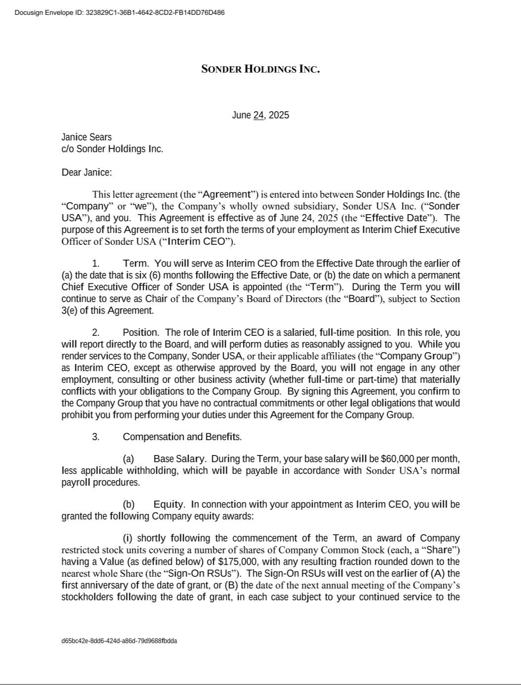

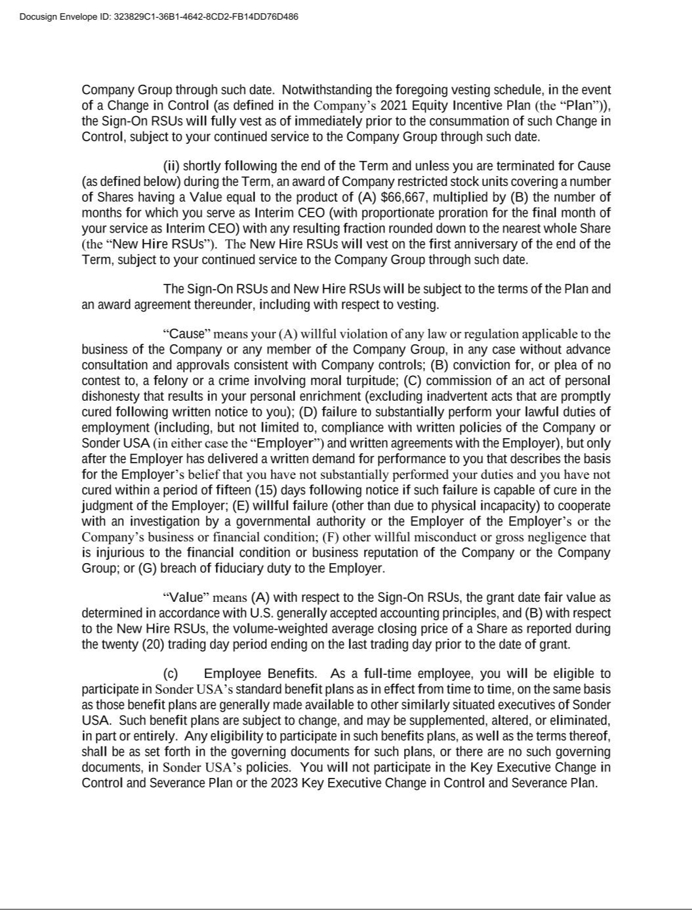

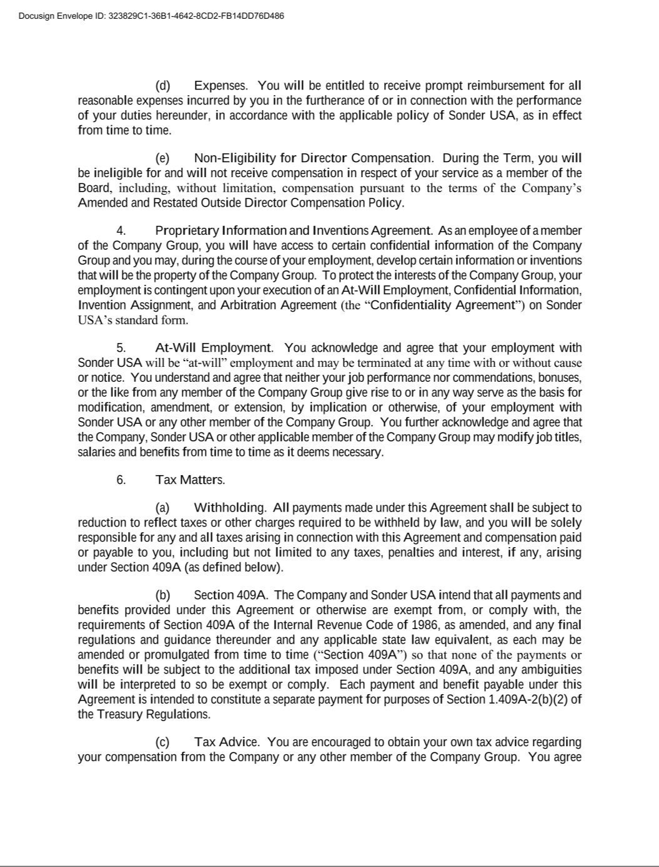

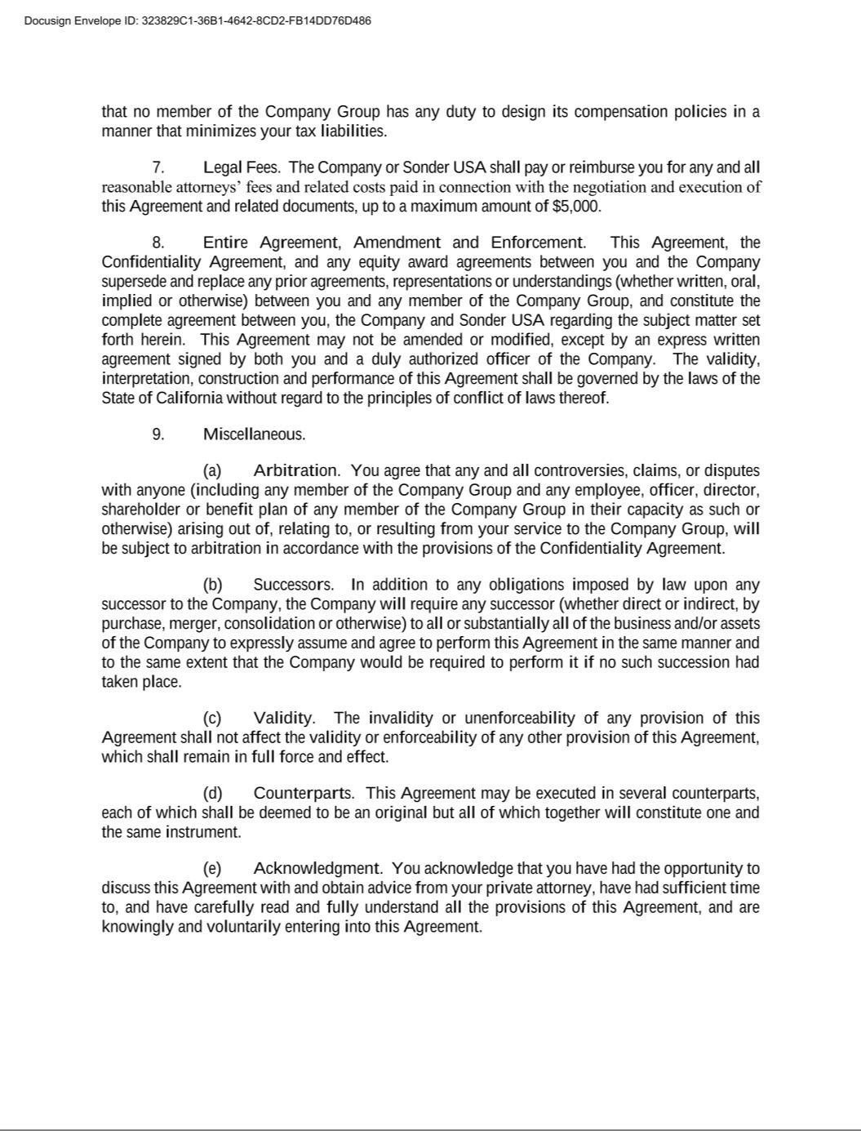

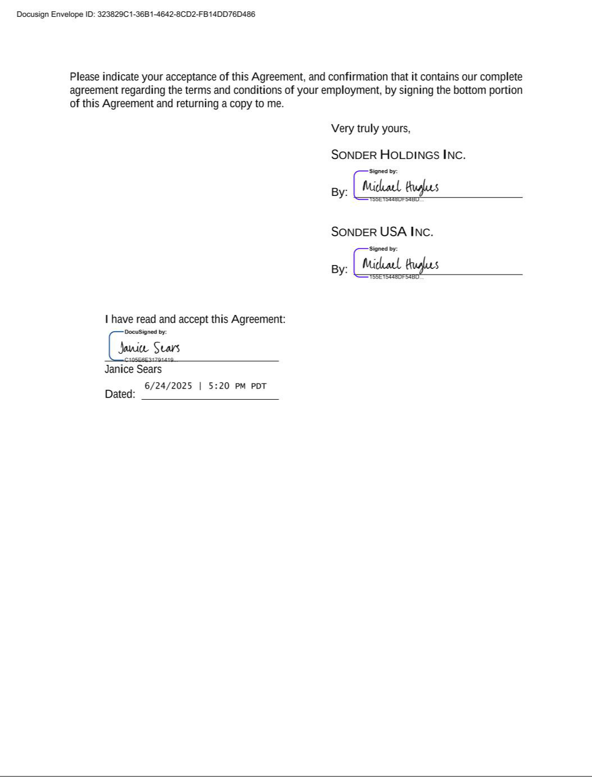

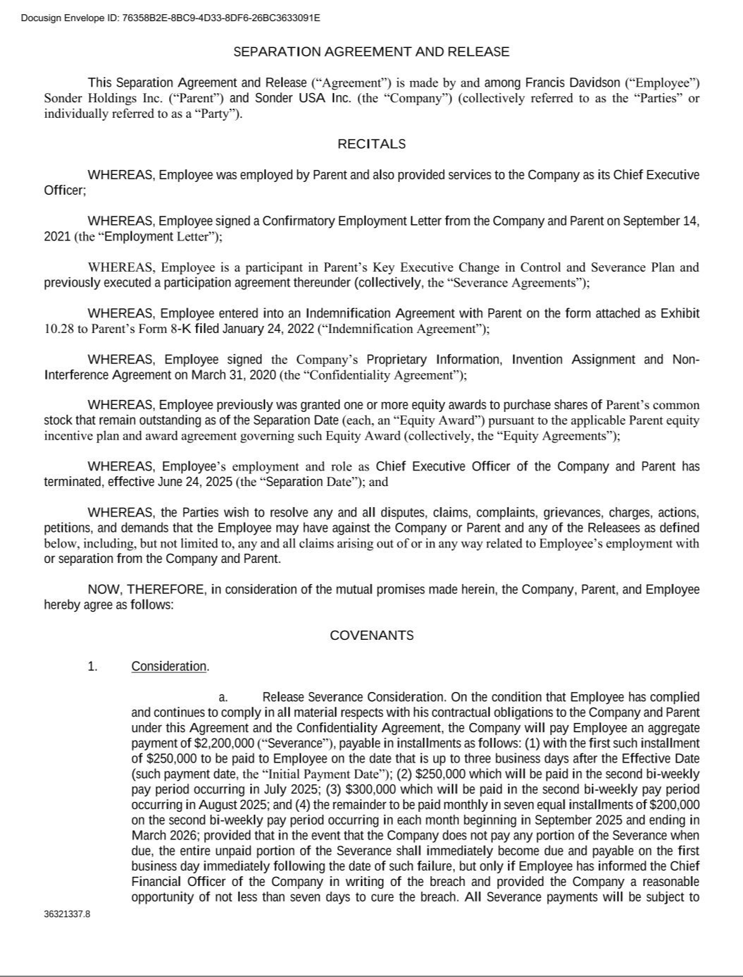

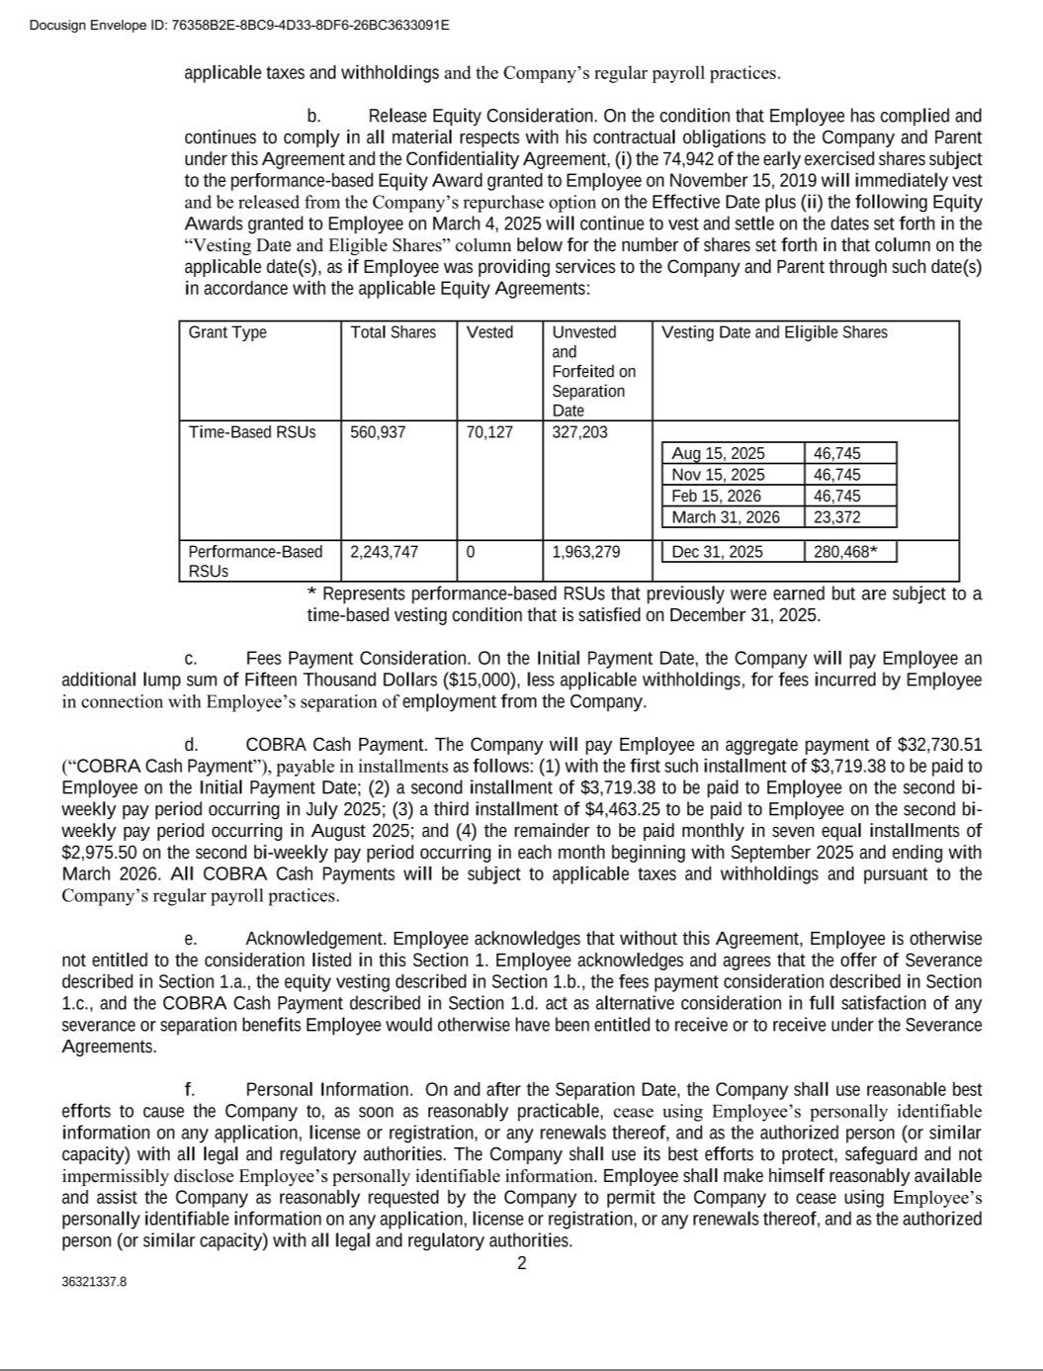

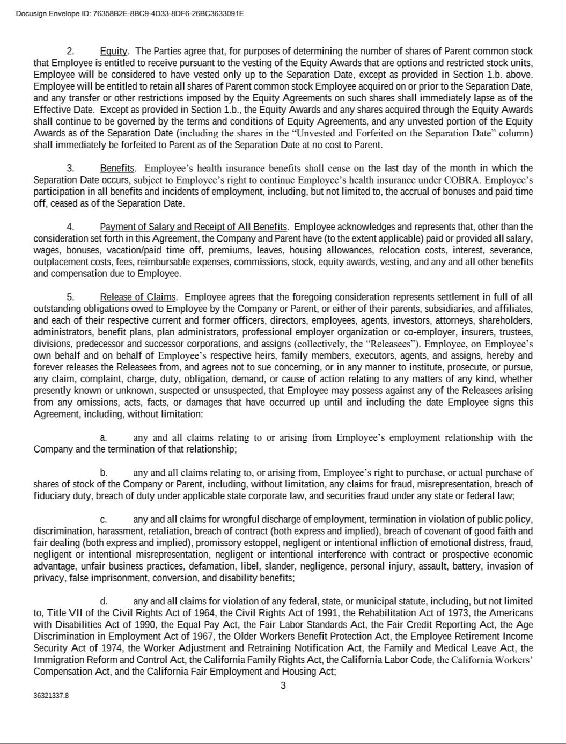

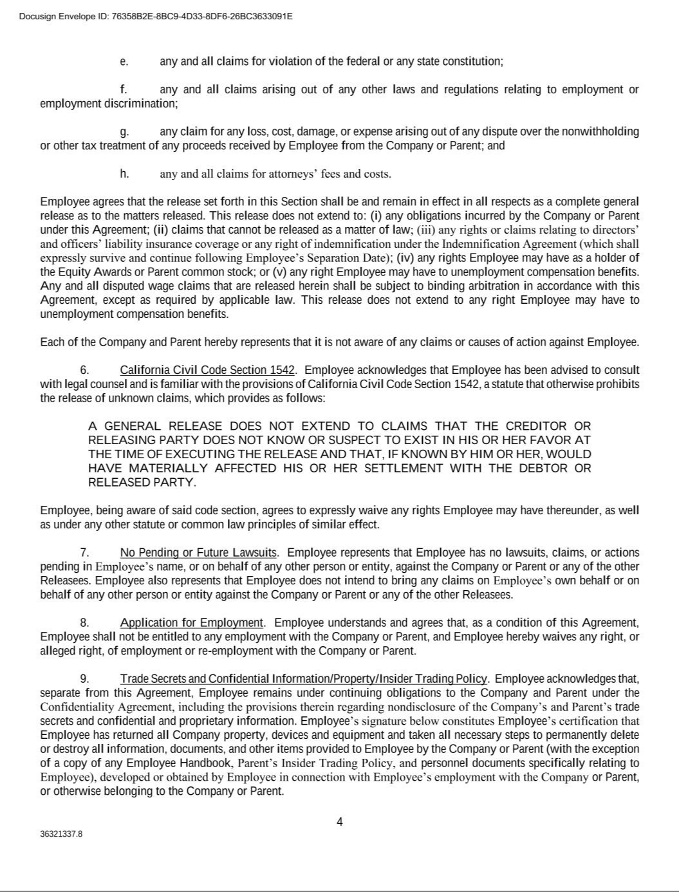

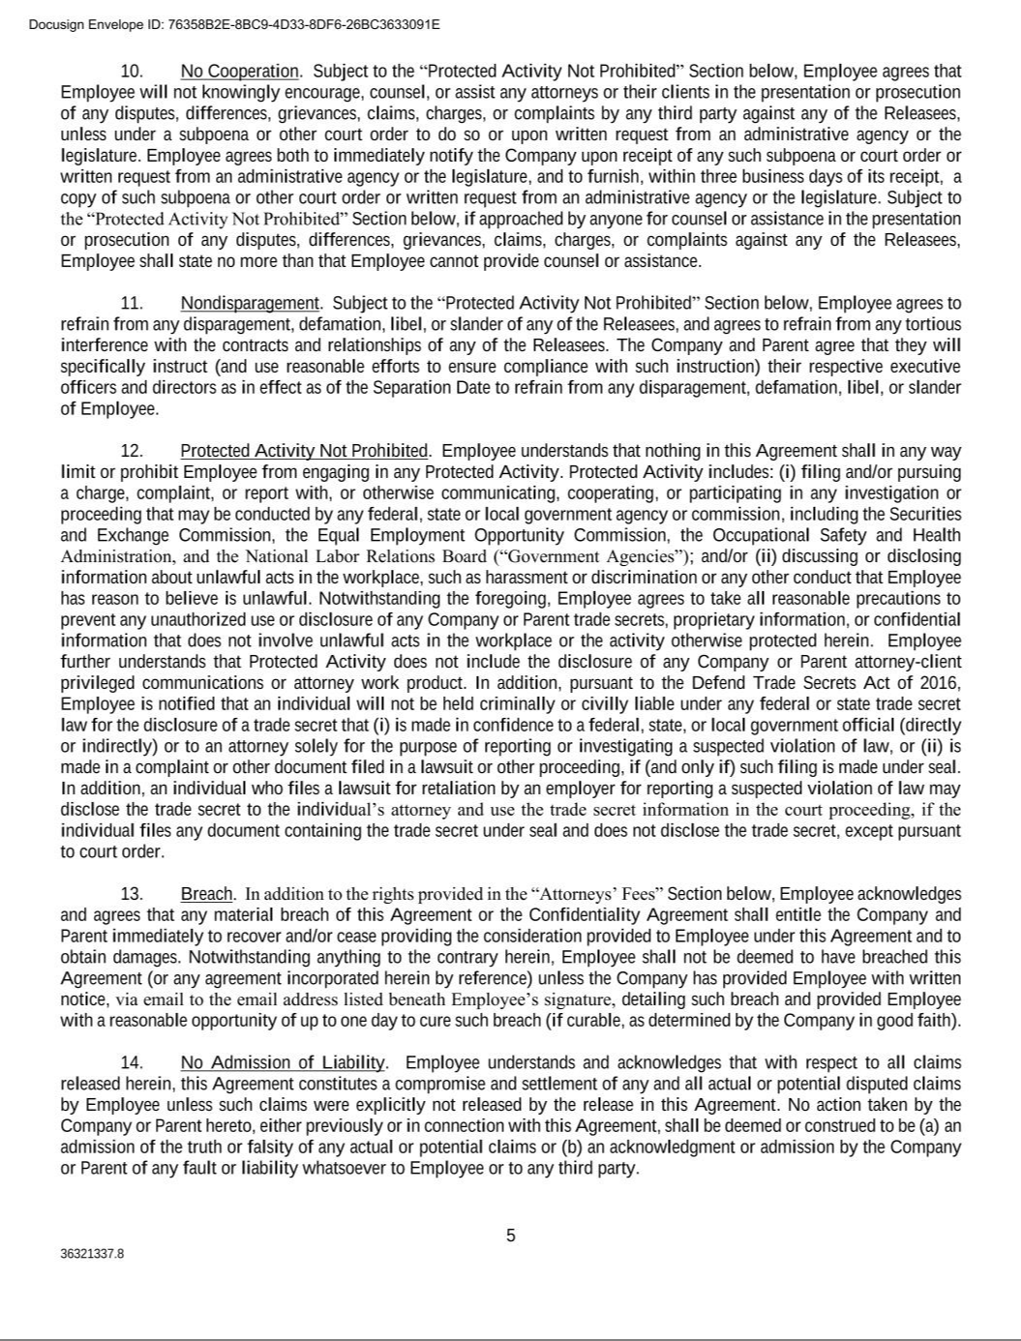

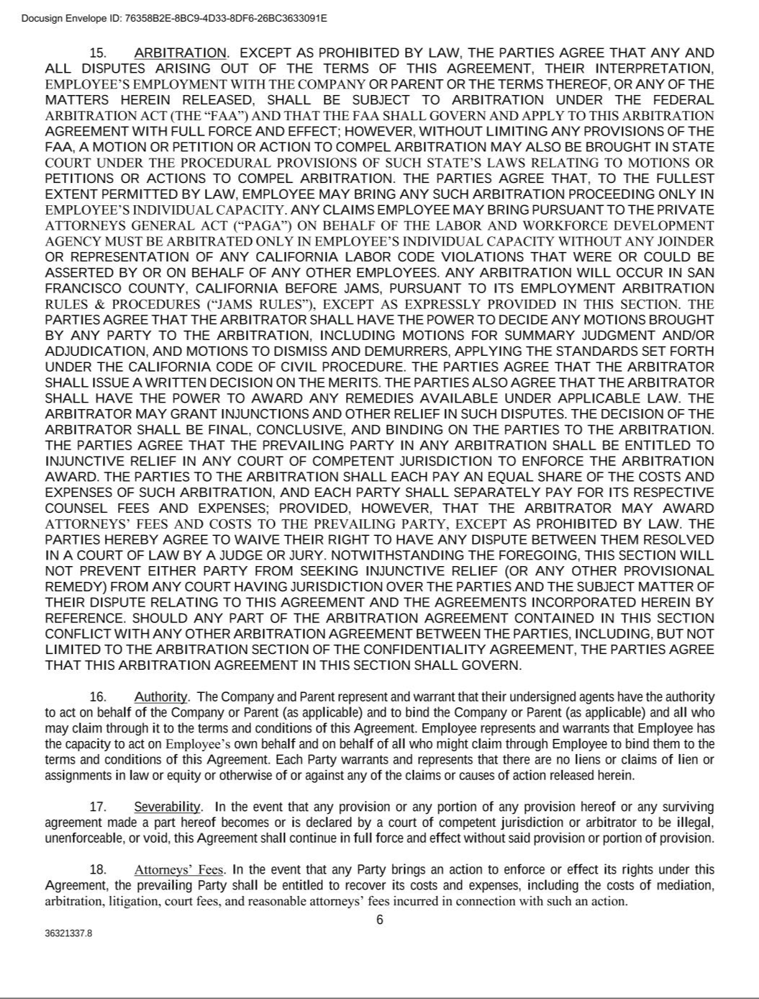

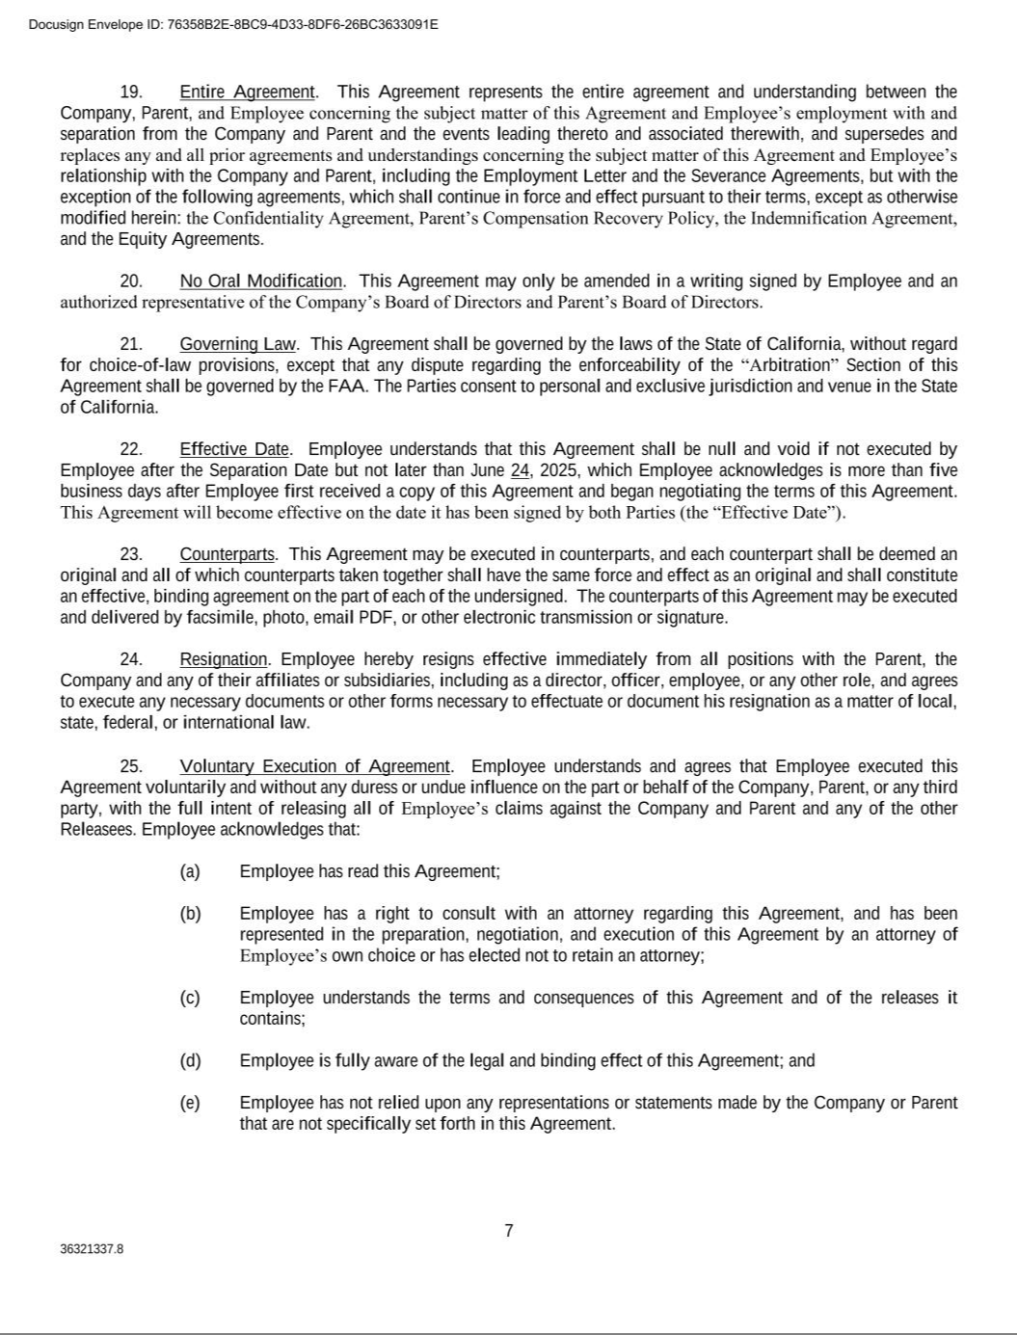

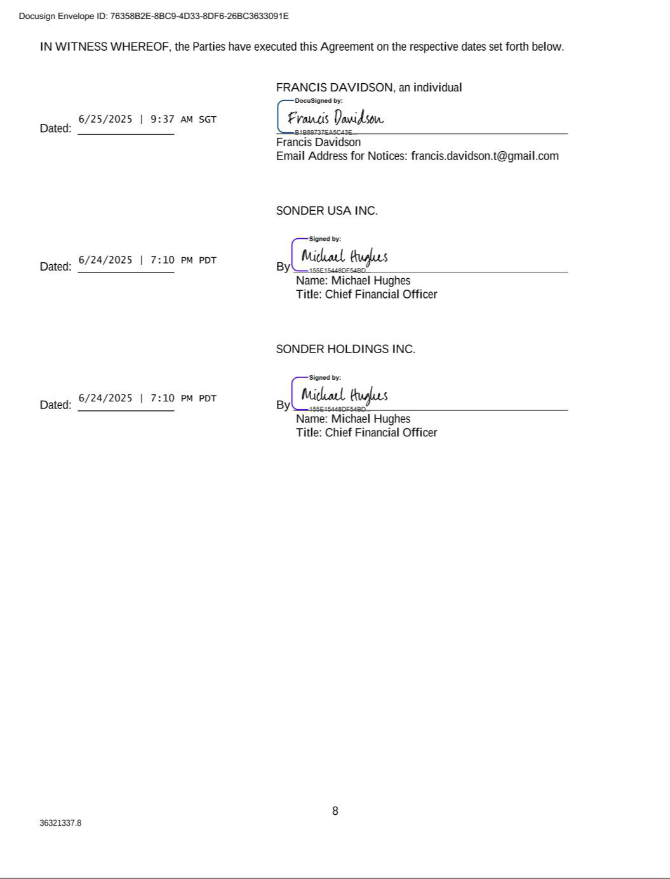

Exhibit 31.1

CERTIFICATION PURSUANT TO

RULE 13a-14(a)/15d-14(a)

AS ADOPTED PURSUANT TO

SECTION 302 OF THE SARBANES-OXLEY ACT OF 2002

I, Janice Sears, certify that:

- I have reviewed this Quarterly Report for the quarter ended June 30, 2025 on Form 10‑Q of Sonder Holdings Inc. (the “Registrant”);

- Based on my knowledge, this report does not contain any untrue statement of a material fact or omit to state a material fact necessary to make the statements made, in light of the circumstances under which such statements were made, not misleading with respect to the period covered by this report;

- Based on my knowledge, the financial statements, and other financial information included in this report, fairly present in all material respects the financial condition, results of operations and cash flows of the Registrant as of, and for, the periods presented in this report;

- I am responsible for establishing and maintaining disclosure controls and procedures (as defined in Exchange Act Rules 13a‑15(e) and 15d‑15(e)) and internal control over financial reporting (as defined in Exchange Act Rules 13a-15(f) and 15d-15(f)) for the Registrant and have:

  - Designed such disclosure controls and procedures, or caused such disclosure controls and procedures to be designed under our supervision, to ensure that material information relating to the Registrant, including its consolidated subsidiaries, is made known to us by others within those entities, particularly during the period in which this report is being prepared;

  - Designed such internal control over financial reporting, or caused such internal control over financial reporting to be designed under our supervision, to provide reasonable assurance regarding the reliability of financial reporting and the preparation of financial statements for external purposes in accordance with generally accepted accounting principles;

  - Evaluated the effectiveness of the Registrant’s disclosure controls and procedures and presented in this report our conclusions about the effectiveness of the disclosure controls and procedures, as of the end of the period covered by this report based on such evaluation; and

  - Disclosed in this report any change in the Registrant’s internal control over financial reporting that occurred during the Registrant’s most recent fiscal quarter (the Registrant’s fourth fiscal quarter in the case of an annual report) that has materially affected, or is reasonably likely to materially affect, the Registrant’s internal control over financial reporting; and

- I have disclosed, based on my most recent evaluation of internal control over financial reporting, to the registrant’s auditors and the audit committee of the registrant’s board of directors (or persons performing the equivalent functions):

  - All significant deficiencies and material weaknesses in the design or operation of internal control over financial reporting which are reasonably likely to adversely affect the Registrant’s ability to record, process, summarize and report financial information; and

  - Any fraud, whether or not material, that involves management or other employees who have a significant role in the Registrant’s internal control over financial reporting.

Date: October 14, 2025 | By: /s/ Janice Sears
 |  | Janice Sears
 |  | Interim Chief Executive Officer
 |  | (Principal Executive Officer and Principal Financial Officer)

Exhibit 32.1

CERTIFICATION OF PRINCIPAL EXECUTIVE OFFICER AND PRINCIPAL FINANCIAL OFFICER

PURSUANT TO 18 U.S.C. SECTION 1350

AS ADOPTED PURSUANT TO SECTION 906 OF THE SARBANES-OXLEY ACT OF 2002

In connection with the Quarterly Report on Form 10-Q of Sonder Holdings Inc. (the “Registrant”) for the quarter ended June 30, 2025, as filed with the Securities and Exchange Commission on the date hereof (the “Report”), I, Janice Sears, Interim Chief Executive Officer of the Registrant, hereby certify pursuant to 18 U.S.C. Section 1350, as adopted pursuant to Section 906 of the Sarbanes-Oxley Act of 2002, that:

- The Report fully complies with the requirements of Section 13(a) or 15(d) of the Securities Exchange Act of 1934, as amended; and

- The information contained in the Report fairly presents, in all material respects, the financial condition and results of operations of the Registrant.

Date: October 14, 2025 | By: /s/ Janice Sears
 |  | Janice Sears
 |  | Interim Chief Executive Officer
 |  | (Principal Executive Officer and Principal Financial Officer)

